
GEF-7 REQUEST FOR PROJECT ENDORSEMENT/APPROVAL
Project Type: MSP
Type of Trust Fund: GEFTF

Part i: Project Information
Project Title: Transition towards low and No-Emission Electric Mobility in the Ukraine: Strengthening electric vehicle charging infrastructure and incentives
Country(ies): | Ukraine | GEF Project ID: | 10271
GEF Agency(ies): | UNEP, EBRD | GEF Agency Project ID: | 01724
Project Executing Entity(s): | Science and Technology Center in Ukraine (STCU),  European Bank for Reconstruction and Development (EBRD) | Submission Date:  Resubmission Date | 10 Dec 2020  26 Feb 2021
GEF Focal Area (s): | Climate Change Mitigation | Expected Implementation Start: | 1 April 2021
 |  | Expected Completion Date: | 31 March 2025
Name of Parent Program | Global Programme to Support Countries with the Shift to Electric Mobility | Parent Program ID: | 10114

Focal/Non-Focal Area Elements
Programming Directions | Focal Area Outcomes | Trust Fund | (in $)
Programming Directions | Focal Area Outcomes | Trust Fund | GEF Project Financing | Confirmed Co-financing
CCM 1-2 | Promote innovation and technology transfer for sustainable energy breakthroughs for electric drive technology and electric mobility | GEF TF | 1,601,376 | 8,190,000
Total project costs |  |  | 1,601,376 | 8,190,000

Project description summary
Project Objective: To support and enable the Government of Ukraine to make the transformative shift to decarbonize transport systems by promoting electric mobility at national scale
Project Component | Component Type | Project Outcomes | Project Outputs | Trust Fund | GEF Project Financing (US$) | Confirmed co-financing (US$)
Component 1: Institutionalization of low-carbon electric mobility | Technical Assistance | Outcome 1:  The Government of Ukraine establishes an institutional framework for effective coordination, develops capacity for policy making and adopts a national strategy to scale up e-mobility. | Output 1.1: A national multi-stakeholder advisory group is established for coordination of government strategy, policies and actions to promote e-mobility in Ukraine. (including gender representation). | GEF TF | 150,250 | 70,000
 | Technical Assistance |  | Output 1.2: Key stakeholders (approx. 125 individuals) are trained and awareness is raised (through at least 7 trainings and related events) on developing policies, regulations, and projects as well as best practices, adopted by leading countries, for promoting e- mobility. | GEF TF | 150,250 | 70,000
 | Technical Assistance |  | Output 1.3: The current e-mobility policy framework, vehicle fleet and trends in energy use and emissions are reviewed and assessed and a national e-mobility strategy and an action plan are developed and submitted to key decision makers for adoption | GEF TF | 150,250 | 70,000
 | Technical Assistance |  | Output 1.4: A gender action plan is developed to mainstream gender aspects in e-mobility and disseminated for implementation | GEF TF | 150,250 | 70,000
Component 2: Short term barrier removal through low-carbon electric mobility demonstrations | Technical Assistance and Investment | Outcome 2: Government and private sector stakeholders adopt lessons learned from the pilots and prepare for scale up of investments in low carbon electric mobility | Output 2.1: EV demonstration projects identified and feasibility assessments conducted (for the installation of up to 350 chargers) | GEF TF | TA 150,000  INV 550,000 | 4,200,000
 | Technical Assistance and Investment |  | Output 2.2: EV charging demonstration project (for up to 350 chargers) implemented and monitoring and analysis report of operations prepared, recommendations drafted and made available to key decision-makers in government and private sector | GEF TF | TA 150,000  INV 550,000 | 4,200,000
Component 3: Preparing for scale-up and replication of low-carbon electric mobility | Technical Assistance | Outcome 3:  Line ministries  enhance enabling policy environment to accelerate the market shift towards appropriate low-carbon electric mobility | Output 3.1 Four best practice 'how to' guides developed and published to enable scale up passenger and freight e-vehicle use and to promote manufacturing of e-vehicles and charging equipment. | GEF TF | 421,626 | 3,665,000
 | Technical Assistance |  | Output 3.2: Ukrainian EV charging market policy and regulatory framework developed in consultation with market participants and submitted for adoption by the government | GEF TF | 421,626 | 3,665,000
 | Technical Assistance |  | Output 3.3: Fiscal, regulatory and local policies (at least 2) to incentivize the purchase of privately owned EVs, the investment in commercial EV fleets and the local manufacturing of electric vehicles developed and submitted for adoption by the Government | GEF TF | 421,626 | 3,665,000
Component 4: Long-term environmental sustainability of low-carbon electric mobility | Technical Assistance | Outcome 4: The Government of Ukraine develops initial policy schemes and regulatory measures and builds capacity to enhance long-term environmental sustainability of low-carbon electric mobility transformation | Output 4.1: E-vehicle power demand on grid assessed and recommendations developed and made available to relevant stakeholders for integration of EV charging into grid management. | GEF TF | 124,500 | 70,000
 | Technical Assistance |  | Output 4.2: Regulatory framework, including financing model, for re-use, recycling, collection and safe disposal of used electric vehicle batteries developed and proposed to key decision makers in government and private sector | GEF TF | 124,500 | 70,000
Monitoring and Evaluation |  |  |  | GEF TF | 60,000
Subtotal |  |  |  |  | 1,456,376 | 8,005,000
Project Management Costs (PMC) |  |  |  | GEF TF | 145,000 | 185,000
Total project costs |  |  |  |  | 1,601,376 | 8,190,000

For multi-trust fund projects, provide the total amount of PMC in Table B, and indicate the split of PMC among the different trust funds here: Not applicable.

Confirmed sources of Co-financing for the project by name and by type
Please include evidence for co-financing for the project with this form. ,,
Sources of Co-financing | Name of Co-financier | Type of Co-financing | Investment  Mobilized | Amount ($)
GEF implementing partner | EBRD | Loan | Investment mobilized | 4,200,000
GEF implementing partner | EBRD | In-kind | Recurrent expenditures | 150,000
Private sector | TOKA LLC | Equity Investment | Investment mobilized | 3,000,000
Private sector | R&S Quantum LLC | Equity Investment | Investment mobilized | 500,000
Private sector | R&S Quantum LLC | In-kind | Recurrent expenditures | 45,000
Private sector | KB Energy LLC | In-kind | Recurrent expenditures | 90,000
Private sector | KB Energy LLC | Equity Investment | Investment mobilized | 30,000
Other | Science and Technology Center in Ukraine (STCU), | In-kind | Recurrent expenditures | 175,000
Total Co-financing |  |  |  | 8,190,000
Also refer to box “Parallel financing through the State Space Agency of Ukraine” under the section “alternative scenario/component 3”.

Describe how any “Investment Mobilized” was identified:
Local stakeholders have been consulted to identify sources of co-financing:
- As detailed in the co-financing letter, EBRD loan relates to project(s) that accelerate an uptake of electric mobility through charging stations in Ukraine in support of the implementation and achievement of the objectives of the GEF-funded project. Subject to EBRD’s standard internal due diligence and approval procedures loan will be mobilized.
- TOKA LLC is active in the field of Electric Vehicles (EV) charging hard- and software and is also a charging point operator. TOKA is owning a network of 360 public chargers and has about 12,000 subscribed clients. The company is making a co-finance contribution of USD 3,000,000 to expand their public slow and fast charging network, to implement smart grid solutions for multi storage dwellings to manage and control the charging of multiple EVs and to provide support software for home-chargers in Ukraine. The first tranche of direct investment amounting to USD 800,000 is scheduled for the year 2021.
- R&S is a provider in the Ukrainian market of electric mobility since 2015. They develop proprietary hardware and software solutions for charging electric vehicles. They have an in-house production of charging stations for commercial and residential/private use. The R&S Quantum, LLC is scheduling to make a co-financing contribution in the value of 500,000 USD in the form of equity investment and 45,000 USD in the form of in-kind contribution over the 4 years of the project’s implementation in Ukraine, starting in 2021. Under this co-finance contribution, the R&S Quantum, LLC intends to support the following project by adding public and private chargers including fast/rapid charges, implementing smart grid solutions for multi-storied buildings in various cities of Ukraine and implementing financial software program for installing home chargers in cities of Ukraine.
- KB Energy is an energy company in the field of energy efficiency and energy conservation. Their co-financing contribution will be for $120,000, of which $30,000 is equity investment mobilized and will include design and development of infrastructure solutions with coordination and technical specifications for connection to electric networks and development of hardware solutions. As well as introduction of technological developments on the production of electric charging stations and software development.

Trust Fund Resources Requested by Agency, Country, Focal Area and the Programming of Funds
GEF Agency | Trust Fund | Country  Name/Global | Focal Area | Programming of Funds | (in $)
 |  |  |  |  | GEF Project Financing  (a) | Agency Fee  (b) | Total  (c)=(a)+(b)
UNEP | GEF TF | Ukraine | Climate Change | CCM 1-2 | 901,376 | 81,124 | 982,500
EBRD | GEF TF | Ukraine | Climate Change | CCM 1-2 | 700,000 | 63,000 | 763,000
Total GEF Resources |  |  |  |  | 1,601,376 | 144,124 | 1,745,500

DOES THE PROJECT INCLUDE A “NON-GRANT” INSTRUMENT? ☐ Yes ☒ No
If non-grant instruments are used, provide in Annex D an indicative calendar of expected reflows to your Agency and to the GEF/LDCF/SCCF Trust Fund.

Project’s Target Contributions to GEF 7 Core Indicators
Update the relevant sub-indicator values for this project using the methodologies indicated in the Core Indicator Worksheet provided in Annex F and aggregating them in the table below. Progress in programming against these targets is updated at mid-term evaluation and at terminal evaluation. Achieved targets will be aggregated and reported any time during the replenishment period. There is no need to complete this table for climate adaptation projects financed solely through LDCF and SCCF.
Project Core Indicators |  | Expected at CEO Endorsement
6 | Greenhouse Gas Emissions Mitigated (metric tons of CO_{2e}) | Total direct: 326,036 tCO₂  Total indirect: 2,226,629 tCO_{2e}
11 | Number of direct beneficiaries disaggregated by gender as co-benefit of GEF investment | Women: 3,672  Men: 9,928  Total: 13,600
The number of direct beneficiaries includes two sets of beneficiaries:
1.) Participants of workshops and trainings over the duration of the project (estimated to be 125). A target for female participants of 30% has been applied; and
2.) Users of the demonstration assets. The project anticipates the development of up to 350 public chargers (320 slow and 30 fast). The IEA estimates densities of 15 electric vehicles per public slow charger and 250 electric vehicles per public fast charger for the year 2025 under a business as usual scenario (IEA Global Electric Vehicle Outlook 2017). This leads to approximately 13,475 beneficiaries of the charging infrastructure (of which 27% are assumed to women and 73% men,).

Project Taxonomy
Please update the table below for the taxonomic information provided at PIF stage. Use the GEF Taxonomy Worksheet provided in Annex G to find the most relevant keywords/topics/themes that best describe the project.
Level 1 | Level 2 | Level 3 | Level 4
Influencing models | Transform policy and regulatory environments
Influencing models | Strengthen institutional capacity and decision-making
Influencing models | Demonstrate innovative approaches
Stakeholders | Private Sector | Capital providers
Stakeholders | Private Sector | Financial intermediaries and market facilitators
Stakeholders | Private Sector | Large corporations
Stakeholders | Private Sector | SMEs
Stakeholders | Private Sector | Individuals/Entrepreneurs
Stakeholders | Civil Society | Community Based Organization
Stakeholders | Civil Society | Non-Governmental Organization
Stakeholders | Civil Society | Academia
Stakeholders | Type of Engagement | Information Dissemination
Stakeholders | Type of Engagement | Consultation
Stakeholders | Type of Engagement | Participation
Stakeholders | Communications | Awareness Raising
Stakeholders | Communications | Education
Stakeholders | Communications | Public Campaigns
Stakeholders | Communications | Behavior Change
Capacity, Knowledge and Research | Capacity Development
Capacity, Knowledge and Research | Knowledge Generation and Exchange
Capacity, Knowledge and Research | Innovation
Capacity, Knowledge and Research | Knowledge and Learning | Knowledge Management
Capacity, Knowledge and Research | Knowledge and Learning | Innovation
Capacity, Knowledge and Research | Knowledge and Learning | Capacity Development
Capacity, Knowledge and Research | Knowledge and Learning | Learning
Gender Equality | Gender Mainstreaming | Beneficiaries
Gender Equality | Gender Mainstreaming | Women groups
Gender Equality | Gender results areas | Access to benefits and services
Focal Areas/Theme | Climate Change | Climate Change Mitigation | Sustainable Urban Systems and Transport
Rio Markers | Climate Change Mitigation 2
Rio Markers | Climate Change Adaptation 0

Part ii: Project Justification

1a. Changes in project design
CHANGES BETWEEN THE CONCEPT NOTE AND CEO ENDORSEMENT DOCUMENT
Concept note | CEO endorsement document | Rationale
Component 1:  Institutional framework, awareness raising and capacity building for electric vehicles | Component 1  Institutionalization of low-carbon electric mobility  Outcome 1  The Government of Ukraine establishes an institutional framework for effective coordination, develops capacity for policy making and adopts a national strategy to scale up e-mobility. | The wording has been simplified for Component 1 but it continues to focus on the institutionalization of e-mobility with a particular focus on the establishment of a national multi-stakeholder advisory group under the governmental body for coordination of development and promotion of e-mobility, to stream-line already existing initiatives and to better coordinate future e-mobility projects. A baseline analysis on the current EV fleet and policy framework has been added.
Component 2:  Development of an electric mobility policy framework with a focus on electric vehicle infrastructure/ charging stations, and fiscal/non-fiscal incentives | Component 2  Short term barrier removal through low-carbon e-mobility demonstrations (former Component 3)  Outcome 2  Government and private sector stakeholders adopt lessons learned from the pilots and prepare for scale up of investments in low carbon electric mobility | Component 2 is the earlier Component 3. Component 2 will be implemented and executed by the EBRD. It will comprise the financing up to 350 chargers that meet the charging standards approved by government by blending GEF grant (USD 550,000) with EBRD loan (co-finance of approx. 4 million USD). Component 2 will comprise 2 outputs:  Output 2.1: EV demonstration selection and feasibility assessments. This output is comprised of technical assistance provided by EBRD to prepare A.) the selection of the demo-projects through an open-tender process and B.) to conduct feasibility assessments and to define all necessary technical specifications to prepare for the investment, implementation and monitoring of Output 2.2.  Output 2.2: EV charging infrastructure investment, implementation and monitoring
Component 3:  Demonstration of electric vehicle charging station infrastructure, public fast charging stations | Component 3  (former Component 2)  Preparing for scale-up and replication of low-carbon electric mobility  Outcome 3  Line ministries  enhance enabling policy environment to accelerate the market shift towards appropriate low-carbon electric mobility | Component 3 is earlier component 2: It focuses on the scaling-up of e-mobility in Ukraine through the development of adequate policies to regulate and structure the EV charging infrastructure market, including both technical regulations (standards of the equipment and standards for installation) and regulations to structure the EV charging market. It furthermore includes the development and alignment of fiscal and local policies to incentivize the investment in both EVs and EV charging infrastructure. The component is completed by outputs on capacity building and awareness raising.
Component 4:  Enabling scaling-up | Component 4  Long-term environmental sustainability of low-carbon electric mobility  Outcome 4  The Government of Ukraine develops initial policy schemes and regulatory measures and builds capacity to enhance long-term environmental sustainability of low-carbon electric mobility transformation | Long term environmental sustainability is addressed through the development of recommendation to use low carbon in power in the EV charging network and in turn to investigate the role of EVs as an enabler for the integration of high shares of variable renewable energies in the power sector. Furthermore, this component targets the development of an initial scheme for the re-use, recycling, collection and safe disposal of used electric vehicle batteries.
GHG emission reductions  Total estimated greenhouse gas emission reductions: 4,886,612 tCO₂.  Estimated direct and indirect emission mitigations of 4,244,209 tCO₂ and 642,402 tCO₂ respectively. | Total direct: 326,036 tCO₂  Total indirect: 2,226,629 tCO_{2e} | Total estimated emission reductions have been revised down-wards due to a change in the methodology of accounting for CO₂ emission benefits from EV charging infrastructure and due to the better understanding of the amount and nature of co-financing.

CHANGES TO CO-FINANCING COMMITMENTS

Co-financing  Total: USD 13,915,000 | Co-financing  Total: USD 8,190,000 | Co-financing doesn't reflect the in-kind co-financing providing by Ministry of Energy, Environment Protection and Natural Resources, and Infrastructure. They have provide letters of co-finance but not quantified the co-finance which will estimated and recorded as part of PIR. The investment mobilized has increased due to additional co-finance by government agencies. Parallel financing by the State Space Agency of Ukraine which will invest a significant amount in production of e-vehicles and charging stations is not included. Further details on the parallel financing are provided below.

1b. Project Description

Global environmental and/or adaptation problems, root causes and barriers that need to be addressed

Global environmental problem:

A global transition to low- and zero-emission mobility is essential to meet international climate commitments, including the Paris Agreement. The transport sector globally is currently responsible for approximately one quarter of energy-related carbon dioxide emissions, and the share in a business-as-usual scenario is expected to grow by 2050. In addition, the transport sector is a leading contributor to short-lived climate pollution, especially black carbon.

The global vehicle fleet is set to double by 2050, and almost all of this growth will take place in low- and middle-income countries. By 2050 two out of three cars will be in developing countries. Therefore, achieving global climate targets will require a shift to zero emissions mobility in all countries, including low- and middle-income countries.

Ukraine's Greenhouse Gas Inventory 1990-2017 showed that, in 2017, the energy sector accounted for around 66% of greenhouse gas (GHG) emissions, of which 15% were from transport sector. Road transport, within the transport sector, was the largest contributor with 70.6%.

Despite that the transport sector is a key enabler of economic growth, this sector has significant environmental and social impacts in terms of CO₂ and local air pollutant emissions. Ukraine has one of the highest mortality rates due to diseases associated with air pollution as a result of inefficient and pollution from energy generation and use, and the lack of an adequate framework to incentivize the use of efficient and clean energy conversion technologies.

At present, Ukraine’s on-road automobile transport system accounts for more than 9.2 million vehicles, with 6.9 million Light Duty Vehicle (LDVs). The vehicle fleet is old and in need of modernization and imported used vehicles account for the largest part of new annual vehicle registrations. Therefore, as of 2019, the average vehicle age of the fleet is about 20.5 years. With a relatively low motorization rate (202 cars per 1000 inhabitants in 2016) and a growing economy (2.5% – 3% annually in 2016-2019), Ukraine’s vehicle fleet is rapidly expanding.

The transition to EVs addresses the development and environmental, is a challenge for Ukraine. Ukraine is a good example of how a low to medium income country can play a meaningful role in the EV revolution. Despite an unstable economy and an average monthly salary of USD 385, Ukraine’s electric car ownership keeps increasing, making it one of the fastest-growing EV markets in Europe. Registrations of electric vehicles (EVs) have steadily increased (see Figure 1) and by the end of 2019, cumulatively about 11,000 EVs and more than 20,000 hybrids have been imported to the Ukraine. Due to low purchasing power, consumers are sensitive to total cost of ownership, which includes both fixed and variable costs of a vehicle over the life of vehicle. Over half of EVs on Ukraine’s roads are imported used Nissan Leafs, which cost between USD 10,000 to 15,000 and have an available range of 120-160 km (during the winter months the range might be reduced by 40% due to unfavorable operating temperatures and the use of the heating). Part of the higher purchase price of these EVs is already compensated by waiving import taxes on EVs (currently enforced until 2022) and by a registration tax scheme which favors electric cars. Depending on the user profile, lower fuel and maintenance costs of EVs tend to more than compensate for the remaining vehicle price differential (after tax incentives) within a short time compared with a similar conventional car. This is due to the very low electricity prices in Ukraine: for private consumers, the kWh of power costs about 3.3 USD, while a liter of gasoline sells for about USD 0.9. The very low electricity price results in annual fuel costs of an EV of only about USD 90, versus USD 945 for a comparable conventional car.

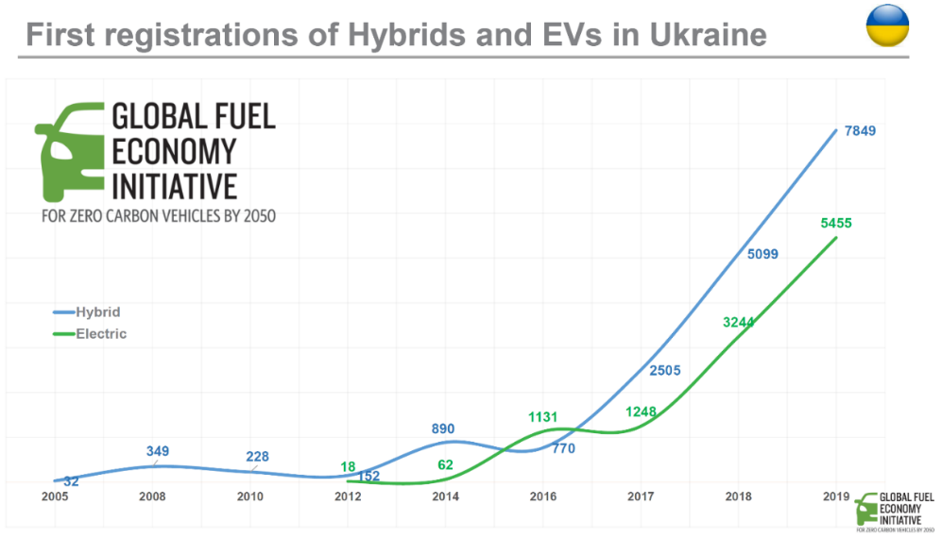
Figure 1 first registrations of electric vehicles and hybrids in Ukraine, 2005 to 2019

The most limiting factor to the faster uptake of EVs in Ukraine is the lack of adequate and safe public charging infrastructure. Although it is estimated that a total amount of 2,700 EV charging stations already exist in the country, these charging stations are not sufficient to attract a wider uptake of e-mobility. According to Ukrainian experts, most of the chargers 1.) are of varying technical specifications, which makes it hard for the consumer to understand compatibility with their vehicles; 2.) have been installed in a way that can be unsafe due to the absence of technical regulation for the installation of EV chargers; 3.) are very often located in a way that is not attractive to the consumer; 4.) follow no transparent and stream-lined billing scheme which makes it difficult for the consumer to compare offers, 5.) cannot be monitored by grid operators since power consumption is not metered separately in most cases (e.g. when installed in a mall or supermarket); 5.) and show very low occupancy rate and therefore low return on investment to the operators.

Given the favorable conditions present in Ukraine with regards to 1.) general and already existing interest in consumers to buy electric vehicles; 2.) already existing tax incentives to import EVs; 3.) the substantial price difference between petroleum fuels and electricity; and 4.) the strong interest of government to increase electricity in the transport sector to compensate for lower power demand from other end-use sectors and therefore make better use of already installed renewable power generation capacity, there is both demand from the consumer side and strong interest from the EV charging business industry to further develop the EV and EV charging market in Ukraine.

In Ukraine, about 54% of the generated power comes from nuclear, 37% is based on coal and gas, and 9% comes from renewable sources. With a grid emission factor of about 490 gCO₂/kWh, the use of grid electricity in electric vehicles leads to significant GHG emission reductions already today.

The transport sector in Ukraine, therefore, has a great potential to reduce energy use, address air pollution and mitigate CO₂ emissions. However, without any immediate policy interventions, in particular in the EV charging market to provide for a consumer-friendly environment, the uptake of electric mobility is likely to get stalled and energy demand and CO₂ emissions in the transport sector will continue to grow significantly in the coming years. So far, mostly vehicle drivers with access to home charging are buying electric vehicles. To pursue the target to transition the transport sector in the Ukraine towards low and no-emission electric mobility, the EV charging market needs to be addressed both from a technical and legislative perspective.

Transition to EVs will also have energy security benefits as Ukraine historically has had a strong dependence on imported fossil fuels. Between 2013-2019, more than 80% of crude oil and oil products in Ukraine were imported (State Statistic Service of Ukraine, 2019). Ukraine’s transport sector ranks third in total final energy consumption, after residential consumers and industry end-users (see Figure 2). Increase in use of renewable energy in general and renewable energy for EVs, will further strengthen these benefits. Recently approved National Renewable Energy Action Plan (NREAP) targets the share of renewable energy in the total final energy consumption (TFEC) to 13.2% by 2030. An IRENA study identifies that total could be boosted to 21.8%.

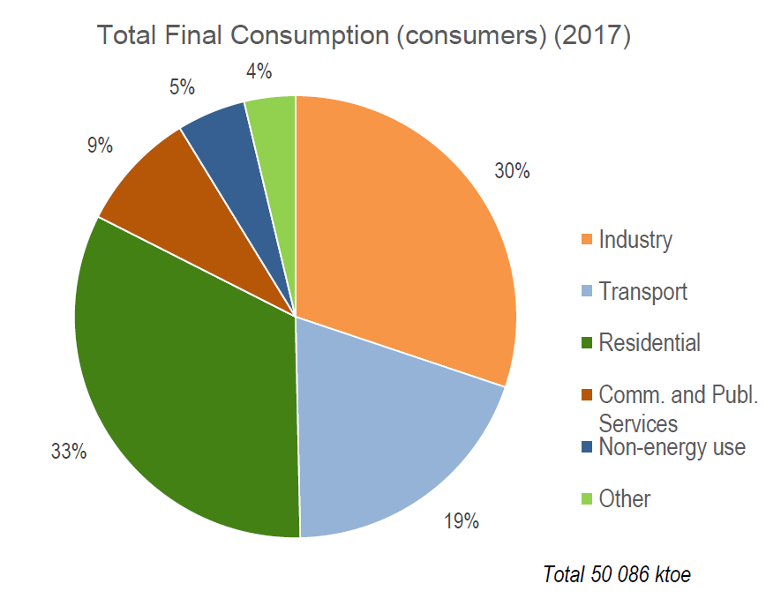
Figure 2 Total final energy use by sector, 2017

Root causes

- Increasing passenger demand - The transport of persons and goods is a key driver of economic growth. Since the latest recession in Ukraine ended in 2015, annual economic growth is averaging 2% to 3%. Increasing demand for transportation of people and goods is a root cause for growth in transport energy demand, and the associated GHG and air pollutant emissions. To mitigate these effects, a decoupling of growing transport demand from energy use and emissions needs to take place.
- Lack of coherent policy and regulatory framework to promote low carbon sustainable transport, including e-vehicles and EV charging infrastructure – The country lacks a sustainable transport strategy and related policy and regulatory framework. This is the case for e-vehicles too. While the macro-economic effects of e-mobility in Ukraine are undoubtedly positive through lower demand for imported petroleum fuels, reduced air pollution and GHG emissions, and co-benefits such as improved public health, there is still a substantial lack of knowledge on how to adequately design incentives to make these benefits accessible.
- Although there is already a significant fleet of EVs in the country, the lack of consumer awareness about the existence of these vehicles as well as their economic, environmental and operational benefits prevent more consumers from considering the option of electric mobility and from benefitting of the lower total cost of ownership of EVs. Due to low electricity prices in Ukraine, higher upfront costs of EVs are paid back quickly as a result of much lower operating costs. This is true for public and private sector fleets as well as individually used private cars.
- Inadequate charging infrastructure - For those who can charge a vehicle at home, EVs (and particularly used EVs) are already a low-cost option for daily commuting or other short distance trips. However, long-distance driving and ownership of EVs in densely populated urban areas are severely hampered by the absence of adequate public slow and fast charging infrastructure. The expansion of the public charging network alongside the regulation and structuring of this market in order to provide for consumer friendly and safe operation is expected to trigger the further uptake of e-mobility in Ukraine.
- High upfront cost of e-vehicles - Currently, new EVs are substantially more expensive compared to new conventional cars. For example, while a new compact car costs around USD 15,000 to 20,000 before taxes, a compact EV costs at least USD 31,000. EV buses and commercial vehicles are also substantially more expensive than comparable conventional models. The higher upfront costs are certainly a root cause that slows market uptake. However, if produced locally and therefore benefitting from competitive cost of labour in Ukraine and if combined with financial products to spread the higher upfront costs over a longer payback period, total cost of ownership can be lowered for EVs, especially when used in fleets with high annual driving.

Barriers to the adoption of Electric Vehicles

Barriers preventing the quick transition to E-Mobility in Ukraine include:

Root Cause | Related barriers
Lack of coherent policy and regulatory framework for promoting low carbon sustainable transport, including for e-vehicles | Lack of expertise, capacity and co-ordination among policy makers  To date, knowledge is limited among policy makers about e-mobility and the need to establish adequate regulation, especially for the vehicle charging market. In combination with a lack of a coordinating framework at different levels of government (national, regional and municipalities) to ensure all actors and stakeholders work towards a common vision, the situation creates a barrier for the faster uptake of the e-mobility market. Several ministries and government agencies are involved in the development and realization of e-mobility policies; however, absence of a harmonized framework and strategy compounds the lack of coordination.  Furthermore, Ukraine continues to undergo government restructuring, including the disbanding and reformation of several key ministries on multiple occasions. In August of 2019 Ukraine merged the Ministry of Energy and Coal Industry with the Ministry for Environmental Protection to create a Ministry of Energy and Environmental Protection (MEEP) in order to promote a more harmonized energy and climate sector along all Ukraine’s declared aspirations. In June of 2020 the Government again separated ministries by separating the energy mandate of the MEEP. Such governmental turbulence requires additional time and efforts to establish new links and coordination between the sectors and stakeholders at each change.  The absence of a strategy on how to integrate EV charging into the Ukraine power grid and the use synergies in supply and demand of electricity for EV chargers for the integration of high shares of renewable power.  Though the EV market is at a nascent stage and thus doesn’t significantly impact the load on grid, in future with accelerated growth of EV this could become a barrier. An early on consideration of development of the EV market and the required charging infrastructure on electricity supply would help avoid the situation. Promoting renewable energy use for charging infrastructure too would require the possibility of such power sources being integrated with the grid to enable viability of renewable energy use. Further, as Ukraine increase the share of renewable energy in grid, the issue of grid integration will have to be addressed. Linking the development of an EV charging network with increasing renewable generation capacity can unlock various synergies. On one hand, steady cost reductions for renewable power generation makes electricity an attractive low-cost energy source to power the transport sector. On the other hand, the cost-effective supply of solar and wind power into the grid requires more flexible power demand. Such flexibility in demand can be introduced with e-mobility and the parallel development of mechanisms to control charging patterns of vehicles, e.g., through differentiated electricity tariffs for times where charging of EVs is preferential for grid stability. The absence of such mechanisms can pose a significant hurdle for the large-scale introduction of e-mobility in Ukraine.
Lack of awareness and knowledge among consumers | Lack of systematic collation of EV experience, and information and knowledge dissemination to consumers  There is a lack of consumer understanding about the availability and viability of the vehicle options, technology, range related to electric mobility in Ukraine. Often termed “consumer awareness,” this is will be crucial to the uptake of electric mobility. The development of electric vehicle markets is fundamentally tied to prospective consumers’ general awareness and understanding of the potential benefits of electric vehicles. The lack of strategy and related elements to promote e-mobility also results in absence of efforts to undertake awareness creation among consumers. Similarly, efforts from private sector too are minimal as lack of clarity on future market of e-mobility prevents spending by private sector on promotion campaigns.
Inadequate charging infrastructure | Insufficient policy frameworks and effective regulation for charging infrastructure  Absence of a coherent regulatory framework for promoting investment in EV charging infrastructure is hampering businesses wanting to invest in EV chargers and consumers wanting to buy an electric vehicle. It leads to products entering the market, which are not safe, and which do not follow a common charging protocol, leading to malfunction or damage to the vehicle. It is fostering the creation of a dispersed charging market with dozens of charging providers which will not be interoperable and whose billing schemes and prices are in-transparent and not comparable. It will make it difficult for grid operators to anticipate EV charging demand since the lack of regulation will lead to a lack of monitoring and integration of EV charging into grid operation and balancing of power demand with supply. It will finally lead to an environment, which is not consumer friendly and which will not attract motorists who do not have the opportunity to charge their EV at home.  The absence of adequate data on EV charging infrastructure to consumers and infrastructure planners  No official statistics exist on the number of charging facilities, however unofficial estimates indicate at least 2,700 charging stations in Ukraine (November 2019). Of these, only about 500 of the charging stations are fast chargers (>19.4 kWh). Only very few ultra-fast chargers (>50kW) are available in Ukraine. Officially collected and regularly updated data on the charging network are a precondition to formulate an E-Mobility Strategy for the Ukraine and to boost the EV market through private sector investment into a much denser network of publicly accessible slow and fast chargers.  A lack of experience with procurement, operation and maintenance of electric charging stations within private sector  There are no sources of guidance to help fleet operators to design business models and schemes for the procurement, operation and maintenance of various modes of EVs and no help available to guide them through the e-mobility market. The absence of technical guidelines specifying minimal requirements with respect to power, range, charging standard etc. of EVs according to different applications makes it difficult for fleet operators to choose the right vehicle and charger.  Limited access to commercial financing to support investment  To date there is limited access to commercial financing available to support investment in e-mobility including for charging stations in Ukraine, which prevents businesses and consumers from becoming familiar with EVs and benefitting from the lower total cost of ownership of EVs. In fact, new EVs are still considerably more expensive compared to conventional vehicles (around 1.5 to almost twice the price in the case of buses), hence tailored financial products are needed to cover the higher upfront costs of EVs and to generally provide financing at lower capital cost and reduce risk perceptions.  Moreover, to date, making EV charging a profitable business almost always relies on subsidies or cross-subsidies (e.g. within utilities who anticipate a growing charging market and therefore accept low return on investment for current charging operations), or on high services prices. The latter also makes driving an EV more costly compared to an ICE.
High upfront cost of e-vehicles | The lack of capacity among national government stakeholders for the design of business models and the absence of available financing that takes into account the local conditions to invest in electric mobility and in particular EV charging infrastructure.  Although a number of incentives for EVs have already been put in place, including a waiver for customs duties and value-added taxes, 10% reduced insurance rates, green license plates and separate parking areas for electric vehicles (alongside fines for internal combustion vehicles that park on those reserved areas), these measures so far have been insufficient to substantially transform the transport sector. In addition, the measures taken so far lack coordination and do not follow a set target or strategy. The scaling-up of the national EV charging network is key for the expansion of the EV market and a strategic approach is necessary to harmonize the EV charging market and to prevent a scattered system with dozens of charging providers with non-interoperable payment systems thus creating a user un-friendly environment. Similarly, creating interest among local vehicle manufacturers to produce electric vehicles can have significant impact on EV prices. Locally produced EVs could benefit from competitive labor costs (already today Renault and Skoda are producing cars in Ukraine at scale) and further tax incentives (e.g., reduced corporate taxes) to bring the price of new EVs closer to conventional cars. Having a long vehicle manufacturing history (including cars, trucks and buses) the Ukraine is well placed to promote local EV manufacturing at scale.

Baseline scenario and any associated baseline projects

In 2016, road transport accounted for about 45% of all passenger transport and 31% of freight transport. Within passenger transport, 35% of all passenger-kilometers have been performed using cars. The road transport sector is thus one of the main CO₂ emitters in the country. The current fleet of light duty vehicles is estimated to account for 6.9 million cars, being responsible for the use of almost 8 billion liters of gasoline equivalents (Lge) and emitting more than 21 megatons of CO₂.

The vehicle market in Ukraine has a turbulent past. Beginning in the early 1990’s, the Ukrainian car market grew constantly to reach record sales of more than 600,000 new and used imported vehicles in 2008. Following an economic downturn, the loss of Crimea and the conflict in Eastern Ukraine, vehicle sales dropped to below 100,000 vehicles per year in 2014 and 2015. Since 2016, the vehicle market is recovering and is assumed to reach pre-crisis levels of 200,000 to 300,000 newly registered vehicles per year in the coming years.

In 2019, Ukrainians purchased 7,542 electric vehicles, according to the Ukrainian Motor Vehicle Manufacturers Association (Ukrautoprom). This included 7,012 passenger cars and 530 commercial vehicles. At the same time, new registrations in Ukraine accounted for about 100,000 vehicles (including new locally manufactured and new and used imported vehicles). Therefore, the share of EVs on total newly registered vehicles accounted for about 7.5%, which is among the highest EV shares globally. At the same time and according to the Vehicle Manufacturers Association, the share of used electric vehicles accounted for 92% in the case of passenger cars, and 96% in the case of commercial vehicles. The average age of used electric vehicles registered in Ukraine in 2019 was four years for passenger cars and six years for commercial vehicles.

To achieve a true transformation towards low and no-emission electric mobility in Ukraine, this momentum needs to be sustained. Therefore, the expansion of the charging infrastructure using adequate technology and being embedded in a coherent legislative framework is crucial to convince consumers to fully switch to electric mobility. Technology regulations needs to address: 1.) Standardization of charging connections and protocols used for both AC and DC charging (Figure 3 provides an overview of global standards); 2.) the installation of EV chargers in order to provide safe operation and to enable monitoring by the grid operator. EV charging market regulation needs to address 1.) the interoperability of charging station and EV charging card providers; 2.) the transparency of billing schemes; and 3.) the comparability of prices.

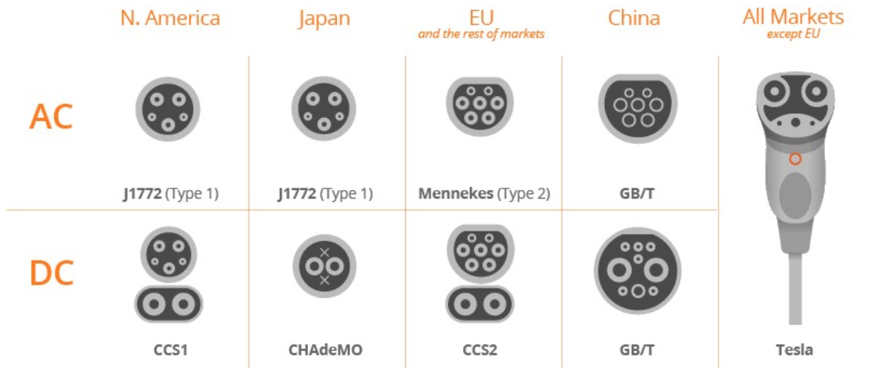

Figure 3 AC and dc ev charging standards around the world (SOURCE: enel x)

In general, it is still challenging to make EV charging a profitable business (not only in the Ukraine). Although initial investments are manageable and even DC fast chargers (~ 50kW) are in the area of USD 30,000 (, see Figure 5), the relatively low margins for the electricity sold in combination with low daily utilization and significant charging times (even with a 100kW charger the time to charge a 30kWh EV battery to 80% takes about 20 to 30 minutes) create a challenging business environment. The development of viable business models is therefore crucial, and often hinges on the availability of preferential financing for example through the integration of concessional loans. This is especially true in a very price sensitive market such as the Ukraine, where most of the EVs are currently charged at home. Nonetheless, the very low power prices in combination with relatively high prices of gasoline and diesel (in relation to the average income) in the Ukraine provide a good starting point for the development of profitable business models for EV charging. It will be part of the project to develop business model and to identify locations for EV chargers to increase daily utilization in order to achieve positive net present values (NPV) of the investment and to increase the internal rate of return. Costs of capital play a crucial role for both parameters.
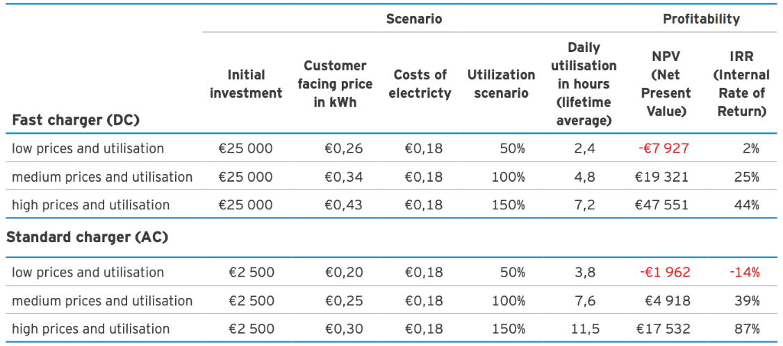
Figure 4 illustrative scenario of EV charging profitability – While cost of chargers vary widly with power output, the low price and utilisation scenario is most applicable to ukraine

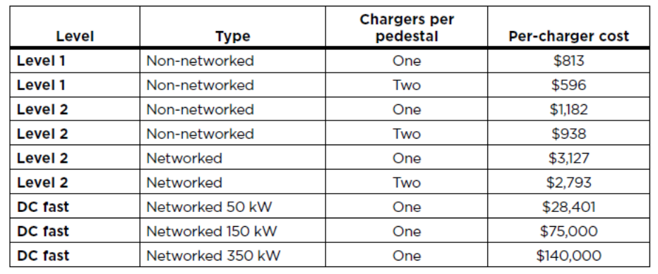
Figure 5 Hardware costs per charger for public and non-public (non-networked) slow and fast chargers

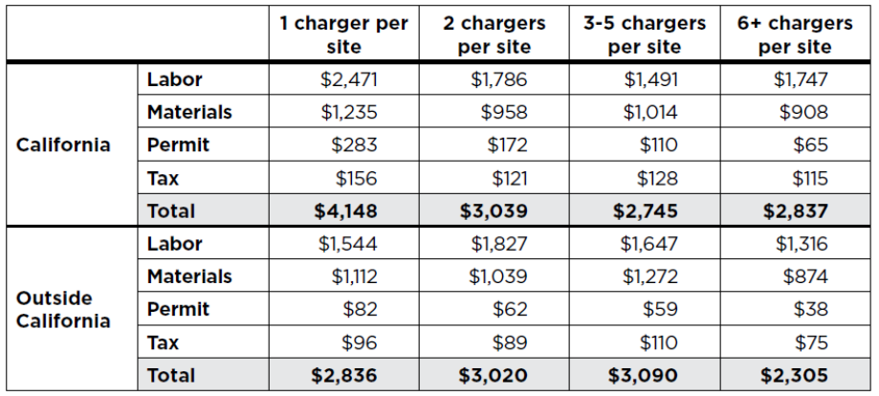
Figure 6 Installation costs for Level 2 public and workplace charger, by chargers per site

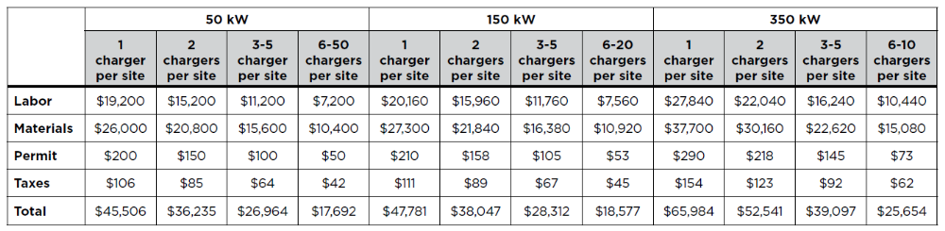Figure 7 Installation costs per DC fast charger by power level and chargers per site.
Figures 5 to 7 provide an overview of hardware and installation costs per charger for slow and fast chargers with and without network for the U.S. It can be seen that the bandwidth of hardware cost (Figure 5) is very high – while a public slow charger (networked) with two charging points is only about USD 3,000, a 50 kW DC fast charger already costs 10 times more (about USD 30,000). A 150 kW fast charger again costs more than twice the amount of the 50kW charger (about USD 75,000), and a 350 kW ultra-fast charger costs about twice as much as the 150 kW charger (USD 140,000). Installation costs also increase significantly with the required power supply. While installation of level 2 chargers with a power output of up to 19.4 kW costs around USD 3,000 to USD 4,000, the installation costs of fast chargers vary between USD 18,000 to USD 66,000, depending on the power output and the amount of installed chargers per site. For further analysis throughout the project document, an average cost of USD 10,000 for hardware and installation cost is assumed for public slow chargers, and an average of USD 50,000 is assumed for hardware and installation costs of public fast chargers.

Figure 8 below shows projections of light duty vehicle (LDV) sales (new locally produced and new and used imported), the LDV stock, LDV energy use and LDV well to wheel CO₂ emissions by technology for the years 2000 to 2050. As described above record high sales of more than 600,000 LDVs in 2008 where followed by record low sales of below 100,000 cars in 2014 with the assumption to reach pre-crisis of 200,000 to 300,000 newly registered vehicles per year in the coming years. Nonetheless, based on the record high sales in 2008 followed by the record low sales in 2014 and 2015, our model predicts a slight drop in the entire light duty vehicle fleet reaching its minimum somewhere in second half of this decade at around 6 million vehicles. In the medium to long term the model estimates the light duty vehicle fleet to grow to about 8 million by 2035 and almost 14 million by 2050.

Under the baseline scenario, the growth of EV sales is assumed to increase slowly, from 7,542 in 2019 to about 20,000 vehicles by 2030. The stalling of EV sales growth is assumed to be a consequence of the inadequate charging infrastructure and the non-sustainable incentive policies to reduce costs of new and used EVs imported to the Ukraine (tax waivers as per current policy will end by 2022). Therefore, under the baseline scenario, the growth of the LDV fleet will lead to an increase of energy use and GHG emissions well above historic values reaching about 25 mega tons of CO₂ by 2035 and almost doubling emissions to 37 mega tons of CO₂ by 2050.

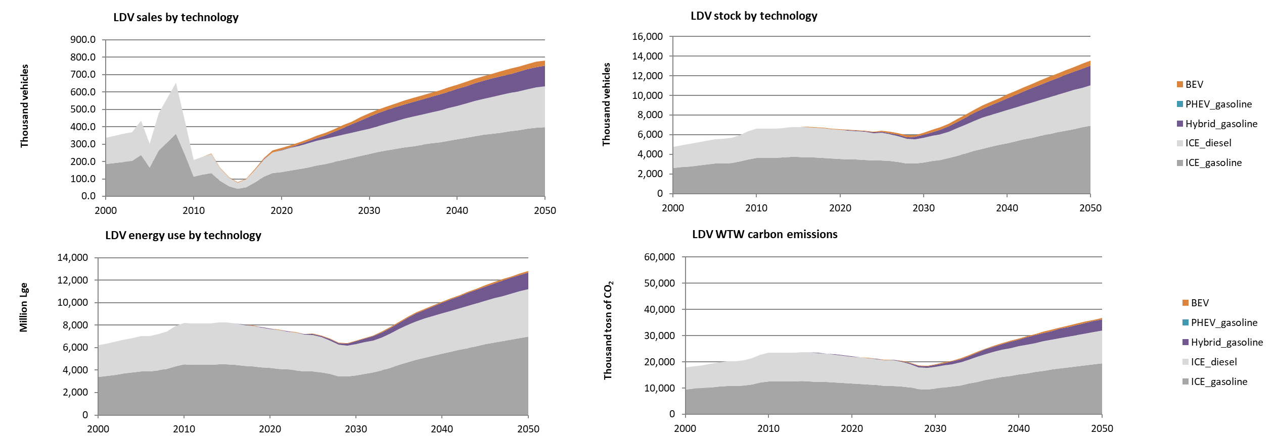
Figure 8 Light duty vehicle sales, stock, energy use and ghg emissions under the baseline scenario

- Broader Sustainable Development and Climate Change Strategies for the country

The NDC target initially submitted states an economy wide reduction of greenhouse gases emissions of 40% compared to 1990 levels. The NDC is not elaborated and doesn’t directly refer to the transport sector. The work on updating and detailing the NDC is ongoing and is likely to include the transport sector.
Ukraine in conjunction with the ambitious Association Agreement with the European Union, is working on the formulation of climate, energy and sustainable transportation policies with the goal to reduce GHG emissions to ensure the transition to a climate-neutral economy of Ukraine by 2070 in a socially acceptable way. Energy efficiency, energy conservation and cost-effective use of resources are the principal approaches to achieve that ambitious target.
A concept for Implementation of the State Policy on Climate Change up to 2030 and the subsequent action plan has been adopted in 2017. It establishes the main principles of state policy in the field of climate change, including 49 measures, among them the development of two national strategic documents: a Low Emission Development Strategy and a National Adaptation Strategy. The European Union will also provide additional 10 million euros to finance the measure "Climate package for a stable economy: (CASE) in Ukraine". This measure provides for the development and implementation of policies and measures that effectively support the transition to climate-neutral, clean, resource-efficient and secure energy supply and consumption. Additionally, the agreement plans to support the development of sustainable urban mobility plans, support local communities in renewable energy sectors and more.

In 2018, a Strategy on Low Emission Development of Ukraine up to 2050 was adopted. According to the Strategy, the indicative GHG emissions reductions target is 31 - 34% by 2050 (compared to 1990 levels). A joint EU-Ukraine resource center will be established to support climate innovation and the introduction of reliable accounting of greenhouse gas emissions and ozone-depleting substances. The operation of the center will ensure further sustainable management of these issues.

- Transport Sector Policies and Strategies - including electric mobility

The National Transport Strategy of Ukraine 2030, (hereinafter the Strategy), which has been developed by the Ministry of Infrastructure and endorsed by the Cabinet of Ministers in May 2018, aim to address comprehensive solutions to existing problems in the sector, introduces priorities for the transport sector development and reflects the European integration course objectives and implementation of provisions of the Association Agreement. The strategy focuses on the decentralization of the transport sector and the better alignment of transport sector investment with overall economic goals. The Strategy, among other areas of improvement, sets reduction of negative impacts of transport to the environment as a priority. The strategy includes use of incentives to use more environment friendly transport modes, including public transportation, such as metro, trams, trolley buses as well as human-powered modes of transport: bicycles (including public bicycle sharing systems), and other modes of last-mile connectivity including establishment of public rental mechanisms for these modes of transport. The Strategy expects results in the area of innovative development of the transport sector, including the “use of high-tech rolling stock on railways, roads (development of new types of transport: electric cars, high-speed trains, etc.), waterborne transport fleet renewal” and mentions the development of incentives to foster these. An aspirational target to reduce GHG emissions from the transport sector by 60% compared to 1990 is set. Nonetheless, no concrete actions for the introduction and scale up of e-mobility are lined out.

There is no independent e-mobility strategy apart from the reference to incentives for sustainable transport as defined above. The Ministry of Energy, in the “Green energy transition until 2050”, has established targets of 0.1% by 2020, 0.5% by 2025 and 10% by 2030 for the share of EVs on newly registered vehicles (comprising locally produced vehicles as well as new and used imported). It needs to be noted that already in 2019, the share of EVs on newly introduced vehicles was about 7.5%, thus significantly over-achieving the 2020 target by a factor of 15.

However, the Ministry of Energy is responsible for the development and implementation of an Action Plan which aims at the preparation of the power sector to fully embrace large scale e-mobility and the respective needs for EV charging. So far, no comprehensive studies to assess the impact of various scenarios of e-mobility penetration on overall power demand as well as daily and seasonal power demand profiles have been conducted. It is also the aim of this action plan to prepare for comprehensive EV charging market legislation.
- Policy and regulatory framework to promote e-vehicles
The mandates to develop and implement policies to cover all legislative aspects of e-mobility lie with 1.) the Ministry of Energy; 2.) the Ministry of Infrastructure; 3.) the Ministry of Environmental Protection and Natural Resources; and 4.) the State Fiscal Service of Ukraine.

The Ministry of Energy is responsible for legislation with regards to power supply including connection of the charging stations to the power grid (including safety regulation) and tariffication of the used electricity. Ministry of Energy is currently spearheading the transformation of the Ukrainian power sector towards a market-based approach for power supply agreements (see description of the energy sector below) and is leading the integration of the Ukrainian grid into the European Union connected power grids. Ministry of Energy is driving the structuring of the EV market, including streamlined electric energy-based billing schemes (based on kWh sold rather than time charged).

The Ministry of Infrastructure is responsible for the development of the charging infrastructure network including the spatial allocation of charging stations as well as other EV policies related to area planning such as the selection of EV specific parking spaces (which are often closely linked with the location of charging stations). The Ministries of Infrastructure legislative initiative has the support of the Cabinet of Ministers to adopt changes to the Law of Ukraine "On Automotive transport" to include relevant electric mobility definitions and terms.

Nature Protection and Natural Resources is responsible for all aspects related to used EV batteries and is leading the implementation of schemes for the collection of used EV batteries for re-use, recycling and safe disposal. Ministry of Environmental Protection and Natural Resources is also responsible for the Climate Change agenda of the Ukraine.

The State Fiscal Service of Ukraine is responsible for fiscal policies, including value added taxes (VAT) and import taxation. It is under the responsibility of the State Fiscal Service to propose tax exemptions, for example for the importation of EVs.

Taxation for importing vehicles to Ukraine is shown in Table 1. Vehicle import tax has three components: 1.) an engine displacement-based excise tax; 2.) an age-based multiplier for the excise tax; and 3.) a value added tax based on vehicle price.

For example, to import a 5-year-old Volkswagen Golf 1.6 TDI (diesel) selling for USD 14,000 on the used-vehicle market in Germany, import duties including excise and VAT would be USD 5,520. In 2018, Ukraine passed a law exempting EVs from VAT (Law of Ukraine No. 2754-VIII dated 11 July 2019). In addition, since the displacement of EVs is zero, the excise tax is also zero. Therefore, the 5-year-old Nissan Leaf, with a maximum mileage of 50,000km (and hence very little degradation of the battery) that sells at approximately USD 17,000 on the used-vehicle market in Germany, would cost in total about USD 2,500 less compared to the conventional VW Golf when imported to Ukraine. The VAT exemption for EVs has recently been extended up to 2022. It is assumed that about 20,000 EVs will be imported to Ukraine in the coming two years.

Table 1 taxation for vehicle importation to ukraine
Engine Type | Displacement | Excise Rate | 1-15 yrs. old | >15 years old | Value Added Tax (VAT)
Gasoline ICE | 3 litres or less | 50 EUR per litre | multiply by age | multiply by 15 | 30% of value
Gasoline ICE | over 3 litres | 100 EUR per litre | multiply by age | multiply by 15 | 30% of value
Diesel ICE | 3.5 litres or less | 75 EUR per litre | multiply by age | multiply by 15 | 30% of value
Diesel ICE | over 3.5 litres | 150 EUR per litre | multiply by age | multiply by 15 | 30% of value

In addition to import duties, an annual transport tax is levied for cars with a market value exceeding 375 minimum monthly salaries (established on January 1 of the reporting year, approx. USD 55,000 in 2019), which are less than 5-years-old and owned by individuals. The transport tax is UAH 25,000 (USD 930) for each car per year and is paid by the car owner, including those of electric vehicles.

Law of Ukraine No. 2754-VIII dated 11 July 2019 also specifies regulation on parking spaces reserved for EVs along with a range of fines to enforce the law. EVs receive distinct green number plates, which are needed to use the dedicated parking space.

- Policies and regulatory framework to promote charging infrastructure (CI)

Under the current legal framework in Ukraine, pricing of commercial EV charging services based on kilowatt-hours is treated as a sale of electricity and not as a provision of a service and is therefore subject to state licensing and regulation by the National Energy and Utilities Regulatory Commission (NEURC). So far, only a few state-owned energy retailers such as Oblenergo or Kyivenergo have such licenses. Existing private sector charging-station operators such as Toka Llc currently bill EV charging services either on a per-minute basis or on other “nominal units” to circumvent cumbersome licensing, through NEURC. Time based pricing is seen to be non-transparent and unfair by consumers as EV charging rates depends on the vehicle and the batteries state of charge and does not account for the actual charger capacity (often deviating from the declared name plate values). The Law of Ukraine on Electricity Market No. 2019-VIII dated April 13 2017 is the principal law regulating relations in the electricity market defining “the legal, economic and organizational principles of functioning of the electricity market, regulat[ing] relations regarding the manufacturing, transmission, distribution, sale and purchase of electricity, to ensure reliable and safe supply of electricity to consumers, taking into account consumer interests, the development of market relations, minimizing the cost of electricity supply and minimizing the negative impact on the natural environment” . This law needs to be amended in a way that charging operations are qualified a provision of a service rather than selling electricity to enable charging providers to bill on the basis of kilowatt-hours, a pricing scheme largely preferred by charging operators and consumers.

Recently, some reforms have begun, which are likely to have a positive impact on the charging infrastructure development in Ukraine. These include: 1) the development of a bill "On the National Geospatial Data Infrastructure", which will facilitate the integration of geospatial data into a global information system with free access to the data; 2) the set-up of a national electronic registry for vehicles and its integration into the EU wide system EUCARIS (European Car and Driving License Information System, which is an information exchange system to share, among others, car- and driving license-registration information).

- Cost of new electric vehicles

Currently, new EVs are substantially more expensive compared to new conventional (ICE) cars. For example, while a new compact car costs around USD 15,000 to 20,000 before taxes, a compact EV costs at least USD 31,000. On average ICE cars cost at least 30% less within the same segment. EV buses and commercial vehicles are also substantially more expensive than comparable conventional models. The higher upfront costs are certainly a root cause that can slow market uptake, particularly for lower income segments of society in Ukraine. Conversely the number of EV producers and the cost of cars slowly decreases year on year, with an ever increasing supply of second-hand electric cars from the U.S. and the rest of Europe.

While no information exists on whether EVs in Ukraine are used by private persons or within commercial fleets, the high share of used EVs (92% for passenger cars) could be interpreted as a sign for high private ownership of electric cars, rather than their use within commercial fleets (which tend to buy or lease new vehicles with service plans and guarantees). In order to make new EVs more attractive to commercial fleets, measure needs to be developed to make new EVs more price competitive. This can for example be achieved by the provision of financing schemes which are tailor-made for the purchase of new EVs.

The portion of overall new car sales in Ukraine covered by loans is currently around 12-15% of the market and has remained steady for the past few years. This relatively low figure reflects the economic uncertainties faced by many Ukrainians that prevent them from making significant medium-term financial commitments. This is in comparison to 2008 when 50% of new car purchases were financed by loans.

Whilst some banks in Ukraine, such as the Credit Agricole Bank, do offer financing for electric cars there are no special incentives on offer.

- Vehicle manufacturing

Ukraine is not only one of the potentially biggest light duty vehicle markets in Europe, but it has also a history of vehicle production in all segments – light duty vehicles, heavy duty vehicles and buses. In 2013, more than 50,000 vehicles were manufactured in the Ukraine, dropping to about 8,500 in 2018. Currently, the following producers are manufacturing vehicles in the Ukraine:
- Bogdan Corporation is a Ukrainian automobile-manufacturing group, including several cars- and bus-makers in the country;
- ElectronMash, specialized in the production of special off-road all-wheel drive vehicles;
- Etalon Auto Corporation, producers of buses and trolley buses;
- Eurocar, assembly line production for Skoda Auto (Volkswagen);
- KRAZ (Kremenchuk Automobile Plant or AvtoKrAZ), production of trucks and heavy-duty off-road vehicles
- AZ (Lviv Automobile Plant) is a bus manufacturing company in Lviv,
- ZAZ (Zaporizhia Automobile Building Plant, part of UkrAvto) is the main automobile-manufacturer of Ukraine, based in the south-eastern city of Zaporizhia. It also produces buses and trucks (formerly AvtoZAZ). Production of Chinese Chery A13 and GM Chevrolet Aveo which stopped in 2018, in 2020 Renault announced to revive passenger car production. ZAZ is to produce the Lada Vesta, Lada Xray and Lada Largus models, which are also to be complemented by Renault Arkana (https://www.world-today-news.com/ukrainian-zaz-revives-production-of-passenger-cars-in-zaporozhye-will-produce-renault/ );

In particular, the presence of Renault and Skoda to manufacture vehicles at large-scale in Ukraine is interesting since both the Renault-Nissan-Mitsubishi Alliance and the Volkswagen Group (Skoda is a brand of the Volkswagen Group) are globally leading EV manufacturers. In May 2020, the Parliament of Ukraine (Verkhovna Rada) has received bills № 3476 and № 3477 that provide the creation of conditions for the production of domestic cars, buses, trucks and special equipment with electric motors in Ukraine”. The Ukrainian company Toka Llc is not only operating charging stations but is also selling locally assembled and imported vehicle chargers with power outputs up to 66kW. There is a big opportunity to channel Ukraine’s vehicle manufacturing expertise for the electric mobility industry.

- Battery end-of -life management

In 2014–2017, Ukraine took initial important steps to improve the situation with regards to waste management through commitment of compliance with the EU Directives as a part of the Association Agreement with the EU and adopting the National Waste Management Strategy until 2030. The National Waste Strategy 2030 identifies moving away from sole reliance on landfill disposal with an increased focus on recycling and recovery for certain waste streams while the residual waste is disposed of into EU-compliant landfills.

In Ukraine, collection and processing of used batteries and accumulators of more than 7 ampere-hours is regulated by the Law of Ukraine ‘On Chemical Sources of Current’ and the Joint Order of the Ministry of Industry, Ministry of Economy, Ministry of Environmental Protection and Natural Resources No. 223/154/165 ‘On Approval of the Regulations on the Collection and Processing of Used Lead-Acid Batteries’ dated December 31, 1996. However, these regulations contain outdated provisions that actually remain unimplemented and do not cover the handling of all types of batteries and accumulators. Whilst the National Waste Strategy to 2030 does mention exhausted batteries it is focused on household batteries and does not mention electric vehicle batteries.

There are a number of generic and electric mobility specific challenges related to battery management.

- There is a discrepancy between the Ukrainian and EU definitions and classifications of waste.
- The responsibility of management of hazardous waste is managed by the Ministry of Nature Protection (previously known as the Nature Protection and Natural Resources of Ukraine) who give a license, which gives an enterprise the right to operate with hazardous waste. The same ministry has a dual authority to monitor compliance with the license conditions. With the one ministry having power to award licences and revoke them. In some countries it is deemed as best practice to split these two roles to avoid a conflict of interest.
- Statistical information on waste is rather unreliable and varies according to different official sources.
- There is currently no specific data, guidance or legal regulations in Ukraine on the disposal of electric vehicles batteries specifically due to the emerging nature of the market.
- There are no legal requirements for municipal authorities or waste management companies regarding battery data reporting or related waste management.
- The issue of organizing the collection and processing of used batteries in Ukraine remains unresolved. Collection of such batteries is carried out on a voluntary basis by public organizations and citizen associations, but due to the lack of proper infrastructure for their processing, they remain stored for further processing. Given the high level of profitability of extracting lead, many business entities have licenses for hazardous waste operations and collect lead-acid batteries. At present, there are several new modern capacities for automatic processing of used batteries, other installations need modernization and introduction of new technologies.

However, given that the existing electric vehicles park in Ukraine is 92% composed of used/second-hand cars, in the coming years this issue will require separate legislative regulation and development of mechanisms for the recycling of used batteries and, possibly, their re-use in power storage at charging stations.

- Energy Strategies and Policies

As part of its climate commitments and in conjunction with the Member States of the European Union, Ukraine is working on the formulation of energy policies including current development of a concept for the “Green energy transition strategy until 2050” to reduce GHG emissions from the energy sector. The Ministry of Energy has developed a concept for the “Green energy transition until 2050” to reduce GHG emissions from the energy sector and become a carbon-neutral economy by the year 2070. The concept formulates a series of goals for the share of renewable energy sources in total energy consumption: 8% of renewables by 2020, 12% by 2025 and 17% by 2030. A recent study carried out by the Heinrich Boell Foundation in Kiev concluded that 91% of renewable energy-based power system by 2050 is feasible in Ukraine. One specific objective of the intensified cooperation with the EU in the energy field is to achieve full integration of the Ukrainian energy system with the European Network of Transmission System Operators for Electricity (ENTSO-E) and in parallel implementing its separation from energy systems of Russia and Belorussia. It also accommodated the opening of the retail and later the wholesale electricity market to comply with Directive 2009/72/EC. This is directly linked to urgently needed regulation in the area of the EV charging market. To date, only large state companies have the right to sell electricity based on the energy sold (kWh). To circumvent this issue of licensing, EV charging providers bill the consumer based on time charged and not electricity sold, which creates an in-transparent market environment since 1.) depending on the name-plate power rating of the charging connection much different amounts of electrical energy will be transferred to charge the car; and 2.) even in case of knowledge of the name-plate capacity of a charger, the actual capacity (in kW) to charge the car depend on a number of parameters such as vehicle model, temperature of the battery, used protocol etc. Charging time is therefore a much less preferential measure to bill consumers compared to energy (in kWh) and respective changes in regulation are needed.
Energy sector

In Ukraine, about 54% of the generated power comes from nuclear, 37% is based on coal and gas, and 9% comes from renewable sources. The grid emission factor of about 490 gCO₂/kWh is below global average, and the use of grid electricity in electric vehicles leads immediately to significant GHG emission reductions.
- Law No. 2712-VIII introduced an auction system to support RES electricity generation. This had been followed by launching new wholesale market model for electricity in July 2019.
- The electricity market in Ukraine is unbundled, with power generators, a transmission system operator (TSO, Ukrenergo), distribution service operators (DSO) and universal service suppliers (USS) being the main actors in the wholesale market.
- In July 2019, a new digitalized system for the bilateral contracts market, the balancing market segment and the ancillary services market was introduced.
- The system includes the obligation to buy renewable power at a fixed feed in tariff, which incentivizes investment in renewable power generation.

In 2019, about USD 4.1 billion were invested in a record installation of 4,500 MW of renewable energy capacity in Ukraine. The existing renewable energy capacities can produce more than 8.4 billion kWh of electricity per year (about 5.5% of total production) and provide electricity to more than 3.3 million households.

The government provides incentives for renewable power through Feed-in-tariff (FiT) which depends on the type of power generation and the commissioning date. This varies between 0.05 USD/kWh and 0.18 USD/kWh. The difference between retail price and renewable power FiT is covered by the state-owned company Guaranteed Buyer, which is a subsidiary of Energorynok.

Electricity prices for end-consumers are regulated according to the decree of the National Energy and Utilities Regulatory Commission of Ukraine (№ 220 dated 26.02.2015), electricity tariffs (effective from 01.03.2017) are:

- Private consumers up to 100 kWh per month: 0.9 Hryvna/kWh (including VAT) ~ 0.033 USD/kWh;
- Private consumers over 100 kWh per month: 1.68 Hryvna/kWh (including VAT) ~ 0.062 USD/kWh
- Industry: 2.30 Hryvna/kWh (including VAT, in Kyiv) ~ 0.085 USD/kWh

While the increase in renewable power generation is very much welcome to reduce emissions, it has reached a critical point and its further increase will inevitably be accompanied with limitations to integrate renewable power generation in the grid. Curtailment of renewable power producers occurred for the first time in November 2019, when the power system dispatchers shut down several wind powerplants in the Zaporizhzhya region. In December 2019 and in January 2020, this situation repeated with other enterprises and locations. Reasons are the lack of flexibility in the grid in combination with a warm winter. The capacities of nuclear power plants and thermal power plants that were prepared for the winter season were not required. The plants were already operating at low output levels: further reducing their power generation was not possible and dispatchers had to reduce renewable power generation. Experts of the TSO Ukrenergo agree that there will be more serious problems during periods of low electricity consumption, for example in spring, and warned that due to the inflexibility of the grid, output of wind and solar power plants might be curtailed by 10% to 30% of their annual generation capacity.

In this regard, scaling-up electric mobility can be an enabling element to unlock this situation, by adding flexibility and significant demand to the grid. Although due to the slow ramp-up of the electric vehicle fleet in Ukraine the immediate effect will be low, it is a useful exercise to evaluate the effects of e-mobility scale-up in the medium and long term in order to inform the e-mobility and energy sector strategies.

Baseline investment

Project name | Implementing agency | Description | Execution period | Budget
Renault electric vehicle selling and servicing contract | Renault electric vehicles | Since April 2018, nine official dealers of Renault in Ukraine (Kyiv, Dnipro, Lviv, Mykolaiv, Odesa and Ivano-Frankivsk) have received the right to sell and service Renault ZOE and Renault Kangoo Z.E. The company deemed the level of infrastructure preparedness for Renault electric vehicles acceptable after the having carried out the second “ZOE Tour, which confirmed that 85% of the inspected charging stations were compatible with the Renault ZOE (https://www.kyivpost.com/ukraine-politics/renault-ukraine-starts-sales-renault-electric-cars-dealer-chain.html | April 2018-ongoing | Unknown
Electric vehicle ride sharing | Uber | In 2019, the taxi company Uber launched “Uber Green” service in Kyiv offering rides in electric cars. It is a business example of visual promotion of EVs and what they stand for. The company started with 200 EVs and has the goal to grow its fleet quickly and to stimulate the development of the electric vehicle market in Ukraine. Uber Green intends to develop partnerships with authorities, automakers and other energy market players to promote a wider use of electric vehicles. | 2019 - ongoing | Unknown
Public Transport infrastructure investment | International Finance Corporation Cities Initiative | In January 2020, the International Finance Corporation (IFC, a member of the World Bank Group) and the Mayor’s Office of the city of Kryvyi Rih agreed to combine efforts to attract investments for reliable and efficient public transport infrastructure. This is part of IFC’s broader strategy to accelerate economic growth in Ukraine. IFC’s support will also include helping the city obtain an international credit rating to enhance its ability to attract long-term financing. This is IFC’s fourth project in Ukraine under its Cities Initiative, which supports development and financing state-of-the-art urban projects. Other Cities’ projects include modernization of high-speed public transport in Kyiv, environmentally-friendly bus fleets in Mariupol and Lviv, and smart-city infrastructure in Zaporizhzhia. Long-term financing under the agreement could possibly be used to further upscale the EV charging market. | 2020-ongoing | Unknown
Transboundary Green Transport Network” (CGTN) project | European Neighborhood Instrument "Hungary-Slovakia-Romania-Ukraine 2014-2020" cross-border cooperation program | The “Transboundary Green Transport Network” (CGTN) project Which is being implemented within the framework of The European Neighborhood Instrument "Hungary-Slovakia-Romania-Ukraine 2014-2020" cross-border cooperation program. The project envisages the installation of 19 charging stations in Ivano-Frankivsk and the partner cities of this project - Baia Mare (Romania), Nyíregyháza (Hungary), Michalovce (Slovakia), Uzhgorod, Mukachevo, Sniatyn, Nadvirna, Yaremche, Kolomyia and Dolyna (Cities in Ivano Frankivsk Oblast region). The project budget for the four countries is € 280,000. | 2020-ongoing | 280,000 Euros
Local city transport II". | The Ministry of infrastructure of Ukraine and the European investment bank | The second phase project has the objective to introduce only ecological public transport: trams, trolleybuses, subway and electric buses. The schemes to be financed under the operation will improve the frequency and sustainability of public transport in the medium and large Ukrainian cities and will have a positive effect on the economy of those cities. | 2021 - onwards | EUR 400 million, including EUR 200 million of EIB funds.

Proposed alternative scenario with a description of project components, outcomes, outputs and deliverables

The objective of this project is to accelerate the shift to electric mobility in the Ukraine. This will be achieved through a combination of Technical Assistance implemented by UNEP and Investment into charging infrastructure implemented by the European Bank for Reconstruction and Development (EBRD). The lack of adequate charging infrastructure alongside respective regulation has been identified as the most important barrier for continued uptake of e-mobility in Ukraine. Therefore, the project focuses on developing technical and market regulations, business models and finance schemes to expand charging infrastructure. The demonstration project lead by EBRD is targeting the piloting of about 350 chargers to implement various types of chargers of different capacities and for various use cases in order to prepare future investments in the up-scaling of the EV charging market. The experience of financing will be used by the EBRD to prepare for the provision of financing for charging infrastructure projects upon the leveraging of additional resources.

The issue of vehicle charging will be embedded in a broad e-mobility strategy addressing all vehicle modes and e-mobility use cases including industry strategies to manufacture electric vehicles and EV supply equipment in Ukraine.

With the support of the Global Programme, the project will develop supportive policies, incentives and strategies to build capacity for change and scale up of the electric mobility market. The project aims to engage with the government and the private sector to demonstrate and scale-up the deployment of electric mobility charging infrastructure in Ukraine. Additionally, the project targets the better integration of EV charging into the power sector to enable better use of renewable energy and to prevent any negative impacts from EV charging to the grid. For example, the project aims to investigate the impact of pricing mechanisms for EV charging to shift charging demand to times of lower power demand and / or higher renewable power supply. The project aims at accelerating the transformation of the energy market in Ukraine supportive to electric mobility scale-up.

The technical assistance provided through the project will address the institutional capacity, coordination and strategy barriers. It will build and support a government and private sector coordinating body to ensure that public and private sector stakeholders are working synergistically on electric vehicle policy and investments. The project will expand on the policy gap analysis carried out during project preparation and develop policy measures to close these gaps both in the transport and the energy sector, and including fiscal, regulatory and local policy measures. It targets at the development of a strategy to prevent a scattered landscape of charging infrastructure operators with different billing schemes and little interoperability. It will support the development of business models for the EV charging market and e-mobility in general, and including technical guidelines for procurement, operation and maintenance of EVs. It will also support the development of a strategy to integrate EV charging networks into the national grid and to unlock synergies between the scaling-up of electric mobility and renewable power integration. Finally, environmental sustainability of e-mobility in Ukraine will be improved through studies and strategies for developing regulation for collection of used EV batteries for re-use, recycling and safe disposal.

The Investment implemented by the EBRD includes the implementation of blended finance targeted at the demonstration and scaling-up of EV charging networks. Financing will allow for the installation of up to 350 EV chargers and aims at a supporting strategic densification of the public fast and slow charging network to incentivize consumers to buy new and used EVs. The demonstration of EV chargers will internalize the policies and regulations developed specific to the EV charging sector and is expected to confirm the proposed business models, therefore helping to create a safer and more predictable environment for investment in EV charging infrastructure up-scaling.

The alternative scenario used to estimate impacts of accelerated EV introduction on energy use and GHG emissions reduction is based on e-mobility targets developed by the International Energy Agency and integrated within their Beyond 2 Degrees (B2DS). The scenario used for the alternative project anticipates the same growth trajectory for the LDV fleet as used in the baseline scenario but anticipates the accelerated introduction of EVs (both battery electric vehicles and plug-in hybrids). Under the alternative scenario, the EV sales share improves from about 5% in 2020 to 20% in 2030, 60% in 2040 and 75% in 2050. This means that by 2030, almost 100,000 EVs will be newly registered in the Ukraine (including new locally produced and new and used imported vehicles). By 2040 absolute EV sales are projected to account for about 300,000 vehicles growing to 575,000 vehicles by 2050 (see section 6 on Global Environmental Benefits for more details. The projected amount of EVs will be in need of around 30,000 public charging stations by 2030, 180,000 by 2040 and about 500,000 public charging stations by 2050. This means that the current available charging infrastructure needs to be scaled up by factor of 12 until 2030 and by a factor of 72 until the year 2040.

The Project includes four components, of which three provide Technical Assistance (component 1, 3 and 4, implemented by UNEP and executed by the Science and Technology Center in Ukraine) and one is dedicated to Investment (component 2, implemented and executed by the EBRD):
- Component 1: Institutionalization of low-carbon electric mobility
- Component 2: Short term barrier removal through low-carbon e-mobility demonstrations
- Component 3: Preparing for scale-up and replication of low-carbon electric mobility
- Component 4: Long-term environmental sustainability of low-carbon electric mobility

Component 1: Institutionalization of low-carbon electric mobility

Outcome 1: The Government of Ukraine establishes an institutional framework for effective coordination, develops capacity for policy making and adopts a national strategy to scale up e-mobility.

Currently, Ukraine’s national policy to encourage the development of electric mobility is unsustainable and not coordinated. Despite considerable support for the development of the electric vehicle market, many legislative initiatives, and in particular the “Concept for the Development of the Electric Vehicles’ Market” have not been endorsed by the government and the process for its implementation is slow. The purpose of this component is to address the institutional awareness, capacity and coordination barrier and to prepare an analysis of existing initiatives that support the development of the electric vehicle market and to bundle their forces in a coordinated manner. Therefore, a multi-stakeholder Advisory Board will be established to coordinate government efforts and to support government institutions on questions of economic stimulation, licensing, certification and attraction of investments in the electric mobility industry.

Furthermore, the effectiveness of current policy instruments will be investigated, and gaps will be identified based on a comparative analysis of Ukrainian and international policies aimed at supporting and developing electric mobility. Based on the policy gap analysis, the project in cooperation with state institutions, will work on the development of a “Strategy for the Electric Mobility Development in Ukraine” as well as its legal basis.

Moreover, the project is being aimed at raising awareness of senior officials, technical specialists and the public about the opportunities and challenges of e-mobility in various transport modes and relevant government and private sector stakeholders will be trained on technical, operational and financial aspects of e-mobility through the events of the Global Electric Mobility Programme carried out through the Central and Eastern Europe, West Asia and Middle East Support and Investment Platform, which will be hosted and managed by EBRD.

Within this Component, the Project will cooperate with the Parliament of Ukraine, the Ministry of Energy and Environmental Protection of Ukraine, the Ministry of Infrastructure of Ukraine, the Ministry for Communities and Territories Development of Ukraine and other relevant state institutions in the field of development and capacity building for electric mobility. As a result of such cooperation, it is expected a development of appropriate regulatory, legal, financial and tax conditions aimed at enhancing the development of the electric vehicle market, taking into account the experience of successful international practices in this market segment, adapting relevantly to Ukrainian realities.

Output 1.1: A national multi-stakeholder advisory group is established for coordination of government strategy, policies and actions to promote e-mobility in Ukraine (including gender representation).

An important output of project will be to establish an Advisory Board, to coordinate work with the Government agencies and relevant committees of the Parliament of Ukraine. The Advisory Board will also be the owner of the E-Mobility Strategy and take overall responsibility for coordination and implementation of the strategy.

The Advisory Board shall include representatives from government agencies, business associations, electric vehicle traders and businesses. Initially, the Advisory Board will be equivalent to the Project Steering Committee (PSC) and shall include 1.) the Ministry of Energy; 2.) the Ministry of Infrastructure; 3.) the Nature Protection and Natural Resources, 4.) the STCU 5.) the EBRD and 6.) UNEP. If required, other ministries and government agencies such as the State Fiscal Service of Ukraine, the NEURC or the State Space Agency will be invited to discuss relevant legislation. The PSC will be hosted by the STCU and co-chaired by the Ministry of Energy and the Ministry of Infrastructure. Towards the end of the project, provisions will be worked out to institutionalize and secure official recognition of the PSC as the Advisory Board and by transferring the Secretariat from the Project Execution Agency (STCU) to the most relevant ministry. The Advisory Board will also expand the group of the PSC by adding private sector and civil society stakeholders. The outcome will be creating a permanent Advisory Board to coordinate and monitor the implementation of the e-mobility strategy.

The project will provide technical support of the Advisory Board. Assistance from the project will be provided through trainings, seminars, study visits, development of information materials, demonstration and methodological materials on the development of the electric vehicle market, provided by the Global Programme, and delivered through the Central and Eastern Europe, West Asia and Middle East Support and Investment Platform.

The institutionalization should essentially present the Advisory Board (AB) as the owner of the E-mobility strategy and will be responsible for coordination on implementation of the strategy since it is not just the body being created but an agenda that the body pushes forward.

D 1.1.1 Draft mandate, institutional structure, rules and procedures of operation, host entity, representation requirements, and workplan of the AB.
D 1.1.2 Meetings of proposed AB held three times a year to guide the development of the e-mobility strategy, to comment and review on draft policy proposals and other project outputs such as the best practice ‘How To’ guides and the studies developed under Component 4
D 1.1.3 Government notification to establish the Advisory Board as a strategic, national, multi-stakeholder advisory group established on e-mobility recognized by the Government of Ukraine.

Output 1.2: Key stakeholders (approx. 125 individuals) are trained and awareness is raised (through at least 7 trainings and related events) on developing policies, regulations, and projects as well as best practices, adopted by leading countries, for promoting e- mobility.

Relevant stakeholder from government, private sector stakeholders, civil society and academia participate in global events carried out through the Central and Eastern Europe, West Asia and Middle East Support and Investment Platform. The participants will include decision makers and/or operational staff as targeted by the platform event. The trainings will follow a curriculum developed by the Global Thematic Working Groups and the Regional Support and Investment Platforms. The program materials will be developed in Ukrainian and English and will be adjusted to the Ukrainian conditions. International and national experts as well as representatives from UNEP and EBRD will be involved in these trainings to disseminate knowledge and services of the GEF Global Electric Mobility Programme. The training will comprise one targeted study visit to a front-running country in Europe. Best practices and lessons learned by the Ukrainian government bodies will also be compiled into a yearly report and shared with the global programme. Training and related events will take place in Ukraine.

D 1.2.1 Program material from global programme translated into Ukrainian language.
D 1.2.2 Participation in first regional electric mobility training
D 1.2.3 Participation in second regional electric mobility training
D 1.2.4 Study visit to a front-running EV market in Europe
D 1.2.5 Participation in the regional EV infrastructure workshop
D 1.2.6 Participation in second Meeting on financing/ marketplace
D 1.2.7 Participation in third regional electric mobility training
D 1.2.8 Participation in replication event
D 1.2.9 Lessons learned and best practice report produced annually

Output 1.3: The current e-mobility policy framework, vehicle fleet and trends in energy use and emissions are reviewed and assessed and a national e-mobility strategy and an action plan are developed and submitted to key decision makers for adoption

Building on the analysis carried out under the Global Fuel Economy Initiative project in Ukraine, a more detailed policy gap analysis including a comprehensive stakeholder mapping will be developed. The gap analysis will expand on the information collected and the missing regulation identified during project preparation including fiscal incentives for EV purchase (Law of Ukraine No. 2754-VIII dated 11 July 2019), the power market regulation (The Law of Ukraine on Electricity Market No. 2019-VIII dated April 13 2017) and the proposed bills to foster EV and EV supply equipment manufacturing (registered bills № 3476 and № 3477), and will be used to inform the comprehensive e-mobility strategy. The strategy will cover all aspects of e-mobility in Ukraine including the various vehicle modes and EV use cases, the required public charging infrastructure and options to locally assemble and manufacture EVs and EV supply equipment. The strategy will formulate aspirational targets for EV market shares for 2025, 2030 and 2050 for the LDV and the heavy-duty vehicle segment. Based on the EV market penetration scenarios, the amount of charging stations needed in 2025, 2030 and 2050 will be estimated. These projections will be used to define scenarios for the analysis of the impact of EV charging, grid integration and renewable power supply developed under Output 4.1. Policy requirements and financing needs to achieve the EV market penetration scenarios will be developed and milestones for achieving those will be set. The e-mobility strategy will also inform the National Transport Strategy 2030 and will be the guiding document to define targets and actions for the Action Plan to prepare the energy sector for the large-scale introduction of e-mobility, which needs to be finalized by Ministry of Energy by 2022.

The collection of transport sector data aims at a systematic monitoring of the energy efficiency of new and used vehicles added to the Ukraine fleet, and uses the methodology developed as part of the Global Fuel Economy Initiative (GFEI) project. It will be expanded to the collection of charging infrastructure data, including the number of chargers, their location as well as their power output and, ideally, occupancy rate, aiming at a better understanding of the load profiles of chargers within the country. This will lead into the development of a monitoring framework to track the progress of the e-mobility strategy in Ukraine.

D.1.3.1 Assessment of policy gaps, a detailed stakeholder mapping, and a catalogue of possible policy measures to address the gaps.
D 1.3.2 A workshop to discuss scope, objective and milestones of the national e-mobility strategy is delivered.
D 1.3.3 A national e-mobility strategy formulating aspirational targets for the market penetration of EVs by mode and the respective EV charging infrastructure needed is drafted, including policy gaps as well financial needs and milestones for closing these, and is circulated for review.
D 1.3.4 A monitoring framework including charging infrastructure data and the respective collection methodology is developed and progress of the EV fleet, EV charging network and policy framework is tracked against the targets set in the e-mobility strategy and the action plan.
D 1.3.5 Ministry of Energy submits the final national e-mobility strategy for adoption by the Cabinet of Ministers.

Output 1.4: A gender action plan is developed to mainstream gender aspects in e-mobility and disseminated for implementation

The gender analysis conducted during the project preparation identified 1.) a lack of knowledge of gender issues; 2.) the scarcity of gender specific mobility data and statistics; and 3.) the need to plan for gender tailored mobility services and to better exploit the synergies between urban and mobility planning as key missing elements towards gender equality in Ukraine. Therefore, gender analysis with the focus on the nexus between e-mobility and gender will be undertaken using mixed methods (survey, expert interviews and focus groups) to explore and understand the gender dimensions of electric mobility in Ukraine. In particular, the analysis will examine how perceptions, attitudes and values towards electric mobility differ by gender. The aim is to uncover the subtle, complex and meaningful ways that gender may influence people’s perceptions and preferences for electric mobility. The analysis will include conducting research on gender demographics within the electric mobility fleet industry - to understand the gender dimensions across the whole ecosystem. Based on the analysis, a report to 1.) identify gaps and / or opportunities with regards to business models and finance where integrating gender into the project in Ukraine will result in wider uptake of electric mobility; and 2.) identify policy gaps to support wider uptake of electric mobility in Ukraine given gender-considerations will be drafted. The findings from the analysis will be used to inform development of the “National strategy and electric mobility for Ukraine’.

D 1.4.1 Gender analysis undertaken using mixed methods (survey, expert interviews and focus groups) to explore and understand the gender dimensions of electric mobility
D 1.4.2 Analysis of gaps and opportunities for gender mainstreaming in e-mobility policies, business models, and finance
D 1.4.3 Arrange a stakeholder engagement workshop in Ukraine to disseminate findings and recommendations for leveraging gender to support electric mobility in Ukraine.
D 1.4.4 Gender mainstreaming actions for “National strategy and electric mobility for Ukraine”.

Component 2: Short-term barrier removal through low-carbon e-mobility demonstrations

Outcome 2: Government and private sector stakeholders adopt lessons learned from the pilots and prepare for scale up of investments in low carbon electric mobility

The demonstration project will be part of an integrated approach to simultaneously adapt technical standards, energy-based metering protocols, market re-structuring to provide interoperability between charging stations and billing schemes from various operators and the provision of attractive financing targeting business oriented private sector stakeholders in the Ukraine. The financing provided by the EBRD will address the challenges lined out in the baseline scenario and is ultimately targeting the provision of sustained financing to further allow the expansion of the EV charging infrastructure. In the medium and long term and in alignment with the ambitious projection of the alternative scenario of an aspirational EV market share of 10% by 2025, 20% by 2030 and 75% by 2050, significant financing is needed to provide for the required public charging infrastructure which is estimated to be within the order of magnitude of 30,000 public chargers by 2030 and up to 500,000 public charging stations by 2050. This level of financing can only be attracted once the economic sustainability of state-of-the-art EV charging is demonstrated at scale.

The EBRD is experienced in financing and supporting climate technology transfer in economies in transition, including in Ukraine. The EBRD brings a strong track record in private and municipal sector investments, based on expertise in market creation and transformation in environmental technologies and the ability to combine large‐scale finance with grant elements from the GEF to achieve scaled‐up impacts. The EBRD’s Transport Sector Strategy highlights that light duty vehicle fleet renewal, charging infrastructure and policy dialogue (strategies, regulation) are critically needed to develop the sector.

The component will target the installation of EV charging stations, which has been identified as a priority in the country, is an area of interest to the operators of the main charging networks and is a key input to achieve greater consumer interest and scale up the EV market in Ukraine. Through this component- led by EBRD - the project will support an investment in EV charging infrastructure, which will benefit from a GEF grant as part of blended finance, and thereby act as a demonstration and contribute to attracting subsequent investments in the e-mobility market in Ukraine. It focuses on addressing financial and related barriers for the installation of EV charging infrastructure, which is 1.) complying with international standards for safe operations; 2.) following international best practices with regards to interoperability, billing schemes and market transparency; and 3.) internalizing viable business models based on the maximization of occupancy rate through strategic localization and integration into easily accessible tools for route planning, price comparison and availability. The demonstration project will therefore internalize the policies and regulations proposed to structure the Ukrainian EV charging market with the expectation to attract more interest by private sector to invest in the up-scaling of adequate charging infrastructure in Ukraine.

As detailed below, this component will first select and establish the feasibility of the demonstration project, and thereafter finance and implement that project.

Output 2.1: EV demonstration projects (for the installation of up to 350 chargers) identified and feasibility assessments conducted

Under Output 2.1, two key activities will be undertaken: (A) develop and apply the selection process to identify the EV charging infrastructure demonstration projects and, (B) conduct feasibility studies to develop financing structure for demonstration projects. The financing and viability of demonstration projects will also provide inputs for establishing financial and fiscal incentives developed under component 3 to support the expansion of charging infrastructure.

A. Demonstration project selection

The selection process to identify the demonstration project will be established within the first 12 months of project implementation. An open application and selection process will be established, consistent with the EBRD’s requirements, and will involve the following features:

D 2.1.1 Technical and other eligibility criteria established. These criteria may tentatively include, among others: global GHG benefits (GHG emissions reductions), technology replication potential, price, speed of implementation, envisaged demand and usage, number of potential beneficiaries, enhanced distributed urban networks, dedicated fast charging “hubs”, secondary towns and villages to interurban fast charging on the key transport corridors, business model, etc. The technical specifications will cover technical standards, metering protocols, requirements for inter-operability among others.
D 2.1.2 Request for proposal document including the criteria for prioritizing proposals and terms of reference developed.
D 2.1.3 Assessment criteria for decision-making established. Decision-making will be in a transparent manner and consistent with the EBRD’s financing requirements.
D 2.1.4 Marketing campaign for advertising the request for proposals.
D 2.1.5 Pre-qualification due diligence completed, as necessary. Projects that may potentially benefit from the grant mechanism as part of blended finance will be evaluated for their bankability (e.g., considering aspects such as the reputation and creditworthiness of the project sponsor).
D 2.1.6 Selection process applied and completed. Once established, the selection process will be applied within the first 18 months of the Project. The selected EV charging infrastructure demonstration project(s) will then be eligible for feasibility support as described below (B. Feasibility Studies).

B. Feasibility Studies

Following the selection of the EV charging infrastructure demonstration project(s), Output 2.1 will support the detailed feasibility assessments required. The feasibility studies are required to further the planning and design of the project(s) and are a pre-requisite to secure financing and achieve financial closure.

D 2.1.7 Feasibility study(ies) for selected demonstration projects developed. As required, feasibility studies will be undertaken for the planning and design of the EV charging infrastructure investment(s). The EBRD, consistent with its procurement practices, will select and oversee the consultants that will undertake the technical and financial feasibility work.

Output 2.2: EV charging demonstration project (for up to 350 chargers) implemented and monitoring and analysis report of operations prepared, recommendations drafted and made available to key decision-makers in government and private sector

Based on the results of Output 2.1., EV charging infrastructure investment(s) will be financed (including GEF-funded grant blended with EBRD loan). The non-GEF portion of the investment value (co-financing) will be covered by the EBRD or other co-financiers and may include raising capital from other financial institutions and private enterprises. The anticipated leverage is approximately: 7:1 (co-financing: GEF) with approximately USD 4.2 million of co-financing expected. The optimal level and type of concessional support will be verified based on the EBRD’s guidelines for use of concessional resources.

The financing will be a blended loan with the GEF portion providing the grant. The number of charging stations will depend on the cost of these, including the technology and whether they are fast charging. To calculate GHG emission reductions, a total number of 350 charging stations is assumed to be put in place under Output 2.2. This is based on estimated (conservative) cost of USD 10,000 per public slow charger (level 2 chargers of 19.4 kW, including cost of installation and connection, see detailed discussion of charger hardware and installation costs under the barriers analysis) and USD 50,000 for fast chargers (50 kW and more, including cost of installation, see barriers analysis). A split of 2/3 slow chargers vs.1/3 for fast chargers is assumed, leading to 30 fast chargers and 320 slow chargers.

This component provides a demonstration, of a considerable scale-up through blended finance (compared to, say, a grant-based demonstration). Post-project sustainability is described under the section on sustainability.

The demonstration infrastructure(s) will be implemented, in compliance with the EBRD’s Environmental and Social Policy 2019 and reflecting appropriate Environmental and Social Impact Assessment (ESIA) and other criteria. The avoided GHG emissions of the project will depend on the final mix and type of charging stations that are financed, their location and anticipated use.

For example, if this investment will be able to increase deployment of public charging stations in the range of 50 to 350 new units, with average capacity of 20 kW, an assumed average rate of usage of charging infrastructure of 10%, this will charge EVs by 876-6,132 MWh, which corresponds to 4-31 million km of mileage. The avoided direct GHG emissions of petrol and diesel vehicles for this mileage will be: 540 – 5,900 tCO₂ per year or 12,600 tCO₂ to 88,320 tCO₂ over the lifetime of the vehicle. Taking into account respective lifetime GHG emissions from power generation of about 5,800 to 40,900 tCO₂ the direct net emission benefit accounts for 6,800 to 47,400 tCO_{2.} In addition, the installation of additional chargers is expected to result in an additional uptake of the e-mobility fleet. A detailed description of direct, secondary direct and indirect GHG mitigation effects is provided under section 6.

A detailed GHG analysis based on the actual numbers of installed chargers as well as load profiles will be carried out for the EV charging infrastructure investment(s) supported under this component, and the final impacts will therefore depend on the type of charging stations financed.

The demonstration project(s) will be monitored, and data will be collected and analysed. The analysis will be reported to the project. The beneficiary (private/municipal sector entity) will be requested to act as a case study under the Project, providing their experiences to the larger e-mobility community in Ukraine, and to the regional investment platform led by EBRD and the Global E-Mobility Programme led by UNEP. The charging stations developed will demonstrate adequate technical standards, energy-based metering protocols, and will be aligned with the proposed EV charging market structuring to provide interoperability between charging operators. Thus, the developed charging infrastructure will be the technical blueprint. Further, the financing structure and business model of each demo project would be assessed for its financial performance to make recommendations on financing structure and business models to attract further investments.

D 2.2.1 Investment signed to private sector investors and municipalities (reported) and up to 350³⁶ charging stations procured, installed and commissioned which adapt technical standards and energy-based metering protocols and which are aligned with the proposed EV charging market structure
D 2.2.2 GHG emission reduction summary reported
D 2.2 3 Data collection, monitoring and analysis summary reported
D.2.2.4 Lessons learnt, recommendations from the financial structure and business models compiled and fed back to demonstration projects.

Component 3: Preparing for scale-up and replication of low-carbon electric mobility

Outcome 3 Line ministries enhance enabling policy environment to accelerate the market shift towards appropriate low-carbon electric mobility

Through a combined preparation of policy measures, business models and financial schemes, the project will establish the regulatory framework and create a positive business environment to move the market to low carbon electric mobility and accelerate the introduction of electric vehicles and EV charging infrastructure. This work is a crucial prerequisite for the successful implementation of up-scaling projects, such as the planned joint venture between the Korean Company Caris and Ukrainian investors. For example, charging electric vehicles requires the use of cables, connectors and communication protocols which needs to be regulated. Communication protocols need to be standardized between the electric vehicles and the EV supply equipment, as well as the EV supply equipment and the grid, i.e., the distribution system operator (DSO).
Parallel financing through the State Space Agency of Ukraine
The State Space Agency of Ukraine (SSAU) is a governmental authority on space related issues in Ukraine. SSAU creates and operates earth and space satellite communication systems, remote sensing of the earth and control and analysis of the space environment. They also provide consistent and authoritative information about climate change. SSAU has been exploring innovative models for sustainable development of the space industry in Ukraine.

The State Space Agency of Ukraine is owner of the state enterprise “Production Association Southern Machine Building Plant Named A. Makarov” which was a former manufacturer of rocket engines. The mentioned enterprise branched out into the mass production of electric trolley buses since 1998. They are continuing this expansion and have now signed a road map and memorandum of understanding with the partner Caris Co Ltd. from South Korea for the anticipated production in Ukraine of 5000 electric buses and 7800 charging stations for a total investment value of 829 million USD (of which 300 million USD for electric buses and 566 million USD for EV charging stations), to be produced during the time frame 2020 to 2023 with a focus on delivery for the domestic market.

The project will support the planned production of EV chargers in Ukraine by developing necessary regulation for technical specifications, installation and operation of EV chargers in Ukraine. By introducing latest international best practice to the Ukraine EV and EV charging market, the project also facilitates the export of EVs and EV supply equipment manufactured in Ukraine to other European and non-European markets.

For the purposes of this project, the total investment value of 829 million USD can be considered parallel investment, for which a co-finance letter is attached under Annex O. It will be further explored during project implementation, whether a smaller portion of this parallel investment can be considered co-finance to the project (e.g. in case some of the produced chargers will be purchased and installed as part of the demonstration project). For this, further discussions about the type and technical specifications of the chargers produced by enterprise “Production Association Southern Machine Building Plant Named A. Makarov” will need to take place during project implementation.

A series of targeted best practice “How To” guidance documents to inform government and private sector stakeholders about the opportunities and benefits of EVs in public passenger and freight transportation fleets as well as the business opportunities and viable business models for EV charging and EV and EV supply equipment manufacturing will be developed. These documents contain technical specifications, a set of “Green Public Procurement Criteria” including the nature of operations, businesses and requirements to participate in public green investment tenders, examples for financing EV and EV charging operations as well as business models adapted to the Ukrainian market to successfully integrate e-mobility. For this, the project will also involve experts in financial and economic analysis from the EBRD office in Ukraine. As part of this output, e-mobility business roundtables will be organized to reach out to private sector stakeholders and in particular the local automobile industry.

The project will outline an EV market structure and develop draft legislation to regulate the EV charging market and to standardize communication between all relevant market actors such as: 1.) the EV driver; 2.) the Charge Point Operator (CPO); 3.) the Charge Location Owner; 4.) the Energy Supplier; 5.) the Regional Grid Operator -Distribution System Operator (DSO); 6.) the E-Mobility Operator /Mobility Service Provider (MSP or EMP); 7.) the Roaming Platform; and 8.) the Transport System Operator (see Figure 6).

Work under this component will address the urgent need to classify the offer provided by charging station operators as delivery of a service and not as sale of electricity. This will enable charging station operators to measure and bill the electricity used to charge the vehicles based on kWh. Regulations developed under this component will cover the technical specifications of new EV chargers as well as the standard procedures for installation and connection to the grid. Specifications on how EV chargers are monitored will be developed. This work will directly feed into the Action Plan to prepare the energy sector for the large-scale introduction of electric mobility, which is to be developed by Ministry of Energy and finalized for implementation by 2022. Timely implementation is crucial to provide the necessary information for the procurement and installation of demonstration chargers implemented under Component 2.

This component will also lead to the development of an interactive map to visualize charging infrastructure as well as their current state of use, price information and, if possible, power demand load profiles. The information collected and visualized will also be used to inform grid operators about current and expected power demand for EV charging. This tool shall also support the identification of strategic locations for new EV charging points.

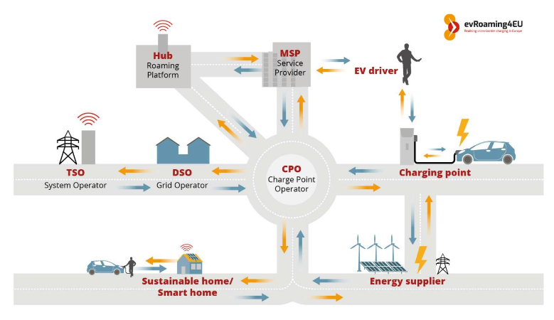
Figure 9 EV market actors

Already existing fiscal incentives for the purchase of EVs will be extended and exit strategies developed, and policies concerning the support of EV and EV supply equipment assembly and manufacturing will be proposed. The legislative work will be carried out in alignment with the Action Plan to prepare the energy sector for the large-scale introduction of electric mobility as requested by the National Transportation Strategy until 2030.

Output 3.1: Four best practice 'how to' guides developed and published to enable scale up passenger and freight e-vehicle use and to promote manufacturing of e-vehicles and charging equipment.

Based on international best practice, and in particular lessons learnt in Western Europe, a series of ‘how to’ guidance documents for electric mobility and charging infrastructure for use by government actors and private sector stakeholders is developed. These ‘how to’ guides include examples of financial models and typical business plans for attracting private investors to the development of electric vehicle charging infrastructure, commercial EV fleets and local EV and EV supply equipment manufacturing capacities. This package comprises the development of at least 4 documents focusing at: 1.) Expansion of the charging network; 2.) Use of electric vehicles in passenger transport fleets; 3.) Use of electric vehicles in freight transport fleets; and 4.) Local manufacturing of electric vehicles and EV supply equipment. A series of e-mobility business roundtables will be held around the best practice ‘How to’ guides to 1.) stimulate local financial institutions to provide tailormade financial schemes for the purchase of new EVs as well as to 2.) create more interest in the Ukrainian automotive industry to locally assemble and manufacture EVs and EV supply equipment.

D 3.1.1 A workshop to discuss scope, objective and milestones of the best practice ‘How To’ guides is conducted.
D 3.1.2 The best practice ‘How To’ guides on 1.) Expansion of the charging network; 2.) Use of electric vehicles in passenger transport fleets; 3.) Use of electric vehicles in freight transport fleets; and 4.) Local manufacturing of electric vehicles and EV supply equipment are drafted and circulated for review.
D 3.1.3 The best practice ‘How To’ guides are disseminated through a webinar series.
D 3.1.4 A series of e-mobility business roundtables held

Output 3.2 Ukrainian EV charging market policy and regulatory framework developed in consultation with market participants and submitted for adoption by the government

The project will use the documentation on best practice for structuring the charging market provided by the Global Programme and expanded as part of the ‘How to’ guides to develop a Ukraine specific Charging Infrastructure directive. Based on the findings, a document is developed, which outlines the EV market structure in Ukraine, including the eventual set-up of a clearing house for information exchange and registration of users for charging transactions, EV charging billing schemes and intra-market participant communication. Furthermore, a policy proposal is developed which 1.) integrates regulation of technical specifications for equipment and installation, and which 2.) proposes necessary amendments to The Law of Ukraine on Electricity Market No. 2019-VIII dated April 13, 2017 to define rights and obligations of the charging station operator as well as the procedure and conditions of their participation in the electricity market, with the aim to enable energy based metering and billing. An interactive map visualizing charging stations, as well as information on state of use, electricity price, and – if possible – load profiles will be developed to track and monitor the EV charging network and to facilitate the selection process for the strategic location of new EV charging stations. The work carried out under output 3.2 will anticipate the targets formulated in the comprehensive e-mobility strategy developed under Output 1.3 and will be carried out with a particular focus on compliance and consistency with developments within the European Union, e.g., with regards to regulation such as charging protocols, certification, roles and responsibilities of EV charging market participants etc. The experience of component 2 will be used to develop the fiscal or financial incentives for investments in the EV charging infrastructure. The work will directly feed into the Action Plan to prepare the energy sector for the large-scale introduction of e-mobility, which needs to be finalized by Ministry of Energy by 2022.

D 3.2.1 Best practice on EV charging market structure from relevant European countries is compiled based on the Global Programme materials, expanded and adapted to the Ukrainian market.
D 3.2.2 Workshop bringing together all relevant actors from government, private sector and finance to discuss measures to regulate the development of EV charging infrastructure.
D 3.2.3 Based on the best practice examples and the workshop input, a document outlining the Ukrainian EV charging market structure including all relevant actors and institutions and defining missing legislative terminology, including aspects of public charging land ownership, is developed and circulated for review.
D 3.2.4 Workshop bringing together all relevant actors from government, private sector and finance is to discuss the proposed framework for regulating EV charging infrastructure.
D 3.2.5 Final proposal for regulating charging infrastructure development including necessary amendments to The Law of Ukraine on Electricity Market No. 2019-VIII dated April 13, 2017 to enable EV charging providers to bill electricity in kWh and missing technical regulations for EV chargers, their installation and operation for adoption by the government.
D 3.2.6 Development of an interactive map tracking EV charging data and to visualize their current state of use, price information as well as – if possible – power demand load profiles to monitor the EV charging network and to help identifying favorable locations for the installation of charging stations.

Output 3.3: Fiscal, regulatory and local policies (at least 2) to incentivize the purchase of privately owned EVs, the investment in commercial EV fleets and the local manufacturing of electric vehicles developed and submitted for adoption by the Government

Existing policies to incentivize the purchase of EVs will be extended and a respective exit strategy will be developed. Based on already existing proposals, a policy proposal to stimulate investment in local manufacturing of electric vehicles will be supported. The policy measures will be developed in collaboration with relevant representatives from Government agencies, according committees such as the Parliamentary Committee on Transport and Infrastructure, the Committee on Energy, Housing and Utilities Services, as well as sectoral business associations.

D 3.3.1 A workshop bringing together all relevant actors from government, private sector and finance to discuss continuation and a viable exit strategy of fiscal incentives for EV purchase is conducted
D 3.3.2 A workshop bringing together all relevant actors from government, private sector and finance to discuss policy gaps to foster local production of EVs and EV supply equipment is conducted.
D 3.3.3 Based on the best practice examples and workshop input, recommendations to Law of Ukraine No. 2754-VIII dated 11 July 2019 to extend fiscal incentives for the electric vehicle market and to define a respective exit strategy are developed
D 3.3.4 Based on bills № 3476 and № 3477 recommendations to stimulate investment in local manufacturing of electric vehicles will be developed.
D 3.3.5 A second workshop is held to validate the recommendations.
D 3.3.6 Draft legislation comprising the entire package of incentives is developed and submitted for adoption by the government.

Component 4: Long-term environmental sustainability of low-carbon electric mobility

Outcome 4: The Government of Ukraine develops initial policy schemes and regulatory measures and builds capacity to enhance long-term environmental sustainability of low-carbon electric mobility transformation

To ensure long-term environmental sustainability, the project will include training and knowledge transfer from international consultants and local specialists to investigate the integration of EV charging into the grid and facilitating increased use of renewable power and to develop schemes and regulations on the collection of used EV batteries for re-use as energy storage, recycling and safe disposal.

The project will, in conjunction with the National Electricity Regulatory Commission of Ukraine and the Ministry of Energy and Environmental Protection of Ukraine, develop proposals for differentiated tariffs for charging station networks. This will stimulate charging of electric cars during hours, when electricity consumption is lowest, in order to obtain further positive effects for the entire energy system such as better balancing of power supply with demand, which can also facilitate the better integration of renewable power. In addition, the project will investigate a future role of vehicle to grid (V2G) applications to further enhance the grid’s flexibility and to build on the potential use of the EV fleet as electricity storage for grid balancing.

Output 4.1: E-vehicle power demand on grid assessed and recommendations developed and made available to relevant stakeholders for integration of EV charging into grid management.

It is the objective of this output to investigate the benefits of EV charging for power grid flexibility and renewable power integration. The recommendations to be developed target the better alignment of incentives provided to green Ukraine’s power sector and to introduce EVs to the vehicle fleet. A study will be developed to elaborate scenarios of future uptake of the EV fleet in Ukraine on power demand and the use of EV charging to better align power supply with demand. This can be achieved through measures of different complexity. For example, charging loads can be shifted from peak hours to times with generally power demand, through differentiated electricity tariffs. The project will develop proposals such as differentiated tariffs for EV charging for public and private chargers to better integrate EV charging systems into the Ukrainian power market. It will further propose a methodology to monitor the load profiles of EV charger’s country-wide in order to establish the data base necessary for the better integration of EV charging in the Ukraine power grid. This will include the technical specifications to develop protocols for data collection and transmission between charging point and grid operators. Future use of vehicle to grid applications (V2G) will be investigated.

D 4.1.1 A first EV charging tariffication and renewable power integration workshop is held.
D 4.1.2 Proposals for better integration of EV charging into the Ukrainian power grid such as differentiated power tariffs for public and private EV charging are developed and submitted for adoption.
D 4.1.3 A study to investigate the further use of EVs for energy storage and grid balancing purposes, including V2G applications is developed.

Output 4.2: Regulatory framework, including financing model, for re-use, recycling, collection and safe disposal of used electric vehicle batteries developed and proposed to key decision makers in government and private sector

At present, there is no legal regulation in Ukraine on the disposal of electric vehicles battery, because the market is still fresh and emerging. However, given that the existing electric vehicles park in Ukraine is 92% composed of used/second-hand cars, in the coming years this issue will require separate legislative regulation and development of mechanisms for the recycling of used batteries and, possibly, their re-use in power storage at charging stations. The project, together with representatives of the Ministry of Energy and Environmental Protection of Ukraine as well as business entities involved in the promotion of electric vehicles, will develop draft regulation to create a system for collecting used batteries from electric vehicles and sending them for safe processing. This draft regulation will build on the latest assessments of the European Commission on “Modernising the EU’s Batteries Legislation”, which aims to “aims to ensure a competitive, circular, sustainable and safe value chain for all batteries placed on the Union market in the context of the Circular Economy”.

D 4.2.1 A used battery collection, re-use, recycling and safe disposal workshop is held.
D 4.2.2 A proposal to collect used EV batteries for re-use, recycling and safe disposal aligned with latest EU regulation is developed.
D 4.2.3 Draft regulation for used EV battery collection and recycling is submitted for adoption to the government.

4) Alignment with GEF Focal Area and/or Impact Program strategies

This programme is aligned with Objective 1 of the Climate Change Focal Area to “Promote innovation and technology transfer for sustainable energy break-throughs”, through CCM 1-2 - Promote innovation and technology transfer for sustainable energy breakthroughs for electric drive technologies and electric mobility.

5) Incremental/additional cost reasoning and expected contributions from the baseline, the GEFTF, LDCF, SCCF, and co-financing

The support of the GEF will be used to cover the cost for the removal of barriers, which prevent the accelerated uptake of the EV market in Ukraine. This includes:
- Building capacity, raising awareness, identifying policy gaps;
- Improving coordination of e-mobility projects through the introduction of an inter-ministerial e-mobility coordination body;
- Developing strategies and studies to introduce and upscale the EV market in Ukraine;
- Developing a regulatory framework for the EV charging market including technical standards for supply equipment and its installation as well as regulatory approaches to structure the charging market;
- Implementation of a financing mechanism to provide loans at preferential conditions for the expansion of the charging network;
- Developing a strategy to integrate the use of renewable power for e-vehicle charging and, inter-alia, to investigate the impact of EV vehicles on the uptake of renewable power integration in Ukraine, and;
- Developing an initial scheme for the re-use and collection of used EV batteries.

Without these interventions supported by the GEF, EV market development would continue in an uncoordinated manner. The absence of an adequate regulatory framework for the EV charging market is likely to lead to an atomized charging market with in-transparent and non-consumer friendly payment schemes, insecure charging installations and the missed opportunity to untap the potential of wide-spread EV adoption as an enabler for the integration of high shares of renewable power. Without the introduction of financial instruments, the expansion of the charging network is assumed to take place at reduced pace. All this is likely to lead to much slower uptake of the EV market, being solely based on the ongoing initiative of early market adopters.

Based on the import of relatively cheap used EVs from the US, and taking into account the low electricity prices, payback times for EVs in Ukraine are short, amounting to less than 2 years. Total cost of ownership including purchase price, cost of financing and fuel costs (and excluding differences in cost of maintenance as well as re-sale value) over an ownership time of 7 years indicate that a used EV can be about 4,400 USD cheaper than a comparable ICE vehicle. The GEF support helps to allow consumers to untap these potential savings by incentivising the faster build-up of charging infrastructure.

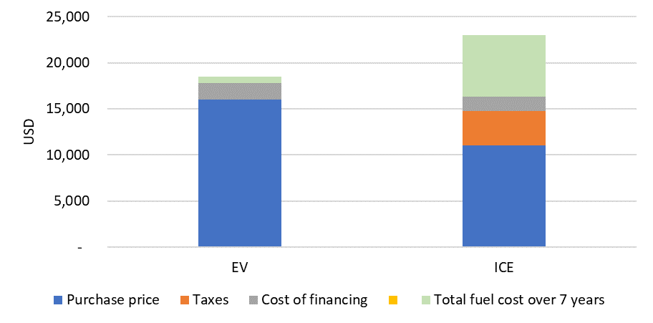

Figure 10 total cost of ownership for a used EV compared to a respective ICE vehicle

In addition, the project is supported by the global project and the Regional Support and Investment Platform for Central and Eastern Europe, West Asia and Middle East, which will be hosted by the EBRD. The global knowledge management component and the regional platform approach seek to bundle effort at a global and regional level to minimize the incremental cost for EV market development by:
- The development of generic tools at global level, which are disseminated through the Support and Investment Platform, and in case of Ukraine through the Central and Eastern Europe, West Asia and Middle East Support and Investment Platform – thus return on investment for development of tools and methodologies is maximized;
- De-risking of the investment risk on the demand side – the bundling of demand for EVs and EV supply equipment at the regional is expected to result in better purchase conditions;
- De-risking of the technology risk on the supply side – through adequate training of EV and EV supply equipment operators, establishment of technical specs and guidelines for proper operation and maintenance, and exchange between numerous projects EVs and EV supply equipment are less likely to face misuse leading to failure or loss.

6) Global environmental benefits (GEFTF) and/or adaptation benefits (LDCF/SCCF)

It is estimated that in 2018, light duty vehicles in Ukraine were responsible for about 21 megatons of CO2 emissions. In the baseline scenario, it is projected that the light duty vehicle fleet in Ukraine will grow to about 8 million cars by 2030 and double to almost 14 million vehicles by 2050. While the growth of vehicle sales and fleet is identical for the alternative scenario, an ample shift to electric mobility is assumed. The sales of EVs (including both battery electric vehicles and plug-in hybrids) are assumed to reach 5% by 2025, 20% by 2030 and 75% by 2050 (while it is assumed that EV penetration stays at current levels of below 2.5% within the baseline scenario, growing in absolute numbers along the general growth of vehicle sales). Following this scenario and assuming a reduction of the carbon footprint of the power mix from around 490gCO₂/kWh today to 400gCO₂/kWh by 2030 and 300gCO₂/kWh by 2050, it will be possible to stabilize energy use and CO₂ emissions from light duty vehicles in Ukraine at year 2010 levels.

The projected CO₂ emissions reductions will stem from the introduction of EV charging points (including both slow and fast charging) in Ukraine. The densification of the charging network alongside the adoption of a streamlined e-mobility policy framework will trigger the uptake of the electric vehicle market in Ukraine. Energy and CO₂ emission savings are not directly achieved by the installed charging equipment but: 1.) will be achieved through the use of electric vehicles, which are charged with the help of the installed charging stations, and therefore replace an equivalent use of conventional internal combustion engine powered vehicles; and 2.) will be achieved by triggering the uptake of EVs in the Ukrainian fleet as a consequence of a denser EV charging network.

Emission reductions are categorized as following:
- Direct emission reductions – based on the amount of electricity sold to charge EVs using the installed 320 public slow and 32 public fast charging stations
- Secondary direct emission reductions – based on the uptake of the EV fleet triggered by the densification of the charging network
- Indirect emission reductions – based on the strengthening of the policy framework, the better coordination of e-mobility projects and the development of business models to incentivize the uptake of the EV market.

A detailed explanation of calculation of the CO₂ emissions reductions for each category can be found in Annex M.

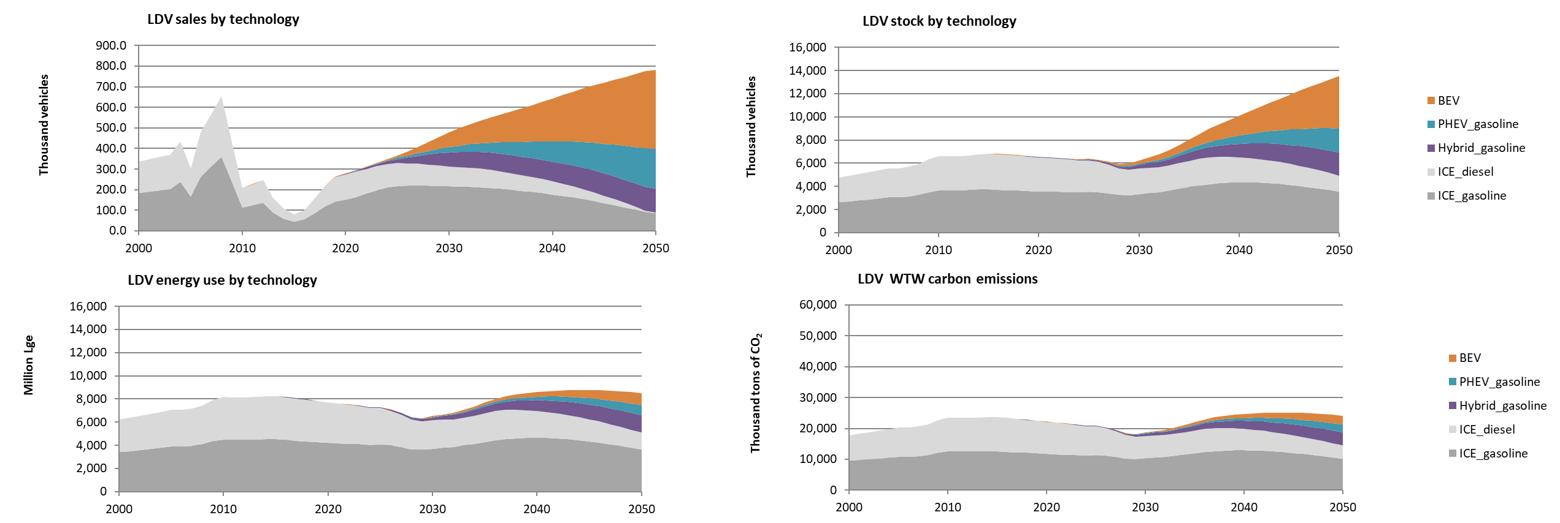
Figure 11 alternative SCENARIO FOR LDV SALES, FLEET, ENERGY USE AND GHG EMISSIONS

To determine the indirect emission reduction potential, a top-down CO₂ mitigation projection was carried out based on above mentioned fleet growth and EV sales shares. The top-down approach resulted in a mitigation potential stemming from the shift to e-mobility of about 13 million tons of CO₂ for the projected time frame from 2021 to 2036. Thereof, total direct emission reductions amount to 47 thousand tons of CO₂. Total secondary direct emission reductions are estimated to account for 278 thousand tons of CO₂. Indirect emission reductions attributable to the project are estimated to 2.2 million tons of CO₂ and are based on the top-down approach using a level I causality factor of 20%. In total, 2.6 million tons of CO₂ emission reductions can be attributed to the project.

Total top-down emission mitigation potential, tCO2 |  | 12,763,327
Thereof attributable to the project:
Total direct emission mitigation from demonstration, tCO2 |  | 47,426
Total secondary direct emission mitigation, tCO2 |  | 278,610
Total indirect emission mitigation, tCO2 |  | 2,226,629
Total project related emissions reductions, tCO2 |  | 2,552,665

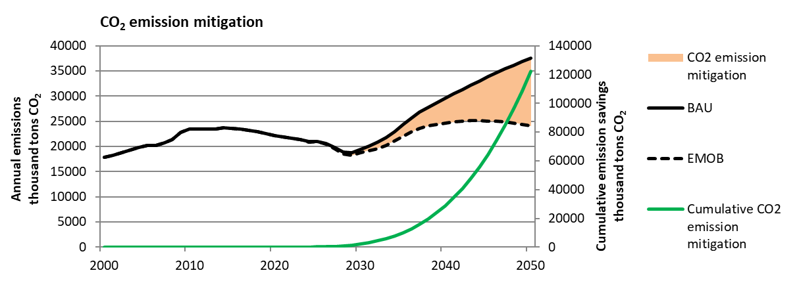
Figure 12 TOP-DOWN CO₂ EMISSION MITIGATION FROM ELECTRIc light duty vehicles in ukraine

7) Innovativeness, sustainability and potential for scaling up

Innovativeness

The project targets innovation from several angels: 1.) Technology; 2.) Environmental; 2.) Business and finance; 3.) Regulatory; 4.) Sector integration; and 5.) Socio-economic:
- Technology innovation focuses on scaling-up the market for a novel transport technology, which has the potential to greatly increase energy efficiency.
- Innovation regarding the environment aims at tapping the potential of EVs to greatly reduce fossil energy use and thus reduce greenhouse gas and air pollutant emissions. New approaches to ensure that EV components such as batteries are manufactured in an environment friendly way and collected for re-use, recycling and safe disposal are aiming at the introduction of an increasing degree of circularity within production processes.
- The promotion of innovative business models based on the integration of web based digital technologies related to internet of things (e.g., with regards to the communication of charging stations with consumers and operators) as well as cloud computing and big-data approaches (e.g. with regards to payment schemes but also the dispatching of power and the integration of renewable power generation) are a key element of the project.
- Innovative regulatory approaches target the structuring of the EV charging market in a way to address interoperability, consumer friendliness and transparency, and equality of access for businesses. Innovative sector integration focuses on a better understanding of the linkages between the transport and the power sector, and the opportunity to use electric mobility as a means to provide flexibility in the power market through energy storage, load shifting and peak shaving approaches, in order to integrate higher shares of renewable power generation within an otherwise stiff power sector, relying on high shares of base-load power generation capacity such as nuclear power and hydro.
- Socio-economic innovation comprises the opportunities for green job creation both in the EV charging but also in the EV manufacturing sector.

Sustainability of market development after the project
The sustainability of the invested GEF resources is ensured based on two principles. First, financing based on the GEF funds blended with an EBRD loan will only be issued to a private (or municipal) sector beneficiary based on the competitive application process under Component 2. Consideration will be made of the viability of the business model for the charging infrastructure funded to ensure that a) the loan issued will be repaid and b) the developed charging infrastructure will operational beyond the project implementation period. Ownership of the charging infrastructure is with the beneficiary of the blended loan.

Second, during project implementation private sector stakeholders focused on scaling-up e-mobility and charging infrastructure will be actively engaged to increase awareness and thereby stimulate the market. Ukraine is not only one of the potentially biggest light duty vehicle markets in Europe, but it has also a history of vehicle production in all segments – light duty vehicles, heavy duty vehicles and buses. In 2013, more than 50,000 vehicles were manufactured in the Ukraine, dropping to about 8,500 in 2018. Currently, the following producers are manufacturing vehicles in the Ukraine:

- Bogdan Corporation is a Ukrainian automobile-manufacturing group, including several cars- and bus-makers in the country;
- ElectronMash, specialized in the production of special off-road all-wheel drive vehicles;
- Etalon Auto Corporation, producers of buses and trolley buses;
- Eurocar, assembly line production for Skoda Auto (Volkswagen);
- KRAZ (Kremenchuk Automobile Plant or AvtoKrAZ), production of trucks and heavy-duty off-road vehicles
- AZ (Lviv Automobile Plant) is a bus manufacturing company in Lviv,
- ZAZ (Zaporizhia Automobile Building Plant, part of UkrAvto) is the main automobile-manufacturer of Ukraine, based in the south-eastern city of Zaporizhia. It also produces buses and trucks (formerly AvtoZAZ). Production of Chinese Chery A13 and GM Chevrolet Aveo which stopped in 2018, in 2020 Renault announced to revive passenger car production. ZAZ is to produce the Lada Vesta, Lada Xray and Lada Largus models, which are also to be complemented by Renault Arkana (https://www.world-today-news.com/ukrainian-zaz-revives-production-of-passenger-cars-in-zaporozhye-will-produce-renault/ );

Sustainability of the market development will be by stimulating the demand site through coordination, harmonized regulation and expansion of the charging network as well as through active involvement of vehicle manufacturers, and notably Renault, which is one of the leading EV manufacturers (Renault-Nissan-Mitsubishi Alliance). Renault is selling new EV (Renault Zoe) in Ukraine.

Furthermore, it is the aim of the project to mobilize additional resources during project implementation to ensure sustained financing for further up-scaling of the EV charging market. Up-scaling the financing of charging infrastructure projects is the key exit strategies of this e-mobility project.

Also, during project development there was large interest in the use of electric buses and support for EV expansion in this segment will be further investigated during implementation of the project.

With the support of the Global Programme and in particular through the Support and Investment Platform for Central and Eastern Europe, West Asia and Middle East, which is hosted by the EBRD, concepts for further upscaling of the e-mobility market in Ukraine will be elaborated. The marketplace events carried out by Support and Investment Platform will help to make matches for future projects between national and city government representatives, the local vehicles manufacturers as well as national and international financiers.

The Support and Investment Platform for Central and Eastern Europe, West Asia and Middle East is expected to be sustained beyond the project time frame and will play a key role in securing on-going financial support to e-mobility projects in Ukraine.

Environmental Sustainability

The project has two outputs dedicated to environmental sustainability:

- The development of an initial scheme to collect used EV batteries for re-use, recycling and safe disposal; and
- The integration of renewable sources of power generation for charging electric vehicles.

Both outputs are of high relevance and ensure that 1.) the issue of potentially hazardous waste is tackled in Ukraine; and 2.) that the long-term sustainability with regards to truly zero- or low-carbon transportation is planned. Elements of circularity are introduced to EV and EV supply equipment manufacturing and use through targeting the re-use of EV batteries, which do not provide the capacity to be used in transport applications anymore, but which still have enough storage capacity to play a role in the power sector. Equally, issues of battery recycling are addressed through the establishment of regulatory schemes which ensure that used EV batteries will be recycled in a way to preserve the maximum number of raw materials such as precious metals (cobalt, copper etc,) and other components such as the catalytic materials for re-use in new batteries.

Literature shows (e.g., IEA Global EV Outlook 2020) that a significant fleet of EVs can play a major role in increasing the flexibility to match variations in power demand and supply in the power sector. This particularly important in the Ukrainian power sector which relies to a large extent on low-carbon base load power generation capacity such as nuclear and hydro power. These base-load capacities have relatively small margins with regards to the variation of power output and pose a challenge when it comes to the integration of high shares of renewable power such as wind and solar. The project targets the better understanding of the future role of electric mobility in a Ukrainian low-carbon power sector aiming at the integration of high shares of renewable power generation capacity.

Potential for scaling-up

As already outlined before, the market potential for EVs in Ukraine is huge due to:
- An already existing fleet of more than 10,000 EVs and more than 2,500 charging points;
- Very low price and low carbon electricity;
- Already available incentives such as the waiver on VAT and import excises;
- The potentially large size of the vehicle market;
- The presence of multiple local vehicle manufacturers among them Renault as well as assembly capacity for Skoda Auto.

It will be part of the project to investigate the development of follow-up projects, which could build on the financing scheme implemented by EBRD, and which could be broadened towards the purchase of electric vehicles (car, buses and trucks) as well as EV supply equipment. It will also be part of the project to actively engage vehicle manufacturers, and namely Renault, to investigate the local manufacturing of EV models.

1c. Project Map and Geo-Coordinates

Demonstration sites | Latitude | Longitude
Ukraine (exact pilot sites for charging infrastructure will be determined after feasibility assessment).  The project is not expected to cause any disputes on land use between Ukraine and its neighbouring countries. | 48° 22' 58.88" N | 31° 10' 58.33"

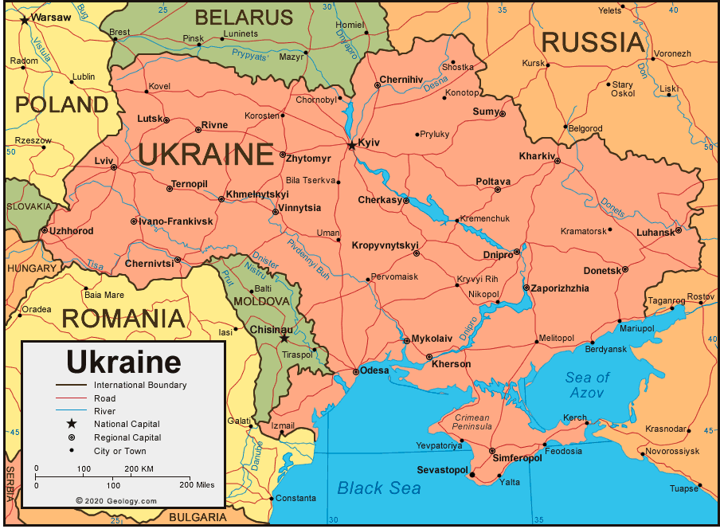

1d. Child Project
The current project is hosted under the “Global Programme to Support Countries with the Shift to Electric Mobility”, led by UNEP.

The Global Programme to Support Countries with the Shift to Electric Mobility was submitted (June 2019 GEF Council) with child projects in Albania, Antigua & Barbuda, Armenia, Bangladesh, Burundi, Chile, Costa Rica, Ecuador. Grenada. India, Indonesia, Ivory Coast, Jamaica, Jordan, Madagascar, Maldives, Peru, Philippines, Saint Lucia, Seychelles, Sierra Leone, South Africa, Sri Lanka, Togo, Tunisia, Ukraine and Uzbekistan.

The Global Programme is divided into 4 components:
- Component 1: Global thematic working groups and knowledge materials
- Component 2: Support and Investment Platforms
- Component 3: Country project implementation
- Component 4: Tracking progress, monitoring and dissemination

The Global Programme has put in place the monitoring framework below to track progress both globally and at the level of the country child projects. 10 indicators have been designed for this purpose: 4 relying on global level information (highlighted in blue) and 6 relying on country level information (highlighted in green).

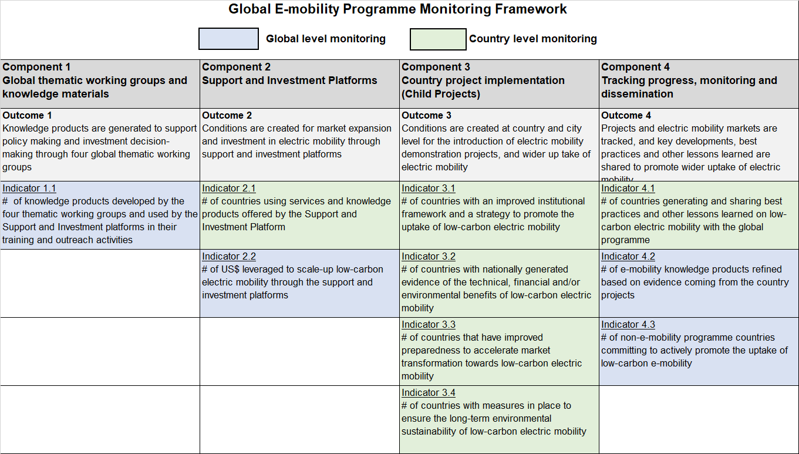
Figure 13 GLOBAL E-MOBILITY PORGRAMME MONITORING FRAMEWORK

The global project will report against this framework on an annual basis, using (1) the global level data from the Global Thematic Working Groups and from the Support and Investment Platforms, and (2) country level data provided by each country project during their annual Project Implementation Review (PIR) process.

For this purpose and whenever applicable, the global level indicators highlighted in green are translated into a country-level indicator in the Project Results Framework located in Annex A of the present CEO Endorsement Document. During project implementation, the Science and Technology Center in Ukraine will be requested to report against the indicators of the country Project Results Framework (Annex A) on an annual basis, during the PIR process.

At the global level, a steering committee integrated by the International Energy Agency (IEA) and the United Nations Environment Programme will coordinate and monitor the implementation and the outputs of the GEF 7 Electric Mobility Programme. On technical gaps, four thematic working groups at the global level will support the rapid introduction of electric mobility in GEF recipient countries. These working groups will generate universal knowledge products that contain best practices, factsheets, interactive tools and guidance, as well as experiences from countries that have advanced their e-mobility market. The working groups will be integrated by representatives from the global programme regional platforms, GEF-7 countries, IEA, vehicle manufacturers, utilities, researchers and the civil society. The governance structure is presented in the figure below. For Central and Eastern Europe, West Asia and Middle East Support and Investment Platform, the regional platform will be led by EBRD.

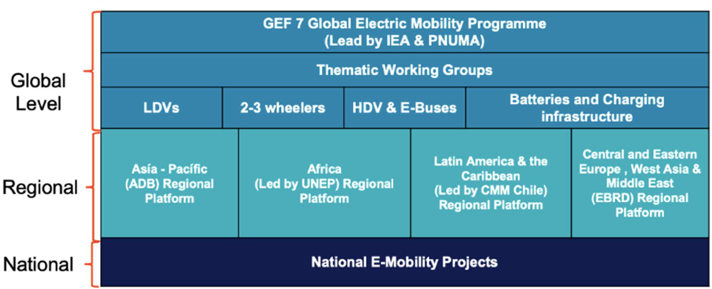

Figure 14 GOVERNANCE STRUCTURE BETWEEN THE GLOBAL PROGRAMME, THE NATIONAL E-MOBILITY PROJECTS, AND THE REGIONAL PLATFORM

The coordination between the global program, the steering committee, the thematic working groups, and the national projects will be facilitated by the regional platform. The role of the regional platform is to provide customized technical assistance to ensure the success of the country projects. Moreover, knowledge products developed by the working groups will be adapted and disseminated by the regional platform according to the regional and national context, specific needs and languages.
The EBRD regional platform will interact with and support participating countries in the region to link with each other through the following activities:
  - The creation of a community of practice for the GEF 7 regional countries;
  - Facilitation of knowledge transfer between countries, and regions;
  - The creation of thematic groups in light-duty vehicles (LDVs), 2-3 wheelers, and buses at regional level;
  - A marketplace between countries, technology providers and financial institutions;
  - Help desk for technical assistance to GEF 7 countries;
  - Personalized assistance from international experts in electric mobility; and
  - Generation of training sessions and workshops.

The national child projects will generate a learning curve on electric mobility that can be transferred to other countries within and outside of the region through the global programme. As a first contact point, the regional platform will facilitate the flow of learnt lessons from child projects, such as: data and demonstration results, working business models, operational know-how, working financial instruments, and working policies and regulations. At the global level, the scenarios proposed to share country knowledge and experiences on electric mobility are the thematic working groups, while at the regional level the countries will participate in the community of practice, the thematic regional groups, the marketplace, trainings and workshops.

2. Stakeholders

The key stakeholders to be involved in the project are summarized in Table 2. Stakeholders are categorized into four groups: 1.) Government, 2.) Private sector, 3.) Finance and 4.) Civil Society.

Key government stakeholders include the key Ministries which will be part of the Project Steering Committee as well as a larger group of Ministries which will be consulted.

The ministries unified in the Project Steering Committee will have the political power to drive the necessary regulatory and fiscal reforms to incentivize the uptake of e-mobility in Ukraine.

Key private sector stakeholders include TOKA LLC (EV charging hardware and software, charging point operator), ChargeX (charging stations and accommodating software solutions), GO TO-U (EV charging platform).

The key financial stakeholder is EBRD that, as a GEF Agency and Multilateral Development Bank (MDB) will be responsible for the implementation and execution of component 2, which uses blended concessional finance to support a demonstration of EV charging station.

The Stakeholder approach is designed to ensure effective engagement of all relevant stakeholders throughout the project lifecycle in Ukraine, building on the meetings and stakeholder workshop conducted during project preparation. The project will aim at maintaining fluid and two-way dialogue with the relevant national and local government institutions and agencies, the private sector, and civil society for national activities, as well as with local and international NGOs, the international community and other participating countries at the global programme level.

Please refer to the report: “Summary of stakeholder consultation meetings and validation workshop”, for information on the engagement of stakeholders during the development of the CEO Endorsement document and associated annexes.

Legal requirements for public consultation in Ukraine
For this project, public consultation will follow any relevant national guidelines and the GEF Guidelines, which require that all GEF-funded projects meet best international practice and specifically the requirements for stakeholder engagement and public consultations. The project stakeholder engagement activities will be robust, and disclosure of information will be made in order to promote better awareness and understanding of its strategies, policies and operations. During disclosure, the project will: (1) Identify people or communities that are or could be affected by the project as well as other interested parties; (2) ensure that such stakeholders are appropriately engaged on environmental and social issues that could potentially affect them, through a process of information disclosure and meaningful consultation; and (3) maintain a constructive relationship with stakeholders on an on-going basis through meaningful engagement during project implementation. The stakeholder consultations will be an on-going process taking place during the project life and will ensure that stakeholders are informed about environmental and social consequences of the project implementation and ensure the opportunity for feedback.

Identification of stakeholders for engagement and methods of communication
In order to ensure inclusive participation and consultation, the following stakeholders have been identified for consultation. The list includes the identified social groups that are associated with the project in different ways: those directly or indirectly engaged in the outcomes of project implementation; those directly or indirectly participating in the project, and those with a capacity to influence and decide on project implementation and outcomes.
- National government - Ministry of energy of Ukraine, Ministry of infrastructure of Ukraine, Ministry of Environmental Protection and Natural Resources of Ukraine, Verkhovna Rada of Ukraine, State Agency for Energy Saving and Energy Efficiency of Ukraine.
- The local government - Kyiv. Odessa, Kharkiv, Lviv state local administrations
- The financial sector is a key project partner to facilitate the access to financing - Oshadbank, Privat Bank, Ukrgazbank (all state-owned).
- EV charging station companies are essential for the provision of charging infrastructure access. For them, the project provides an opportunity for their private investment to be supported by an improved government policy and regulatory framework and support.
- Utility providers - UkrEnergo, YASNO
- Civil Society Organizations - ISA, Consumers Union of Ukraine, AVERE Ukraine

During its planning stage, the project has organized a series of stakeholder meetings and a stakeholder workshop in particularly, on November 14th, 2019 – presentation of GEF Global E-mobility Programme for Ukraine on stakeholders meeting in the Ministry of infrastructure of Ukraine$ November 22nd, 2019 - “Ukrainian roadway to E-mobility” national conference and workshop with participation of key governmental, as well as public/private stakeholders in Ukraine; February 20th, 2020, National working group meeting to discuss the status of preparation for the GEF Global E-mobility Programme; September 17th 2020 – UNEP, EBRD with the Ministry of Energy of Ukraine, ISA, TOKA LLC, Science and Technology Center of Ukraine. On September 23rd UNEP, EBRD with the Ministry of Infrastructure of Ukraine, ISA, STCU and a final validation workshop is planned for end of October / early November 2020. Interviews will all the stakeholders identified above have taken place in order to identify their concerns and priorities and to integrate their knowledge and needs. As a result, the project is taking appropriate responsive measures throughout its lifespan to consolidate and maintain the wide current support built up during the planning stage. As a result of the project design activities, the interests and concerns of the key stakeholder groups have been identified and are presented in the table below.

Table 2: Stakeholders engagement plan

Stakeholder main group | Stakeholder name | Existing activities with potential to be leveraged | Content engagement, contributions to the project (identified by Component)
State government | Ministry of Environmental Protection and Natural Resources https://menr.gov.ua/ | Provide public administration and ensure implementation of state policy for environmental protection | All components: Lead agency and part of steering committee
State government | Ministry of Energy | Provide public administration and ensure implementation of state policy for environmental protection | All components: Lead agency and part of steering committee
State government | Ministry of Infrastructure of Ukraine (MIU) https://mtu.gov.ua/content/hto-mi-e.html. | Provide public administration and ensure implementation of state policy for infrastructure - including transport | All components: Lead agency and part of steering committee
National government | Ministry for Communities and Territories Development of Ukraine (MCTDU)  http://www.minregion.gov.ua/about/about-min/polozhennya-pro-ministerstvo-rozvitku-gromad-ta-teritoriy-ukrayini/ | Provide public administration and ensure implementation of state policy on public housing infrastructure development. | All components: views will be sought on full project lifecycle.
National government committees | Verkhovna Rada of Ukraine (https://rada.gov.ua/) | Creation of legislative base in the field of electromobility, transport infrastructure, approves priority areas as a separate national program or as part of the Program of Activities of the Cabinet of Ministers of Ukraine | All components: views will be sought on full project lifecycle. Particularly responsible for legislative initiatives.
National government committees | Committee of the Verkhovna Rada on issues of environmental policy and natural resources. | Creation of legislative framework on behalf of state government | All components: views will be sought on full project lifecycle. Particularly responsible for legislative initiatives.
National government committees | Committee on Energy, Housing and Utilities Services.  Infrastructure | Creation of legislative framework on behalf of state government | All components: views will be sought on full project lifecycle. Particularly responsible for legislative initiatives.
National government committees | Committee on Finance, Tax and Customs. | Creation of legislative framework on behalf of state government | All components: views will be sought on full project lifecycle. Particularly responsible for legislative initiatives.
State Companies | National Energy Company "Ukrenergo"  (https://ua.energy/about-en/) | Is a state energy company which has the functions of operational and technological management of the Unified Energy System of Ukraine (UES) and transmission of electricity by backbone power grids from generation to regional power grids of power supply companies | All components: Support of the activities of the Project in the field of development of regulation on infrastructure for e-mobility in Ukraine
State Agencies | State Agency on Energy Efficiency and Energy Saving of Ukraine (https://saee.gov.ua/en ) | Implements the state policy in the field of efficient use of fuel and energy resources, energy saving, renewable energy sources and alternative fuels. | The Agency will assist in:  - Development of analytical reports  - Implementation of the pilot project to establish the infrastructure of charging stations integrating with electricity storage and solar panel.  - Support in attraction of co-financing
European Agencies | European-Ukrainian Energy Agency (EUEA) (http://euea-energyagency.org/en/about-euea/mission-and-objectives ) | Unite the companies and organizations which focus on RE and Energy Efficiency, work on the development of the energy market, with the sustainable development of business, promote energy initiatives in Ukraine, and develop the classification of economic activities in the field of electric vehicles market in Ukraine). | European-Ukrainian Energy Agency will participate in spreading information about the Project's activities among its members and followers. It will be involved in an information campaign of the Project on e-mobility in Ukraine.
Associations/ NGOs | NGO "Ukrainian Association of Electric Vehicles Owners" (http://ev-ua.org/about-us/). | Is an organization that is united companies and organizations which are constructed, supplies, sells, and maintains electric vehicles, develops charging stations infrastructure, and companies that have investment programs for electro mobility projects, research markets, and provide consulting services | NGO “Ukrainian Association of Electric Vehicles Owners” will participate in spreading information about the Project's activities among its members and followers. It will be involved in an information campaign of the Project on e-mobility in Ukraine.
Associations/ NGOs | Association of Ukrainian Cities (AUC)  https://www.auc.org.ua/). | Focuses on support and development of local self-government in Ukraine. AUC works on develop bills, regulations, proposals to amend the legislative framework of local self-government and local governance, strengthen the infrastructure of the urban economy, provide high-quality public services, protect the public order to improve the environmental situation in cities. | Association of Ukrainian Cities (AUC) will participate in pilot project’s and also will spreading information about Project’s activities among its members and followers. It will be involved in information campaign of the Project on e-mobility in Ukraine.
Associations/ NGOs | European Association for Electromobility, Sustainable Transport and Infrastructure of Ukraine AVERE Ukraine (https://avere.org.ua ) | Is an institution and a European network of national electromobility associations which represents the industry of sustainable transport, elaborates the policy, supports growth and cares of the interests of EV users and equipment manufacturers and other related stakeholders. | European Association for Electromobility will participate in spreading information about Project’s activities among its members and followers. It will be involved in an information campaign of the Project on e-mobility in Ukraine.
Private Sector | TOKA LLC (EV charging hardware and software, charging point operator), | Expected that targeted partnerships with national and European private sector will increase the potential of mobilizing financial resources and mechanisms required | Will be consulted throughout project.
Private Sector | ChargeX (charging stations and accommodating software solutions), | Expected that targeted partnerships with national and European private sector will increase the potential of mobilizing financial resources and mechanisms required | Will be consulted throughout project.
Private Sector | GO TO-U (EV charging platform) | Expected that targeted partnerships with national and European private sector will increase the potential of mobilizing financial resources and mechanisms required | Will be consulted throughout project.
Private Sector | Vehicle manufacturers such as Renault or the Volkswagen Group | Expected that targeted partnerships with national and European private sector will increase the potential of mobilizing financial resources and mechanisms required | Will be consulted throughout project.  Will be integrated in the national awareness raising campaign.
Gender mainstreaming - government | Ministry of Regional Development, Construction, Housing, and Communal Services | Responsible for government policy relating to construction, housing and communal services. | Component 1 - The Ministry will be invited to participate in the gender and electric mobility analysis taking place as part of component 1.
Gender mainstreaming - government | Ministry of Social Policy  Government | Responsible for government policy relating to social policy. | The Ministry will be invited to participate in the gender and electric mobility analysis taking place as part of component 1.
Gender mainstreaming - government | Commissioner for Gender Equality Policy | Responsible for government policy relating to gender quality. | The Commissioner will be invited to participate in the gender and electric mobility analysis taking place as part of component 1.
Gender mainstreaming | League of Professional Women  http://lpw.org.ua/en | The League of Professional Women (LPW) is a Ukrainian non-governmental, non-profit organization. LPW unites representatives of business, science, education, mass media and public spheres. The LPW promotes the active role of women in the economic and society's life of Ukraine, through networking, information & cultural support, learning and professional development. | This organization will be invited to participate in the gender and electric mobility analysis taking place as part of component 1.
Gender mainstreaming | Ukrainian Women Fund  https://www.uwf.org.ua/en/ | Ukrainian Women's Fund is an international charitable organization and provides civil society organizations (CSOs) in Ukraine, Moldova and Belarus with financial, information and consultation support. | This organization will be invited to participate in the gender and electric mobility analysis taking place as part of component 1.
Gender mainstreaming | Women’s Energy Club of Ukraine  http://www.wecu.com.ua/en/ | Non-governmental organization Women’s Energy Club of Ukraine is a voluntary, self-dependent professional association of women working in energy related spheres in Ukraine. They have more than 60 members, among us are energy experts, representatives of Ukrainian and international organizations working in Ukraine on energy sector reforms, Members of the Committee on Fuel and Energy Complex of the Parliament of Ukraine, energy business and NGOs. | This organization will be invited to participate in the gender and electric mobility analysis taking place as part of component 1.

The project envisages the establishment of three main mechanisms for consulting stakeholders in project execution and communication:

- Project steering committee (PSC) - acting as an advisory committee made up of government, civil society and financers - to meet three times a year. The PSC will be transformed into the national, multi-sectoral e-mobility Advisory Board by the end of the project.
- Project working group - made up of government, civil society, finances and private sector providing technical inputs and advice to the project - to meet three to four times a year as required. The project will start with one working group, but it may split into specific themes as the project progresses.
- A project newsletter - distributed to all stakeholders three times a year.

Finally, select what role civil society will play in the project:

☐ Consulted only;
☒ Member of Advisory Body; contractor;
☐ Co-financier;
☐ Member of project steering committee or equivalent decision-making body;
☐ Executor or co-executor;
☐ Other (Please explain)

3. Gender Equality and Women's Empowerment
Does the project expect to include any gender-responsive measures to address gender gaps or promote gender equality and women’s empowerment?
☒ Yes
☐ No

If possible, indicate in which results area(s) the project is expected to contribute to gender equality:
☐ closing gender gaps in access to and control over natural resources;
☒ improving women’s participation and decision making; and or
☐ generating socio-economic benefits or services for women.

Does the project's results framework or logical framework include gender-sensitive indicators?
☒ Yes
☐ No
Gender analysis:

Gender and mobility

Lower employment rates, part-time roles and low-wage positions are the main factors contributing to disparities between genders in the labour market, in social life and in transport behaviour in Ukraine. Generally, the gender imbalance emerging from current patterns and trends in mobility and transport reveals the existence of a disparity, which essentially affects three things:
- the lack of knowledge of gender issues and the scarcity of gender mobility data and statistics,
- the need to plan gender tailored mobility services and
- the need to better exploit the synergies between urban and mobility planning.

According to many studies, gender differences in travel patterns are mainly accounted for by the division of roles in the labour market and the family, which affect women’s employment conditions, income levels and mobility needs. Women’s travel patterns differ from men’s in many ways: women are likely than men to: travel shorter distances, use public transportation, engage in non-work travel outside rush hours, make multi-stop trips, run household errands (usually with children or dependent elderly persons), and be safer drivers.

In addition, women tend to adopt more environmentally friendly mobility patterns. Women tend to be greener not only because they have a more limited access to cars, but also because they have a different attitude towards mobility. While women’s lower rate of motorization forces them to use more public transport as well as walk and cycle more, women are also more willing to reduce their use of the car, are more positive towards reducing environmental impacts of travel and are also more positive towards ecological issues.

The scant attention paid to gender differences is in part due to the lack of gender-differentiated statistics, which make it hard to understand gender differences in reasons for making journeys, journey frequency, distance travelled, mobility related problems in accessing services and employment.

While research on electric mobility and gender is limited, the research paper ‘Are electric vehicles masculinized? Gender, identity, and environmental values in Nordic transport practices and vehicle-to grid?’ highlights that:

The gendering of electric mobility has a long history, one that can be traced back to the 1880s, and it extends well beyond the “women or men like electric vehicles more” types of arguments. Some of the earliest discussions of automobility at this time, when electric vehicles (EVs) were more prominent (in terms of market share) than they are now, were gendered. Due to ease of operation and relative cleanliness, electric cars were known as “women’s vehicles” in the 1900s. In the 1920s, it is women we have to thank for numerous improvements and innovations made through tinkering such as electric ignitions and starters, interior designs, safety harnesses, and larger trunks. The adoption of driving also enabled women to challenge dominant gender roles at the time, demonstrating their capability and autonomy in driving long distances—showing men (and society) that women could travel unescorted across a country. Manufacturers explicitly exploited gender norms when they tried to frame other types of cars as masculine at the dawn of the motoring age. Some of these gendered aspects of mobility extend into today, especially when one examines the preferences held for different modes of transport. Differences between women and men are found in several dimensions of mobility, and …the magnitude of gender differences can shift between dimensions.”

We also know that women and men may follow different decision-making processes and have different responses to both their choices of vehicle purchase (electric or otherwise) and how they access electric vehicle charging stations (e.g. the relationship between driving range, choice of charging locations, the level at which environmental impact versus financial cost influences purchasing decisions). In the absence of collecting data and building knowledge of such potential differences, this project could inadvertently create differential barriers and opportunities for women and men.

Thus, understanding any gender differences is vital to this project (both at policy level and through the demonstration project) to ensure that sustainable mobility is appealing and accessible to all people.

Gender framework in Ukraine

The Ministry of Social Policy (MoSP) is the main institutional body, responsible for developing, implementing and coordinating gender policies in Ukraine. The Expert Council to Consider Claims with regard to Gender Discrimination was set up, consisting of representatives of the MoSP, Ukrainian Parliament Commissioner for Human Rights, other public authorities and NGOs. To facilitate the gender-sensitive policies, the Equal Opportunities Caucus1 was formed in the Parliament yet in 2011. In accordance with Decrees of oblast’s public administrations and Kyiv city public administration, the regional coordination councils on issues of family, gender equality, demographic development, preventing domestic violence and trafficking in human beings have been created. The State Statistics Service is authorized to collect gender-disaggregated statistics; the relevant data are biannually summarized in statistical booklets ‘Women and Men in Ukraine’ based on international standards. Though the list of statistical indicators is still limited, it provides information on gender disparities in education, healthcare, labour force participation and employment, asocial phenomena, etc. Numerous efforts have been taken to build capacity of public officials in terms of development, implementation and monitoring of gender policy, with regard to gender statistics, gender budgeting, gender education and sensitivity, etc. In total, more than 30 thousand public officials and members of council were covered with training workshops and awareness raising programs during 2006-2014 (Ukraine National Review 2014). The role of civil society and international organizations remains quite high in advocating for gender equality in Ukraine, as many legislative initiatives, institutional developments and advocacy efforts in the field of gender equality were pushed by non-governmental sector.

Ukraine succeeded in development of a progressive legislation and institutional environment, shaping the frameworks for enhancing gender equality and non-discrimination. The country has ratified the core international documents with regard to gender equality. Yet in 1948, Ukraine joined the Universal Declaration of Human Rights, while the country signed the ILO Equal Remuneration Convention (1951), the Discrimination (Employment and Occupation) Convention (1958) and the Workers with Family Responsibilities Convention (1981) later on. In 1980, Ukraine ratified the UN Convention on the Elimination of All Forms of Discrimination against Women (CEDAW) and the Optional Protocol thereto (2003). The country also signed the European Social Charter and the Beijing Declaration and Platform for Action on Gender Equality and Women’s Empowerment in 1995. In November 2010, Ukraine ratified the Council of Europe Convention on Action against Trafficking in Human Beings. Finally, Ukraine signed the Convention on Preventing and Combating Violence against Women and Domestic Violence (Istanbul Convention) in 2011; however, it hasn’t been ratified yet. The expert group of public officials and representatives of CSOs is currently working on harmonization of the Ukrainian legislation with provisions of the Convention.

In 2000, Ukraine joined the UN Millennium Declaration at the UN Millennium Summit, and by doing so has undertaken the responsibility of reaching the Millennium Development Goals (MDGs) by 2015. Promoting gender equality was set among the principal Goals, while gender dimension was also clearly traced within other Goals, dealing with reducing child mortality or improving maternal health, combating the epidemics of HIV/AIDS and tuberculosis, or eradicating poverty. To address the Gender Goal, two specific targets have been set: i) to ensure gender representativeness at the level of no less than 30–70 percent in representative bodies and high-level executive; and ii) to halve the gap in incomes between women and men. A set of indicators has been outlined for annual monitoring of progress, including gender ratio among the Members of the Parliament, gender ratio among the members of local councils, gender ratio among the higher-level civil servants, and ratio of average wages between women and men.

The national legislation of Ukraine guarantees the equal rights for women and men, basic principles of gender equality being established in the Constitution. In 2001, the Parliament adopted the Law ‘On Prevention of Domestic Violence’, which became a driving force in promoting the equal rights and opportunities for women and men in all domains of public life. The Presidential Decree ‘On Improving the Work of Central and Local Executive Authorities on Ensuring Equal Rights and Opportunities of Men and Women’ (2005) stipulated development of the national gender machinery by establishing the gender working groups and coordination councils and appointing the gender advisors in the central and local authorities. The Law of Ukraine “On Ensuring Equal Rights and Opportunities of Women and Men” was passed in 2005 after prolonged advocacy campaigns supported by CSOs; it came in force in the early 2006. The Law determines the main directions of the national gender policy, establishes the national gender machinery, and prohibits gender-based discrimination. However, some provisions of the Law do not stipulate specific sanction for their violation.

The Ukraine-EU Association Agreement, signed in 2014, entails a commitment to ensure equal opportunities for women and men in employment, education, training, the economy, and in society and decision-making. Gender equality is enshrined in the Ukrainian Constitution.

More information on gender in Ukraine can be found in this World Bank Report:
https://openknowledge.worldbank.org/bitstream/handle/10986/24976/Country0gender0ent0for0Ukraine02016.pdf?sequence=4&isAllowed=y

Gender challenges in Ukraine

However, despite these existing gender equality and women’s empowerment frameworks, Ukraine still faces challenges that affect the enjoyment of equal opportunities and rights by women in general and those facing compound discrimination in particular. The root causes can be found in patriarchal attitudes and stereotypes, but also in deeply rooted systemic gaps which have not been addressed. These include weak rule of law, low capacity of the institutional mechanisms for gender equality and lack of political will.

Some of the examples of systemic gender inequality in Ukraine include:
- Low level of participation by Ukrainian women in political and civic processes, especially in higher positions,
- Patriarchal culture and deeply entrenched gender stereotypes,
- Widespread gender-based violence etc.

The ongoing reforms pay marginal attention to gender equality, the national and international commitments on gender equality and women’s human rights, as well as the new gender equality priorities caused by the conflict.

UN System and gender in Ukraine

Promoting gender equality as a driver of sustainable country development, the UN System in Ukraine supports government, parliament and civil society to ensure the political, social and economic participation of women, to accelerate empowerment of women and strengthen their role in national reforms processes, to facilitate Ukraine’s adherence to international treaty obligations and to achieve the SDGs by 2030.

The United Nations Country Team (UNCT) is committed to support Ukraine in meeting its obligations on gender equality and women’s rights under the international normative framework on gender equality and women’s empowerment, including but not limited to the following:

The 2030 Agenda for Sustainable Development recognizes that human rights play a central role in the development and gender equality is crucial for achieving SDGs with strong emphasis on addressing inequality and discrimination applying the principle of ‘leaving no one behind’ and ‘reaching the furthest behind first’.

EBRD: gender inclusion and responsiveness

Gender inclusion and responsiveness in EBRD projects has become increasingly important as a means of transitioning towards improved representation, equal opportunity and project sustainability. As in all Countries of Operation, Ukraine has programs and initiatives in place to address the gender gap and, along with EBRD’s commitment to its “Strategy for the Promotion of Gender Equality 2016 – 2020,” will ensure that the project is more closely aligned to gender equality. EBRD’s Gender Strategy is supported by a clear theory of change focused on ‘Equality of Economic Opportunity’, and points to three key objectives of: (i) increased access to finance and business support for women-led businesses; (ii) increased access to employment and opportunities and skills for women; and (iii) improved access to services. These objectives are essentially addressing deep-rooted structural barriers denying women in particular: participation in, contribution to, and receiving enhanced benefits of, the local economy.

Opportunities

The introduction and scaling-up of EV technologies can also be transformative, serving as an opportunity to implement changes, so that EVs improve the mobility conditions and options of women and to facilitate a more balanced access to transportation jobs. By involving women effectively in project design and implementation, and ensuring that interventions are gender sensitive, the project may support the introduction of increased economic opportunities for women in the transport and electricity sectors and support a just-transition of the workforce from existing high-emission technologies.

Gender Action Plan

The guiding principle of the project will be to ensure that both women and men are provided equal opportunities to access, participate in, and benefit from the project.

The gender action plan has a two-pronged approach – embedding gender mainstreaming within the project components and also supporting stand-alone gender mainstreaming to ensure gender is given the attention and priority it deserves.

Embedded into all project components

- All stakeholder engagement (workshops, meetings, surveys, etc.) data will be sex-disaggregated and effort will be made to seek gender balance.
- All data collection will also be sex-disaggregated which is essential to demonstrate gender inputs over the life of the project and provide a reference point for assessing gender equality results. While collecting quantitative data is more easily measured, the Project will also aim to collect qualitative data to support a more nuanced understanding of gender results, as well as to validate quantitative data.
- Gender-sensitive recruitment will be practiced at all levels wherever possible, especially in selection of project staff. Gender neutral TORs will be used to mainstream gender in the activities of consultants and experts. In cases where the project does not have direct influence, gender-sensitive recruitment will be encouraged. Furthermore, whenever possible the existing staff will be trained regarding gender issues to raise awareness.
- All decision-making processes will consider gender dimensions. At project management level, an identified member of the Project Steering Committee (PSC) will be there to ensure that gender dimensions are represented.
- At the level of project activity implementation, effort will be made to consult with stakeholders focusing on gender equality and women’s empowerment issues. This is especially relevant in policy review and formulation.
- To the extent possible, efforts will be made to promote participation of women in training activities, both at managerial and technical levels, as participants and trainers. This can include advertising of the events to women’s technical associations, encouraging companies to send women employees, selection of the trainers, etc.
- Efforts will be taken to ensure at least 30% women participation in all activities of the project.

Gender-oriented actions will be conducted by the following partners:
- The Chief Technical Advisor/Project Manager. For this position, previous experience in the implementation of gender action plans is considered as relevant for the selection process. The Chief Technical Advisor will be in charge of annually monitoring this gender action plan as part of the project monitoring effort.
- Government of Ukraine - relevant ministries.

Stand-alone gender mainstreaming activities (component 1)

- An electric mobility and gender analysis will be undertaken using mixed methods (survey, expert interviews and focus groups) to explore and understand the gender dimensions of electric mobility in Ukraine. In particular, the analysis will examine how perceptions, attitudes and values towards electric mobility differ by gender. The aim is to uncover the subtle, complex and meaningful ways that gender may influence people’s perceptions and preferences for electric mobility. Although one must take care about promoting gender essentialism or determinism—reducing everything to biology or gender—existing transport data for other mobility sectors does show, in statistically significant ways, how men and women self-reportedly differ in how they use transport (or “consume” mobility services) – including express preferences for transport modes and prioritize the particular attributes of vehicles.
- Approach to the analysis will be to develop an outline describing the parameters and methodology of the analysis – making use of existing gender guidance and best practice:
- Conduct research on gender demographics within the electric mobility fleet industry - to understand the gender dimensions across the whole ecosystem.
- Conduct a mix of methods (survey, expert interviews and focus groups) with relevant stakeholders to collect data as detailed in the methodology.
- Develop a draft report along with recommendations and an updated gender action plan for the Ukraine electric mobility project including:
  - Identify gaps/opportunities where integrating gender into the project in Ukraine will result in wider uptake of electric mobility.
  - Identify policy gaps to support wider uptake of electric mobility in Ukraine given gender-considerations.
  - Develop innovative models on how to finance uptake of electric mobility taking into account gender dimensions
- Arrange a stakeholder engagement workshop in Ukraine to disseminate findings and recommendations for leveraging gender to support electric mobility in Ukraine.
- Collate stakeholder feedback on recommendations for leveraging gender to support electric mobility in Ukraine.
- Finalize the report with updated recommendations for leveraging gender to support electric mobility in Ukraine.
- As a result of the analysis this action plan will be updated, and progress monitored by the Project Manager.
- The findings from the analysis will be used to inform development of the “National strategy and electric mobility for Ukraine’.
- The awareness raising activities as part of the project are designed in a way - that address the particular needs of women.

This approach is expected to be sustained after project termination through the inclusion of the project’s recommendations within the practice of the national government and urban public transport authorities, as well as within the private sector.

4. Private Sector Engagement
The private sector is a key stakeholder from whom participation and benefits will be secured under all Components. Under Component 2, private enterprises will play a key role in putting forth, developing and implementing EV charging station project(s), and will benefit directly from both technical assistance and blended financing. Private enterprise includes operators of charging infrastructure as well as operators and developers of applications to map charging points, accessibility and prices. Enterprises receiving funding will be selected based on a transparent and competitive process. The project will leverage the EBRD’s experience in promoting sustainable energy technologies and private sector engagement to accelerate adoption of advanced environmental technologies and practices including electric vehicles and e-mobility infrastructure.

The private sector will play a key role within the consultative process to inform the strategies and policies developed under the project, in particular with respect to technical and operational specifications of charging infrastructure, as well as policies developed to support the local assembly and manufacturing if EVs and EV supply equipment. The private sector will equally benefit from the EV market targets set in the e-mobility strategy as this will provide some planning security as for the expansion of the e-mobility market in Ukraine. It will help the private sector with the marketing of new EVs, since a consumer friendly and dense EV charging network is the prerequisite to convince consumer to buy new EVs, which will be used beyond daily commuting.

As outlined above, Ukraine has significant vehicle manufacturing capacity:

- Bogdan Corporation is a Ukrainian automobile-manufacturing group, including several cars- and bus-makers in the country;
- ElectronMash, specialized in the production of special off-road all-wheel drive vehicles;
- Etalon Auto Corporation, producers of buses and trolley buses;
- Eurocar, assembly line production for Skoda Auto (Volkswagen);
- KRAZ (Kremenchuk Automobile Plant or AvtoKrAZ), production of trucks and heavy-duty off-road vehicles
- AZ (Lviv Automobile Plant) is a bus manufacturing company in Lviv,
- ZAZ (Zaporizhia Automobile Building Plant, part of UkrAvto) is the main automobile-manufacturer of Ukraine, based in the south-eastern city of Zaporizhia. It also produces buses and trucks (formerly AvtoZAZ). Production of Chinese Chery A13 and GM Chevrolet Aveo which stopped in 2018, in 2020 Renault announced to revive passenger car production. ZAZ is to produce the Lada Vesta, Lada Xray and Lada Largus models, which are also to be complemented by Renault Arkana (https://www.world-today-news.com/ukrainian-zaz-revives-production-of-passenger-cars-in-zaporozhye-will-produce-renault/ );
The project aims to reach out to car manufacturers present in Ukraine, and with EVs within their current vehicle portfolio, to collaborate on the awareness raising campaign, this is especially true for Renault, which is already selling EVs in the Ukraine and which is expected to revive vehicle production in Zaporizhia Automobile Building Plant, part of UkrAvto.

A number of private sector EV charging operators as well as EV charging station manufacturers are directly involved in the project:
- TOKA Llc
- KB Energy Llc
- R&S Quantum Llc
- The state enterprise “Production Association Southern Machine Building Plant named after A. Makarov, through the State Space Agency of Ukraine

EV supply equipment is already assembled and manufactured in Ukraine. The companies will provide their expert support in the review of proposed technical regulation for charging stations as well as their installation, operation and monitoring. The project outputs will help the manufacturers and operators to have better access to the Ukrainian power market and to meter and bill clients based on energy sold (kWh) instead of alternative measures. The proposed regulation, which will seek for alignment with EU regulation will enable the manufactures to have a better access to EU markets.

The project seeks for the participation of commercial fleet operators to procure and operate new EVs within their fleets for passenger and freight transportation. The ‘How to’ guides will provide information on business models, technical specifications, financing models to benefit from the substantially lower total cost of ownership of EVs in fleet operations.

Through involvement of the various private sector player, it will be ensured that the measures and recommendations to be developed are addressing the right issues faced by private sector stakeholders.

5. Risks

Risk description | Main categories | Risk level rating | Risk Mitigation  Strategy and Safeguards | By Whom / When?
The growing power demand from electric vehicles in a Ukraine could increase the mismatch of power supply and demand | Technical / | Moderate | The project comprises an analysis on power demand from EV charging on the Ukrainian grid and develops control mechanisms to better align demand and supply. | Whom: Project team, government  When: implementation
Leadership and ministerial changes: change in leadership and priorities in the government | Political | High | The development of the e-mobility has always been supported by Ukrainian authority notwithstanding the fact of relatively often change of governments. Continue to engage through local partners. | Whom: Project team, When: Pre-implementation
Higher upfront cost of electric vehicles may pose a barrier to implementation and scale up of activities | Economic | Low | Currently, Ukraine has a favorable legal framework for the development of electric vehicles. In particular, electric cars buyers are exempt from customs duties, VAT, excise tax. Therefore, the total cost reduction is 17% of the price of the car. These benefits are set until 2022. It is expected that, because of the project activity, this government policy will be continued, which in turn will contribute to increase in the number of electric vehicles in Ukraine. | Whom: Project team, government  When: Implementation
Objection or  low commitment from industry to technology changes. | Economic | Low | Ukraine has a well-developed technological base, engineering personnel, launching platforms, and sufficient reserves of substances that can be used to launch the production of electric vehicle components, the production of lithium batteries, the production of own models of electric vehicles and charging stations. At the same time, there are no serious competitors that produce internal combustion engines and classic cars in Ukraine. Thus, the development of the electro mobile industry can become one of the main sectors of development of the national economy. | Whom: Project team, government  When: Implementation
Major results of the project may not be seen before the end of the project period. | Political | Moderate | UNEP has a strong track record of developing and implementing projects in the field of electromobility and is well aware of the parameters that determine the success or failure of project implementation. The risk will be reduced through close collaboration with Project Partners, participants and contractors, detailed development of an action plan, and a system of effective and transparent monitoring and evaluation. The steps aimed on initialization of carbon-electric mobility and implemented pilot projects will give a possibility to show noticeable results during the implementation of the Projects. | Whom: Project team, government, civil society  When: Implementation
Lack of interest or participation from market players/private sector. | Economic | Low | Over the last 5 years, the Ukrainian electric transport market has grown rapidly due to significant tax preferences granted by the government. The main player today is the private sector. To maintain this positive dynamic, the project, in collaboration with government agencies, will work on a long-term state policy framework and facilitate coordination at all levels. | Whom: Project team, national\international experts, governmental agencies, civil society organizations.  When: implementation
Lack of linkages with available funding/financing for EVs fleets. | Financial | Substantial | Existing environment for e-mobility created by the Government of Ukraine is quite favorable. The project activity will be aimed at creating opportunities to attract cheap credit for electric transport through discussions and agreement with government agencies and other stakeholders. In addition, the project, in cooperation with the relevant state bodies, will work to improve the regulatory framework for attracting investment to the industry. | Project team, national\international experts, government agencies
Technical and EV charging market regulations are delayed and will not be in place before the start of the demonstration project | Political | Medium | In this case, the chargers to be installed under the demonstration project will seek for permission from government in order to be enabled to mimic the proposed policy changes. | Project team, private sector stakeholders taking the EBRD loan
Higher electricity use might lead to higher emissions | Environment | Moderate | The rise in electromobility will cause an increase in total electricity consumption, including from fossil sources. However, as a signatory to the Paris Agreement, Ukraine pursues a policy of reducing greenhouse gas emissions, including reducing its share of electricity from oil, coal and gas. In particular, the Ministry of Energy and Environment Protection approved the concept of a "green" energy transition, which foresees the abandonment of coal-fired power plants by 2050. The project will work to assist government agencies to help create renewable energy from solar power plants. | Project team, national\international experts, government agencies
Materials from EVs (e.g., from batteries) might generate environmental pollution | Environment | High | This issue is quite pressing for Ukraine since 92% of registered electric vehicles have been used for 4-5 years. One of the priorities of the project will be to develop a mechanism for the collection and recycling of used batteries with potential integration into the worldwide net of battery recycling. | Project team, national\international experts, Ministry of Energy and Environmental Saving of Ukraine, Ministry of Infrastructure of Ukraine
Inadequacy of the exit strategy and lack of ownership of the program after the end of the GEF funded activities and inability to source resources to continue the program's activities in the medium/long term (including thematic working groups and support and investment platforms). | Political / Financial | Moderate | The project provides an e-mobility strategy, action plan and steering committee as the key instruments for project ownership and sustainability.  The project provides financial schemes and business models to facilitate the sustainability of charging stations. | Project team and Government
Silent EVs introduce additional road safety hazards on roads | Technical | Low | EV approval regulations in many countries have already introduced requirements for EV to produce noise while circulating at low speeds. These regulations will serve as a reference for the project’s proposals on regulatory reforms. | Project team and government
Traditional gender barriers in the transport sector remain, and women are marginalized in accessing new opportunities through this project. | Social | Moderate | The gender action plan and analysis will ensure full gender integration. | Project team
The COVID-19 pandemic affects project implementation due to travel restrictions, restrictions with regards to meetings and meeting size;  and restricted access to offices; | Organizational / Economic | Moderate | The project anticipates potential restrictions in the beginning of the project, e.g. with regards to travel and meetings. The mitigation strategy includes the organization of virtual workshops and meetings, which has proven to be a good alternative during project development. Restrictions will be most likely relieved before the need for physical meetings and workshops becomes compulsory. | The COVID-19 pandemic affects project implementation due to travel restrictions, restrictions with regards to meetings and meeting size;  and restricted access to offices;
Climate risk: there is an increased risk of extreme weather events globally, such as floods and heavy rains, etc. which can cause damage of charging stations. | Environmental | Low | Locate the charging stations considering weather factors. | Project team

Climate Risk Screening

- How will the project’s objectives or outputs be affected by climate risks over the period 2020 to 2050, and have the impact of these risks been addressed adequately?

Ukraine is a large country with most of its area being forested, arable, forest-steppe or steppe. In the past 20 years, strong floods have affected nearly one-third of the population. On opposite, droughts also occur now every three years. Average temperature is expected to increase by 0.5 to 1.0 degree Celsius over the next 30 years with increased incidence of extreme weather events including droughts and flash floods. Regional and seasonal precipitation patterns are expected to change. It is anticipated that these risks will not have any major impacts on the project’s objectives and outputs as long as some basic principles with regards to the selection of the location of charging infrastructure are considered. According to the anticipated risks, these locations should be secured against flooding. The charging equipment itself should be resilient against high temperatures in summer (35 degree Celsius and above) and low temperatures in winter (-20 degree Celsius and below). This high spread in summer and winter temperatures as well as occasional large amounts of snow in winter need to be taken into account when selecting equipment. Due to more frequent extreme whether events an increasing number of power supply outages can be anticipated which can effect economic viability of charging infrastructure.

- Has the sensitivity to climate change, and its impacts, been assessed?

Sensitivity to climate change and its impacts has been assessed based on information found in the USAID Climate Change Risk Profile Factsheet Ukraine (https://www.climatelinks.org/resources/climate-change-risk-profile-ukraine ). The three main concerns are: 1.) charging infrastructure affected by flooding; 2.) charging infrastructure affected by high temperature differences and eventually large amounts of snow; 3.) charging infrastructure affected by increased number of power outages. Risk number one needs to be addressed when choosing the location for the pilot infrastructure. Risk number two needs to be addressed by selecting adequate equipment. Risk number three needs to be addressed by ensuring adequate transmission and generation capacity is available for power supply at the selected location, with an acceptable amount of power outages in the recent past.

- Have resilience practices and measures to address projected climate risks and impacts been considered? How will these be dealt with?

Resilience practices need to be addressed when 1.) selecting the location for charging equipment installation, and 2.) selecting the charging equipment, based on the climate risks and sensitivities identified under i) and ii) above.

- What technical and institutional capacity, and information, will be needed to address climate risks and resilience enhancement measures?

Technical capacity to address climate risk needs to include the knowledge about past and future likelihood of flooding if charging infrastructure is expected to be installed in areas which principally are not excluded from flooding. Technical capacity also needs to include the ability to correctly judge fields of application of chargers based on the technical specifications. Institutional capacity includes the ability to receive detailed information about reliability of power supply for eventual EV charger locations.

The STAP guidance on climate risk screening is consistent with the understanding that GEF-funded investments are increasingly exposed to risks associated with climate change and natural disasters. In addition, a climate risk screening during project design is considered essential to enable identification and inclusion of appropriate risk mitigation to be included in projects. The STAP guidance recommends a risk screening process that addresses hazard identification, assessment of vulnerability and exposure, risk classification, and a risk mitigation plan to manage these risks.
Under Component 1, the EBRD will apply its active approach to assessing climate risks and opportunities for investment projects and will involves a number of its departments (ESD, E2C2, EPG, Country Risk team). As this Project is designed to reduce GHG emissions in part through demonstration investment project(s), climate risk screening by the EBRD will therefore be conducted at the investment project level in two steps: (i) at eligibility and (ii) during investment project appraisal.
Eligibility: A simplified preliminary risk screening will be incorporated into the eligibility criteria where key risks and suitable risk mitigation measures will be considered. These criteria may include categorisation of the potential investment project, where the nature and level of environmental and social investigations, information disclosure and stakeholder engagement required will be considered commensurate with the nature, location, sensitivity and scale of that potential investment project.
Project appraisal: Investment project(s) will undergo environmental and social appraisal both to help EBRD decide if the project should be financed and, if so, the way in which environmental and social risks and impacts should be addressed in planning, implementing and operating a project. While the exact scope of the appraisal will be determined on a case-by-case basis, it will be appropriate to the nature and scale of the project and commensurate with the level of its environmental and social risks and impacts. The EBRD makes use of a number of processes to address climate risk, with a focus on the climate resilience of the investment, and climate risks on the surrounding environment:
- Climate Resilience Investments team (in E2C2) reviews investments for climate adaption and resilience risks to identify climate change impacts that will affect their operations; and identifies opportunities to develop and implement strategies to address and implement adaptation measures. In particular, the process includes:
- Involvement in the sub-project design process at internal concept review.
- Where the climate change risk is assessed, initial steps are taken to identify areas of vulnerability.
- Assessment of the extent of that risk (i.e. what could be the potential impact on the sub-project).
- Identification of design and measures to improve resilience. These can be hard or soft measures (e.g. integrated into the infrastructure design, feasibility studies, or wider technical assistance measures).
- Measurement of benefits of climate resilient infrastructure.
- ESD oversees the ESP 2019, which provides a comprehensive framework for the identification, avoidance, and mitigation of adverse impacts to people and the environment. In addition, EBRD projects/clients must meet ten EBRD Performance Requirements (PRs). The 1st PR on Assessment and Management of Environmental and Social Risks and Impacts assesses, where relevant / in scope, climate hazards and risks and their impact on the project and wider environment. The Bank through its Environmental and Social Impact Assessments (ESIAs) will screen projects for environmental and social impacts. Where the climate risks are identified in screening as being material to the sub-project impacts, the ESIA’s will align with the four main elements identified by the STAP. An Environmental and Social Action Plan (ESAP) will be developed for each demonstration investment(s) to mitigate associated risks that were identified during project preparation.

COVID 19 risk analysis

Opportunities
According to today’s knowledge, there seems to be a correlation between air quality and COVID-19, whereby COVID-19 incidence and mortality are significantly higher in areas that have high levels of local air pollution. This includes particulate matters (e.g. PM2.5, PM10) as well as N2O from both mobile (e.g. trucks and cars) and stationary (e.g. coal power stations) emission sources. Since electric mobility has the potential to significantly contribute to improved urban air quality, we assume that it will play an important role in countries’ strategies to respond to the COVID-19 pandemic.
Similarly, a shift to electric mobility will significantly reduce the dependency of countries to import petroleum petrol fuels. It therefore increases resilience against restrictions or price spikes resulting from international crisis.
While during COVID-19 vehicles sales have plummeted, electric vehicles sales have been relatively less affected. The IEA estimated that global car sales between January and April in 2020 dropped by about one-third from the same period in 2019, with around 9 million fewer cars sold. The IEA expects however that electric cars are likely to have a much better 2020 performance than the rest of the auto industry. Similarly, analysts from Bloomberg New Energy Finance have estimated that the electric segment of car sales will continue to outperform in terms of growth the traditional cars one as we move past the crisis, even though oil prices at a historic low will create some negative headwinds. However, orders of buses are likely to suffer delays if public perception of mass transit as being unsafe will persist.
Furthermore, in terms of green recovery, clean mobility is expected to play a key role in getting the global economy back on track. Continued social distancing measures may have an impact on how transportation services are used, and in particular public transportation, but certain modes of public transport are expected to grow, in particular in low and middle-income countries. These modes include 2&3 wheeler taxis, or usual taxis and ride-hailing providers using passenger cars, to reduce close contact with higher numbers of riders. For many of these modes good electric alternatives are available

Challenges and Risks
At the time of submission of the CEO Endorsement Document, many countries around the world, including the Ukraine, are again imposing measures to control the COVID 19 pandemic, making it almost impossible to organize for physical meetings and travel. At this time, the way forward and the timing to release or impose additional measures is unclear because of the nature of the pandemic, which includes the appearance of regional hot-spots of the pandemic, depending on the season and many more variables.
- Travel restrictions. International travel has been significantly impacted and it is uncertain how long the COVID-19 travel restrictions will continue to apply. This includes restrictions such as the possession of negative COVID-19 tests, quarantine upon arrival or even suspension of travel from and to certain countries and regions
- Restrictions with regards to meetings and meeting size. Many governments in countries around the world have restricted in-person group meetings. Depending on the dynamics of the pandemic, meetings are suspended completely or only small meetings under certain conditions can be held., such as restrictions with regards to meeting size and distancing. As the COVID19 pandemic evolves at a different pace among countries, regions and continents, it is still uncertain when, in-person meetings will be able to be organized with limited or no restrictions in most of the Global Programme partner countries.
- Restricted access to offices etc. Currently, many employees able to work from home are working under telecommuting arrangements worldwide. At this point, it is possible that social distancing measures will lead to changed work schedules including part time work from home.
- Shift of government priorities. The COVID-19 related restrictions have had and will continue to have severe impacts on the global economy. At this point it is difficult to make assumptions regarding the extent to which this will affect government priorities with regards to the allocation of budget and work force. What can be said is that there is a clear case to be made for electric mobility to be seen as a key pillar for sustainable and clean transportation investments in the context of for economic recovery plans.

Part of the project implementation requiring face-to-face meetings and in-country missions could therefore be delayed or cancelled. Some of the envisaged travel budgets might therefore not be implemented.

6. Institutional Arrangement and Coordination

Institutional arrangements

This project is funded by the GEF and co-financed by EBRD and TOKA LLC, R&S Quantum LLC,KB Energy LLC and STCU.

The project will be co-implemented by UNEP and EBRD, whereby UNEP is the lead agency receiving all Project Management Costs (PMC). EBRD will report to UNEP by 1.) Submitting substantial progress implementation reports to the UNEP Sustainable Mobility Unit (SMU) and 2.) Submitting financial reports to the GEF Unit of UNEP.

For components 1, 3 and 4 as well as project management and monitoring and evaluation; UN Environment Programme will be acting as the GEF Implementing Agency. For component 2 EBRD will be acting as the GEF Implementing Agency.

Refer to Annex K for further details on the roles and responsibilities of the Implementing and Executing Agencies.

The project will be co-executed by the Science and Technology Center in Ukraine (STCU) and EBRD:

STCU

For Components 1, 3 and 4, the Executing Entity will be the STCU. The STCU is an intergovernmental organization with the status of a diplomatic mission, established in 1993. The STCU was created and is governed by the Agreement to Establish a Science and Technology Center in Ukraine originally signed by Canada, Sweden, Ukraine, and the United States of America. Subsequently, Sweden was replaced by the European Union. The STCU has extensive experience in the implementation of international projects. STCU aims to advance global peace and prosperity through cooperative Chemical, Biological, Radiological, and Nuclear (CBRN) risk mitigation by supporting civilian science and technology partnerships and collaboration that address global security threats. It supports the integration of scientists with applicable knowledge in the field of global threats into global scientific and economic communities through national, regional, and international research collaboration. After the review and reform of existing STCU activities, the focus of the Center was also shifted to addressing problems concerning climate change and global warming. STCU will be supported by the International Standardization Academy (ISA), which already led the project development process in Ukraine and which also coordinated outreach to Ministries and private sector stakeholders.

EBRD

EBRD will be the Executing Entity for Component 2. This work will be led by the Energy Efficiency and Climate Change (E2C2) and the Economic, Policy and Governance (EPG) teams in EBRD’s headquarters and the Regional Office (RO) in Kiev, Ukraine, supported by the banking team located in the RO and headquarters. The Donor Co-Financing (DCF), Environmental and Sustainability Department (ESD) and the Gender team, located in headquarters, will also support the activities and advise on reporting.

Responsibilities of the Operational Leaders (OLs) include the origination of investment project, management of the internal approval process, management of the consultants and their work (including leading the procurement of consultants), and oversight on the overall component implementation, as well as the monitoring and reporting of the progress. The investment project will have a separate team structure created to comply with EBRD internal approval procedures. These teams will involve experts from Credit, Environment and Sustainability Department, Economics, Policy and Governance (EPG) department, Legal Department, Banking, etc.

The responsibilities of the EBRD’s OLs also include preparation of the ToRs for consultants to conduct the marketing and other supportive work, including consultant selection, review of the content and assessing quality of outputs provided by consultants.

The OLs will also engage with and draw on other units within the EBRD if the need arises – such as experts from Legal Department (OGC), Communication Department, and others.

Output 2.1 will be implemented in combination with a series of consultancies overseen by the EBRD. Due to the specificity of tasks to be undertaken, the Project activities will be either delivered by a consortium of companies or will be split into distinct tasks. At least two consultancies are anticipated under Output 2.1 and will be focused on delivering: (1) demonstration project selection support; and (2) feasibility studies support implementation support including technical and financial feasibility work.

Output 2.2 involving blended finance aspects of Component 2 will be executed through the EBRD working with private sector and/or municipal sector entities as direct beneficiaries.

The main project bodies are the following (refer to Annex K for more details).

Coordination

A Project Steering Committee (PSC) will be established to provide overall guidance and oversee the progress and performance of the project as well as to enhance and optimize the coordination and contribution with various project partners. The PSC will be co-chaired by the Ministry of Energy and the Ministry of Infrastructure and will convene at least once per year. The Steering Committee will include: Ministry of Environmental Protection and Natural Resources, Ministry of Energy and Ministry of Infrastructure, UNEP and EBRD along with representation from civil society/NGO. The National Energy and Utilities Regulatory Commission as well as the State Space Agency are invited to join upon request.

A Project Management Unit (PMU) will also be established within STCU to manage day-to-day operation of the project. The PMU will be headed by the National Project Director (NPD) who will be the Senior Deputy Executive Director of STCU who will be responsible for execution of project.

Ad-hoc Technical Working Groups (TWG) will be formed to facilitate the implementation of the project components. The TWG will be based on the various components and will meet regularly during project implementation to work inter alia on delivery of the project. The TWG will be coordinated by and report to the NPD. The TWG will meet regularly during project implementation.

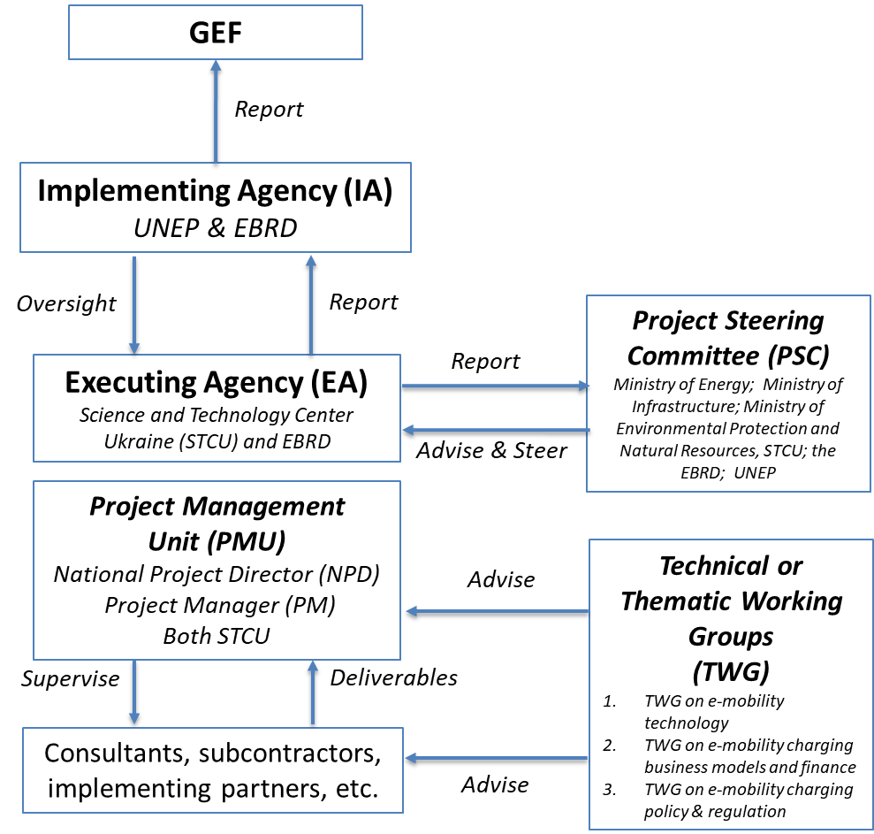

Refer to Annex K for further details on the roles and responsibilities of the Implementing and Executing Agencies.

Coordination with other initiatives:

As described, this project will work closely with the GEF Global Electric Mobility Programme, especially through the Investment Platforms for Central & Eastern Europe as well as the Working Groups of the Global Programme.

The project will also coordinate with:
- The “Transboundary Green Transport Network” (CGTN) project Which is being implemented within the framework of The European Neighborhood Instrument "Hungary-Slovakia-Romania-Ukraine 2014-2020" cross-border cooperation program. The project envisages the installation of 19 charging stations in Ivano-Frankivsk and the partner cities of this project - Baia Mare (Romania), Nyíregyháza (Hungary), Michalovce (Slovakia), Uzhgorod, Mukachevo, Sniatyn, Nadvirna, Yaremche, Kolomyia and Dolyna. The project budget for the four countries is € 280,000.
- The joint Ukraine-South Korea project for the production of charging station for electric vehicles Being led by Caris Co (South Korea), Socrates Development (Ukraine) and the State Financial Institution for Innovation(SFII)).
- The Global Fuel Economy Initiative (GFEI) project to support the introduction of cleaner fuels and vehicles. Implemented by the ISA, this project has developed mechanisms crucial for the tracking of the fuel economy of the new vehicle market and can provide valuable input to the Ukraine GEF E-Mobility project.
- City projects under the IFC’s broader strategy to accelerate economic growth in Ukraine, partly through projects including the modernization of public transport in Kyiv, Mariupol, Lviv and Zaporizhzhia.

7. Consistency with National Priorities

As Ukraine has committed itself to limiting greenhouse gas emissions by joining and ratifying the following international legal agreements:
- United Nations Framework Convention on Climate Change (dated May 9, 1992, New York)
- The Kyoto Protocol (dated December 11, 1997, Kyoto)
- The Paris Agreement (dated December 12, 2015, Paris)

According to Article 9 of the Constitution of Ukraine: "International treaties in force, consented by the Verkhovna Rada of Ukraine as binding, shall be an integral part of the national legislation".

Ukraine has pledged and unconditional and economy wide mitigation target under the Paris Agreement for the year 2030, which envisages GHG emission of at least 40% below 1990 levels, including LULUCF.

Ukraine has not defined a conditional target and is currently working on the definition of the Nationally Determined Contribution (NDC) most likely including a transport sector target.

The project contributes to the objectives and outcomes formulated in the latest UNDAF and in particular to outcome 4.2 “By 2022, national institutions, private business and communities implement gender-responsive policies and practices to achieve sustainable management of natural resources, preservation of ecosystems, mitigation, adaptation to climate change and generation of green jobs” addressing indicators “4.2.2. Share of energy produced from renewable sources in the total final energy consumption (7.3.1 (UA))”, and “4.2.4. Share of population benefited from improved coverage by cost-efficient and sustainable energy in the public sector, disaggregated by sex”.

Sustainable Development Goals

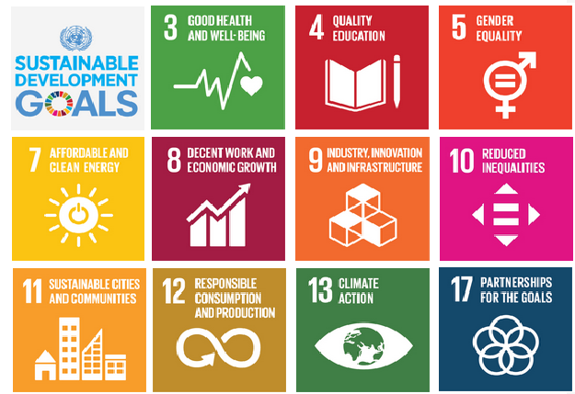

The project contributes to SDG targets:
3.9, 5.5, 7.1, 7.2, 7.3, 7A, 7B, 8.2, 9.2, 9A, 9B, 11.2, 11A, 12.4, 12.7, 13.2, 13.3, 17.6

8. Knowledge Management
The project is part of the global GEF-UNEP Programme on Electric Vehicles which leaded by UNEP and IEA together. It will actively participate in the global programme’s global and regional activities through all components. For example, by participating and contributing to the knowledge exchange in the Regional Support and Investment Platforms for Central & Eastern Europe, West Asia and the Middle East, which will be hosted by the EBRD, and the relevant global working groups of the Global Project, as well as by providing insights and knowledge.

A knowledge management strategy will be developed at the start of the project that will be presented in a written document and shared with all relevant project stakeholders so that they will be part of the development and implementation of the knowledge management component of the project.

STCU, with the support of ISA will collect performance indicators and knowledge products and communicate them to the Regional Support and Investment Platform as well as the Global Programme lead (SMU of UNEP).

Proposed knowledge outputs to be produced and shared with stakeholders

In order to introduce and scale up electric vehicle fleets in Ukraine this project will develop:
- A national e-mobility strategy (D 1.3.3);
- A monitoring framework and data collection methodology to track the progress in implementing E-mobility strategy (D 1.3.4);
- A Gender Analysis (D 1.4.1);
- Selection and assessment criteria for demo project financing (D 2.1.2 and D 2.1.3);
- Feasibility studies for the planning and design of the EV charging infrastructure investment(s) (D 2.1.7);
- GHG emission reduction summary report (D 2.2.2);
- Lessons learnt and recommendations from the financial structure and business models of the demonstration projects (D 2.2.4);
- A series of best practise ‘How to’ guides (D 3.1.2)
- A document outlining the Ukrainian EV charging market structure including all relevant actors and institutions and defining missing legislative terminology (D 3.2.3)
- An interactive map tracking EV charging data and to visualize their current state of use, price information as well as – if possible – power demand load profiles to monitor the EV charging (D 3.2.6)
- Recommendations to Law of Ukraine No. 2754-VIII dated 11 July 2019 to extend fiscal incentives for the electric vehicle market and to define a respective exit strategy (D 3.3.3)
- Proposals for better integration of EV charging into the Ukrainian power grid such as differentiated power tariffs for public and private EV charging (D 4.1.2)
- A study to investigate the further use of EVs for energy storage and grid balancing purposes, including V2G applications (D 4.1.3)
A proposal to collect used EV batteries for re-use, recycling and safe disposal (D 4.2.2)

All the knowledge and lessons will be generated, recorded, and shared at three levels – in the thematic Global Working Groups, the Regional Support and Investment Platform, and in the country project. A KM framework will be set up in the project to capture data and lessons.

The EBRD is hosting the Central & Eastern Europe, West Asia and the Middle East Platform. Therefore, the linkage of this Ukraine Project with the Platform will be close. The Project will benefit from lessons learnt and experience gained to other GEF-funded projects in the region, such as the GEF E-Mobility Projects in Albania, Armenia, Belarus, Jordan and Uzbekistan.

Plans to learn from relevant projects, programs, initiatives& evaluations
The project could learn lessons and best practices from other GEF child projects and the EC SOLUTIONS plus city projects. The global thematic working groups are aimed to develop relevant knowledge, based on demand and based on operating environments of the child projects. The main purpose of the support and investment platforms is to create a community of practice where countries and cities can share experiences and best practices. By inviting non GEF /EC projects to these communities, the opportunities for countries and cities to share experiences and best practices is maximized.

How knowledge and learning will contribute to overall project impact and sustainability
The tools developed, best practices collected, and knowledge generated during the project will continue to be available to country and cities after the project has ended. UNEP, with EC plus partners, will continue with supporting the regional platforms so that these can continue to take the lead in supporting a shift to electric mobility in their respective regions. As non GEF and EC projects will be included in the platforms and the communities of practice from the start of the GEF programme, the platforms will continue after the GEF programme has ended. All knowledge and tools will thus continue to support a shift to electric mobility in these regions.

Plans for strategic communications
As this project will be a part of the first global electric mobility programme, a communication component has been designed to communicate the progress made in this project with global programme and other country projects.

A public awareness campaign on the benefits of electric vehicle introduction will be carried out. The project will also participate two global conferences which will be organized over the course of the GEF7 electric mobility global programme to bring together all stakeholders, including the in-country projects, in collaboration with the EC SOLUTIONS plus project. The first conference will be a global launch of the programme and will be a joint launch of the GEF and EC SOLUTIONS plus. It is expected to involve all partners and other interested organisations, will outline the global programme, and will start developing partnerships and networks. It will also have a communications and media component.

The second global conference will take place at the end of the programme and will showcase progress made by the country projects and the programme more broadly. It will be an additional opportunity to exhibit the knowledge and materials generated by the global thematic platforms. It will also ensure continuation and sustainability of the programme after the 4-year project term expires. It will also communication and media component and will include a press release and press conference.

The programme will develop a communication plan at the start of programme implementation, to list planned communication activities at all three levels, global (working groups & global meetings), regional (platforms) and national level.

9. Monitoring and Evaluation

Monitoring and Evaluation (M&E) activities and related costs are presented in the costed M&E Plan (Annex J) and are fully integrated in the overall project budget.

The project will comply with UN Environment Programme standard monitoring, reporting and evaluation procedures. Reporting requirements and templates are an integral part of the legal instrument to be signed by the Executing Agency and the Implementing Agency

The project M&E plan is consistent with the GEF Monitoring and Evaluation policy. The Project Results Framework presented in Annex A includes SMART indicators for each expected outcome as well as end-of-project targets. These indicators along with the key deliverables and benchmarks included in Annex L will be the main tools for assessing project implementation progress and whether project results are being achieved. The means of verification to track the indicators are summarized in Annex A.

The M&E plan will be reviewed and revised as necessary during the project Inception Workshop (IW) to ensure project stakeholders understand their roles and responsibilities vis-à-vis project monitoring and evaluation. Indicators and their means of verification may also be fine-tuned at the inception workshop. General project monitoring is the responsibility of the Project Management Unit (PMU) but other project partners could have responsibilities in collecting specific information to track the indicators. It is the responsibility of the Project Manager to inform UN Environment Programme of any delays or difficulties faced during implementation so that the appropriate support or corrective measures can be adopted in a timely fashion.

The project Steering Committee (PSC) will receive periodic reports on progress and will make recommendations to UN Environment Programme concerning the need to revise any aspects of the Results Framework or the M&E Plan. Project oversight to ensure that the project meets UN Environment Programme and GEF policies and procedures is the responsibility of the UN Environment Programme Task Manager. The UN Environment Programme Task Manager will also review the quality of draft project outputs, provide feedback to the project partners, and establish peer review procedures to ensure adequate quality of scientific and technical outputs and publications.

Project supervision will take an adaptive management approach. The UN Environment Programme Task Manager will develop a project Supervision Plan at the inception of the project, which will be communicated to the Project Management Unit and the project partners during the Inception Workshop. The emphasis of the Task Manager’s supervision will be on outcome monitoring but without neglecting project financial management and implementation monitoring.

Progress vis-à-vis delivering the agreed project global environmental benefits will be assessed with the Steering Committee at agreed intervals. Project risks and assumptions will be regularly monitored both by the Project Management Unit, the project partners and UN Environment. Risk assessment and rating is an integral part of the Project Implementation Review (PIR). The PIR will be completed by the Project Manager and ratings will be provided by UN Environment’s Task Manager. The EBRD will provide inputs to the PIR related to implementation of Component 2. The quality of project monitoring and evaluation will also be reviewed and rated as part of the PIR. UN Environment’s Task Manager will have the responsibility of verifying the PIR and submitting it to the GEF. Key financial parameters will be monitored quarterly to ensure cost-effective use of financial resources.

A Mid-Term Evaluation (MTE) will be undertaken as it is a four year project. This review will include all parameters recommended by the GEF Evaluation Office for Terminal Evaluations (TE) and will verify information gathered through the GEF tracking tools, as relevant. The review will be carried out using a participatory approach whereby parties that may benefit or be affected by the project will be consulted. Such parties were identified during the stakeholder analysis (see section 2 above). Members of the project Steering Committee could be interviewed as part of the MTR process and the Project Manager will develop a management response to the review recommendations along with an implementation plan. Results of the MTR will be presented to the Project Steering Committee. It is the responsibility of the UN Environment Programme Task Manager to monitor whether the agreed recommendations are being implemented.

The Terminal Evaluation will be managed jointly by UNEP and EBRD Evaluation Offices. The UNEP Evaluation Office will, however, lead the Terminal Evaluation (TE) and will liaise with the IUCN Evaluation Office throughout the process. Key decision points in the evaluation process will be made jointly by the Evaluation Offices in a collaborative manner [finalisation of Evaluation ToRs, selection of evaluation consultants, review of draft report and acceptance of final report].

The Terminal Evaluation will provide an independent assessment of project performance (in terms of relevance, effectiveness and efficiency), and determine the likelihood of impact and sustainability. It will have two primary purposes: (i) to provide evidence of results to meet accountability requirements, and (ii) to promote learning, feedback, and knowledge sharing through results and lessons learned among UNEP, EBRD and GEF, executing partners and other stakeholders. The direct costs of the evaluation will be charged against the project evaluation budget. The UNEP Task Manager will inform the UNEP Evaluation Office of the approaching Terminal Evaluation one year before the operational completion of the project.

The Terminal Evaluation report will be sent to project stakeholders for comment. Formal comments on the report will be shared by the Evaluation Offices in an open and transparent manner. The project performance will be assessed against standard evaluation criteria using a six-point rating scheme. The final determination of project ratings will be made by the Evaluation Offices of UNEP and EBRD when the report is finalised. The evaluation report will be publicly disclosed and will be followed by a recommendation compliance process”.

The GEF Core Indicator Worksheet is attached as Annex F. It will be updated at mid-term and at the end of the project and will be made available to the GEF Secretariat along with the project PIR report. As mentioned above, the MTR/MTE and TE will verify the information of the tracking tool.

The direct costs of reviews and evaluations will be charged against the project evaluation budget. A summary of M&E activities envisaged is provided in Annex J. The GEF contribution for this project’s M&E activities (including audits and evaluations) is US$ 60,000

10. Benefits
In conjunction with the substantial CO₂ emission reductions, a significant reduction of the emissions of air pollutants such as NOx, SOx, PM and CO will be achieved, as electric vehicles will not generate any such pollutant emissions. Since the demonstration will be carried out in urban areas, the project will also contribute to improved urban air quality, better human health and reduced related deaths.

In addition, the programme will contribute to significant cost reductions resulting from reduced expenditures by (country) on fuel imports, since the consumption of petroleum-based fuels will be reduced due to the increased deployment of electric vehicles. Therefore, the project is also expected to improve energy security within (country), since the share of local energy resources used in the transport sector will grow and dependency on imported fuels will decrease.

This project will focus on batteries used for electric vehicles, including issues with respect to the re-use, recycling and safe disposal of used EV batteries. Thus, the project not only looks into the mitigation of GHG and air pollutant emissions but also anticipates emerging environmental issues stemming from a large-scale market introduction of electric vehicles and seeks to develop strategies and policies to mitigate the associated risks.

This project will carry out study on the options to link-up with better integration of variable renewable power in grids for electric vehicle recharging. To that end, the project may result in additional GHG emissions reduction stemming from the possible enabling role of electric mobility for the up-scaled integration of variable renewable power.

Currently, electric vehicles numbers are still modest, and, with the exception of China, are concentrated in OECD countries. However, there is significant demand from other countries to start introducing electric mobility and be part of the global introduction and shift to electric mobility. Given the environmental and economic benefits, there is a large potential to bring EVs to all markets around the world. In terms of economic benefits, the introduction of electric vehicles in (country) not only reduces oil expenditures but also opens a pathway to increased industrialization, since the lower complexity of EVs might provide the leeway to locate vehicle manufacturing and assembling to parts of the world where this has not occurred to date. As such the growth in electric vehicles is predicted to be a major driver for the creation of a new green industry with green jobs. Early involvement of developing countries in the electrification of the global vehicle fleet will facilitate these countries to develop manufacturing and assembling opportunities.

PART III: CERTIFICATION BY GEF PARTNER AGENCY(IES)
GEF Agency(ies) certification

This request has been prepared in accordance with GEF policies and procedures and meets the GEF criteria for CEO endorsement under GEF-7.

Agency Coordinator, Agency Name | Signature | Date  (MM/dd/yyyy) | Project Contact Person | Telephone | Email Address
Kelly West,  Senior Programme Manager  & Global Environment Facility Coordinator  Corporate Services Division  UN Environment |  | 26.02.2021 | Sudhir Sharma | +662-288-1441 | sharma66@un.org

PART IV: ANNEXES

The CEO Endorsement Document annexes may be found in the following pages.

Annex A: Project Results Framework

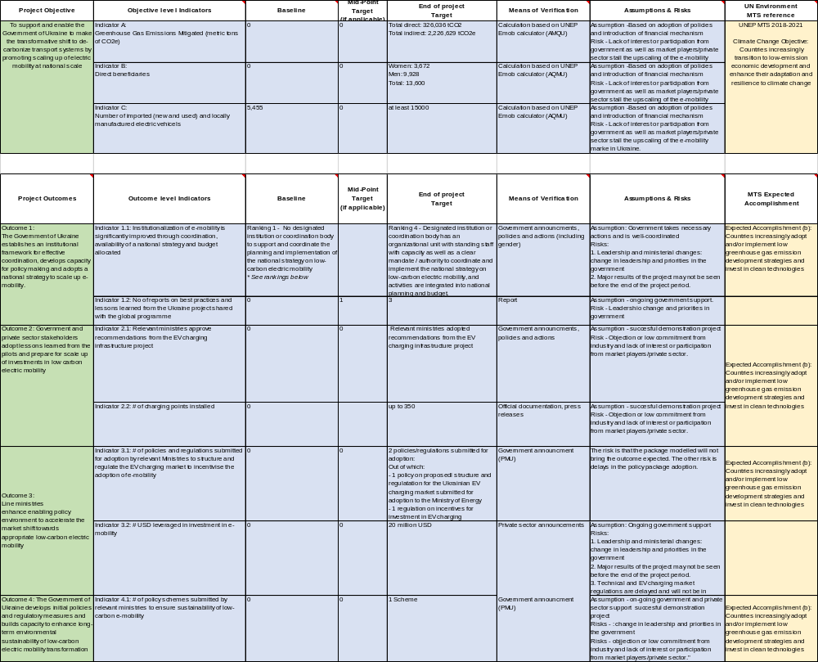

Annex B: Response to Project Reviews

Please refer to the separate pdf files which include all responses to the GEF’s reviews:

Annex B.1 – Responses to GEF Sec reviews (on the PFD)
Annex B.2 – Responses to GEF Sec reviews (on the PFD addendum)
Annex B.3 – Responses to STAP comments
Annex B.4 – Responses to Council comments

Annex C: Status of Utilization of Project Preparation Grant (PPG)

Provide detailed funding amount of the PPG activities financing status in the table below:

PPG Grant Approved at PIF: US$
Project Preparation Activities Implemented | GETF/LDCF/SCCF Amount (US$)
Project Preparation Activities Implemented | Budgeted Amount | Amount Spent  to date | Amount  Committed
AQM Unit Personnel and Agreement with the country | 50,000 | 44,513.14 | 5,486.86
Total | 50,000 | 44,513.14 | 5,486.86

If at CEO Endorsement, the PPG activities have not been completed and there is a balance of unspent fund, Agencies can continue to undertake exclusively preparation activities up to one year of CEO Endorsement/approval date. No later than one year from CEO endorsement/approval date. Agencies should report closing of PPG to Trustee in its Quarterly Report.

Annex D: Calendar of Expected Reflows (if non-grant instrument is used)

Provide a calendar of expected reflows to the GEF/LDCF/SCCF Trust Funds or to your Agency (and/or revolving fund that will be set up) – if applicable.

Not applicable.

Annex E: Project Map(s) and Coordinates

Demonstration sites | Latitude | Longitude
Ukraine (exact pilot sites for charging infrastructure will be determined after feasibility assessment).  The project is not expected to cause any disputes on land use between Ukraine and its neighbouring countries. | 48° 22' 58.88" N | 31° 10' 58.33"

Annex F: GEF 7 Core Indicator Worksheet

Core Indicator 6 | Greenhouse gas emission mitigated
 |  |  | Tons (6.2) (6.1 emissions from AFOLU do not apply)
 |  |  | Entered |  |  |  | Entered
 |  |  | PIF stage | Endorsement |  |  | MTR |  |  | TE
 | Expected CO2e (direct) |  | 4,244,209 | 326,036
 | Expected CO2e (indirect) |  | 642,402 | 2,226,629
Indicator 6.2 | Emissions avoided
 |  |  | Tons
 |  |  | Expected |  |  |  |  | Achieved
 |  |  | PIF stage |  | Endorsement |  |  | MTR |  | TE
 | Expected CO2e (direct) |  | 4,244,209 |  | 326,036
 | Expected CO2e (indirect) |  | 642,402 |  | 2,226,629
 | Anticipated Year |  | 2035 |  | 2036
Indicator 6.3 | Energy saved
 |  |  | MJ
 |  |  | Expected |  |  |  |  | Achieved
 |  |  | PIF stage |  | Endorsement |  |  | MTR |  | TE
 |  | Expected direct | 49,073,720,2011 |  | 3,769,796,857
 |  | Expected indirect | 7,427,7874,446 |  | 154,472,563,844
Indicator 6.4 | Increase in installed renewable energy capacity per technology
 |  | Technology | Capacity (MW)
 |  | Technology | Expected |  |  |  |  | Achieved
 |  | Technology | PIF stage |  | Endorsement |  |  | MTR |  | TE
Core Indicator 11 | Number of direct beneficiaries disaggregated by gender as co-benefit of GEF investment
 |  |  | Number
 |  |  | Expected |  |  |  |  |  | Achieved
 |  |  | PIF stage |  |  | Endorsement |  |  | MTR |  | TE
 |  | Female |  |  |  | 3,632
 |  | Male |  |  |  | 9,928
 |  | Total |  |  |  | 13,600

Annex G: GEF Project Taxonomy Worksheet

Level 1 | Level 2 | Level 3 | Level 4
☒Influencing models
 | ☒Transform policy and regulatory environments
 | ☒Strengthen institutional capacity and decision-making
 | ☒Convene multi-stakeholder alliances
 | ☒Demonstrate innovative approaches
 | ☒Deploy innovative financial instruments
☒Stakeholders
 | ☒Private Sector
 |  | ☒Capital providers
 |  | ☒Financial intermediaries and market facilitators
 |  | ☒Large corporations
 |  | ☒SMEs
 |  | ☒Individuals/Entrepreneurs
 | ☒Civil Society
 |  | ☒Community Based Organization
 |  | ☒Non-Governmental Organization
 |  | ☒Academia
 | ☒Type of Engagement
 |  | ☒Information Dissemination
 |  | ☒Partnership
 |  | ☒Consultation
 |  | ☒Participation
 | ☒Communications
 |  | ☒Awareness Raising
 |  | ☒Education
 |  | ☒Public Campaigns
 |  | ☒Behavior Change
☒Capacity, Knowledge and Research
 | ☒Capacity Development
 | ☒Knowledge Generation and Exchange
 | ☒Innovation
 | ☒Knowledge and Learning
 |  | ☒Knowledge Management
 |  | ☒Innovation
 |  | ☒Capacity Development
 |  | ☒Learning
☒Gender Equality
 | ☒Gender Mainstreaming
 |  | ☒Beneficiaries
 |  | ☒Women groups
 | ☒Gender results areas
 |  | ☒Access to benefits and services
 |  | ☒Knowledge generation
 | ☒Chemicals and Waste
 |  | ☒Emissions
 |  | ☒ Disposal
 | ☒Climate Change
 |  | ☒Climate Change Mitigation
 |  |  | ☒Energy Efficiency
 |  |  | ☒Sustainable Urban Systems and Transport
 |  | ☐Climate Finance (Rio Markers)
 |  |  | ☒Climate Change Mitigation 2

Annex H: INDICATIVE Terms of Reference for Project Personnel, Consultants and Subcontracts
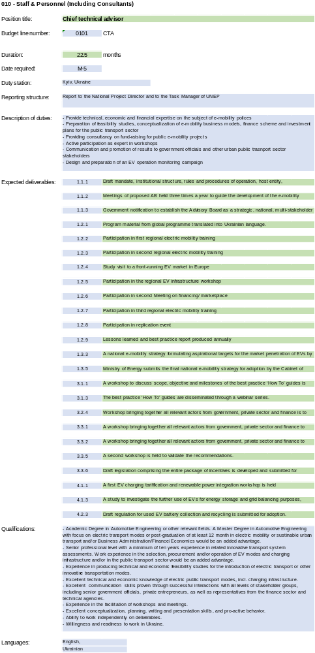
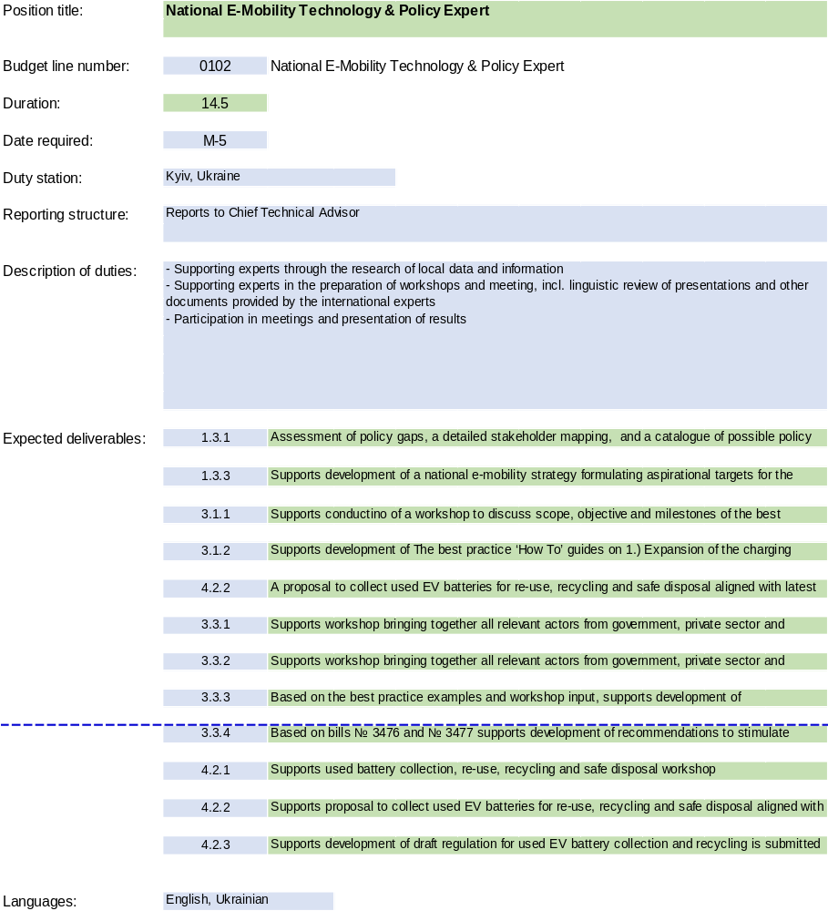

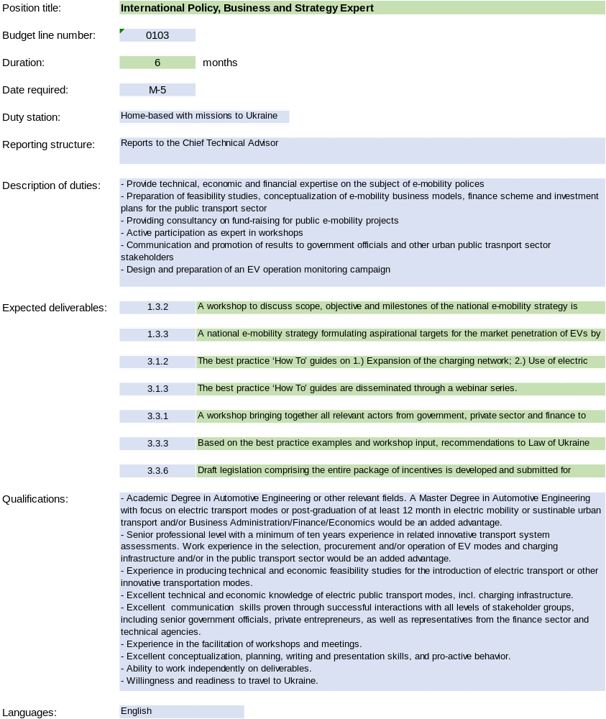
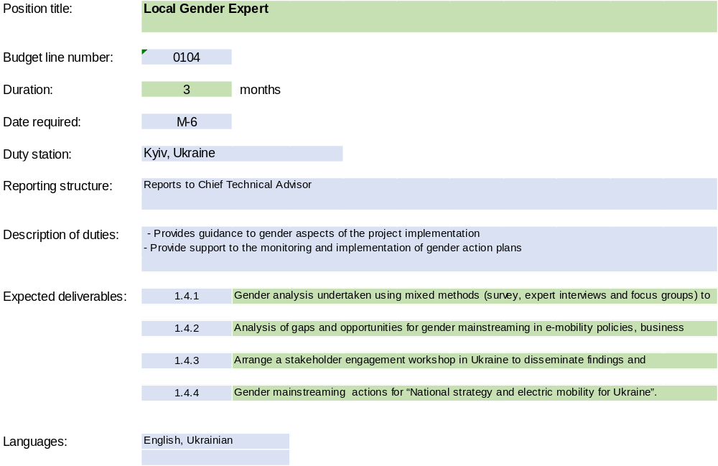
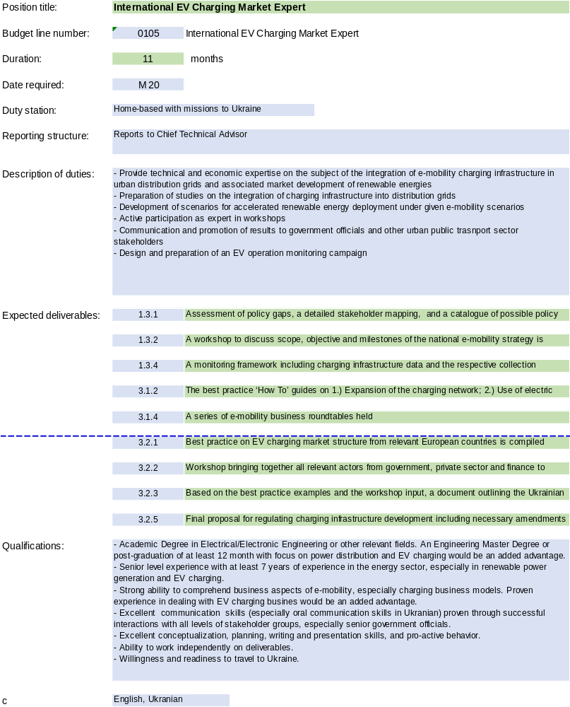
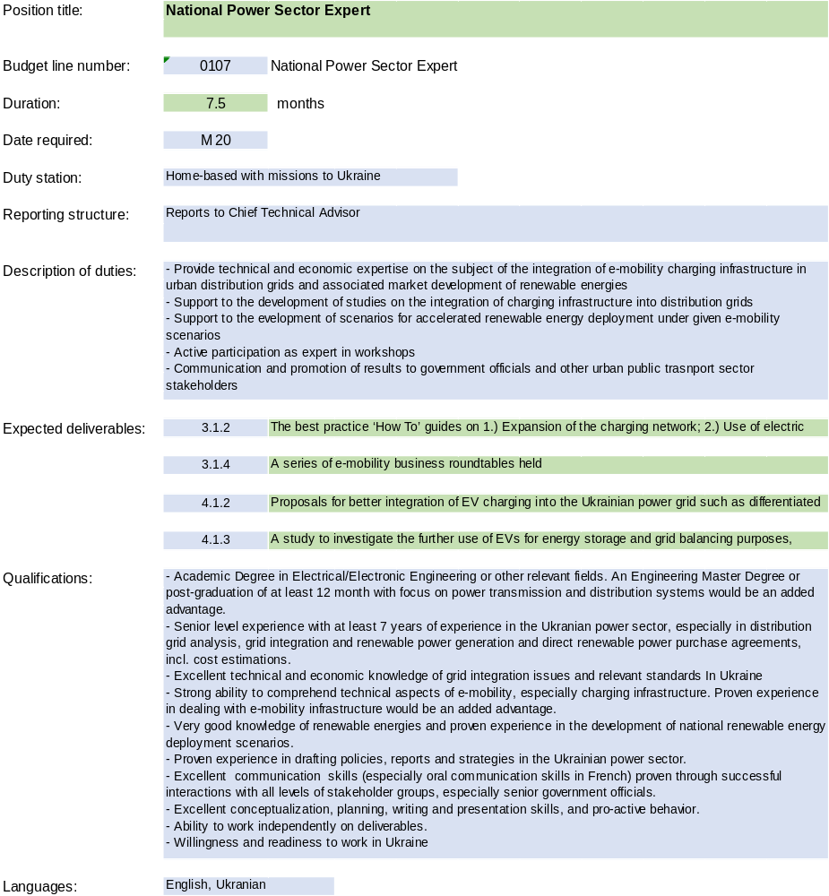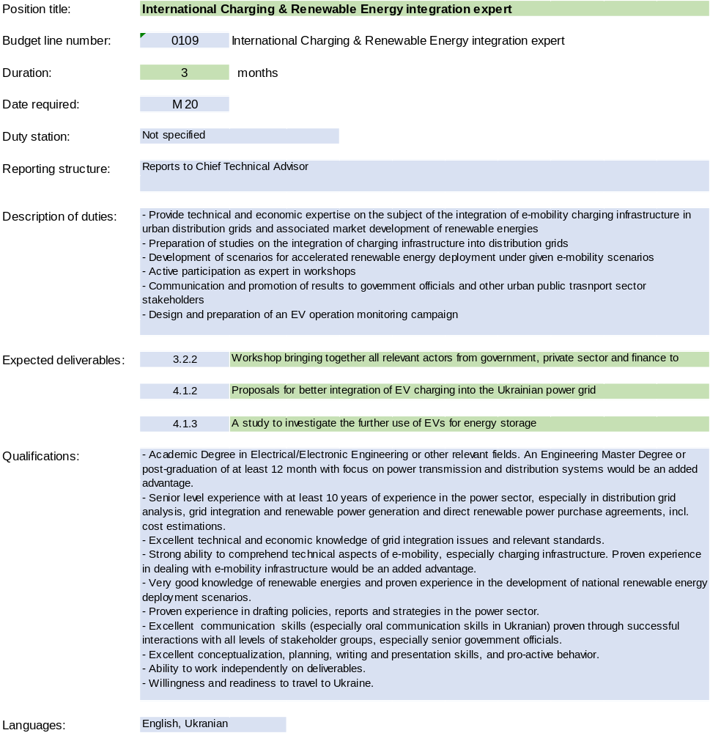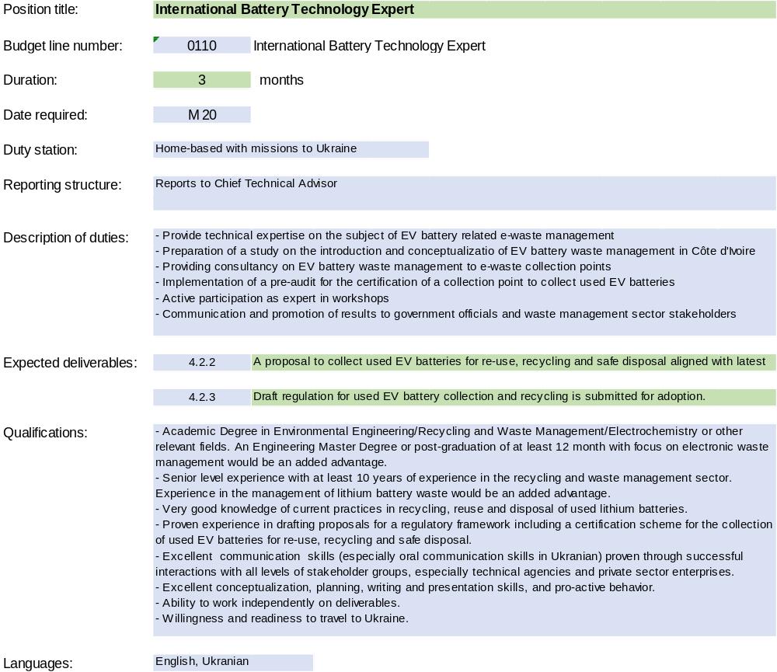

Annex I-1 Detailed GEF budget
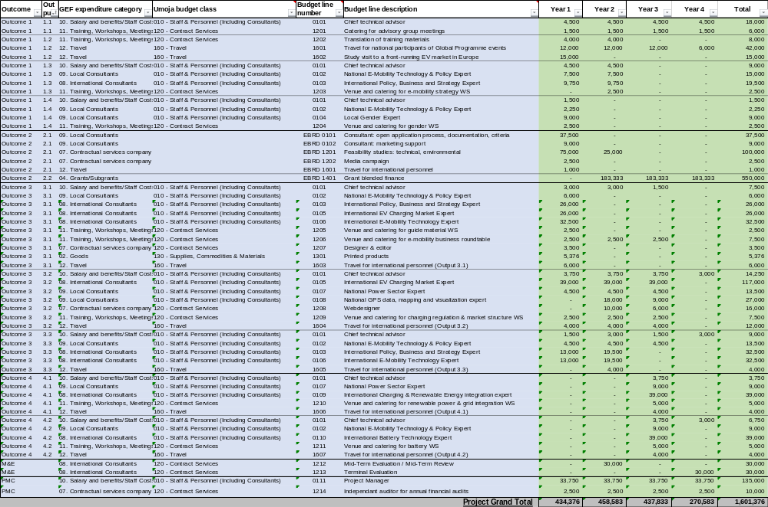

Annex I-2 Detailed Co-finance budget
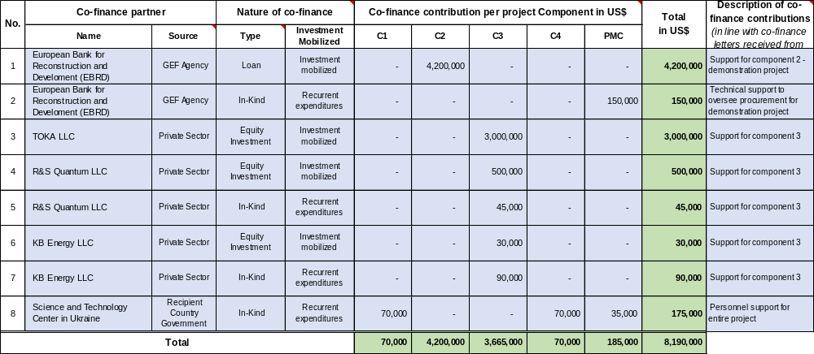

Annex J: M&E Budget and Workplan

M&E Activity | Description | Responsible Parties | Timeframe | Indicative budget (USD)
Inception Workshop (IW) | Report prepared following the IW; which includes:  - A detailed workplan and budget for the first year of project implementation,  - An overview of the workplan for subsequent years, divided per component, output and activities.  - A detailed description of the roles and responsibilities of all project partners  - A detailed description of the PMU and PSC, including an organization chart  - Updated Procurement Plan and a M&E Plan, Gender Action Plan  - Minutes of the Inception Workshop | Execution: PM (or CTA)  Support: PM | 1 report to be prepared following the IW, to be shared with participants 4 weeks after the IW (latest) | GEF: as part of PM / CTA budget
Steering Committee Meeting | Prepare minutes for every Steering Committee Meeting. | Execution: PM (or CTA)  Support: | At least 1 per year  Minutes to be submitted 1 week following each PSC meeting | GEF: as part of PM / CTA budget
Half-yearly progress report | Part of UN Environment Programme requirements for project monitoring.  - Narrative of the activities undertaken during the considered semester  - Analyzes project implementation progress over the reporting period;  - Describes constraints experienced in the progress towards results and the reasons. | Execution: PM (or CTA)  Support: PMU | Two (2) half-yearly progress reports for any given year, submitted by July 31 and January 31 (latest) | GEF: as part of PM / CTA budget
Quarterly expenditure reports | Detailed expenditure reports (in excel) broken down per project component and budget line, with explanations and justification of any change | Execution: PM (or CTA) and Financial Officer  Support: PMU | Four (4) quarterly expenditure reports for any given year, submitted by January 31, April 30, July 31 and October 31 (latest) | GEF: as part of PM / CTA budget
Project Implementation Review (PIR) | Analyzes project performance over the reporting period. Describes constraints experienced in the progress towards results and the reasons. Draws lessons and makes clear recommendations for future orientation in addressing the key problems in the lack of progress.  The PIRs shall be documented with the evidence of the achievement of end-of-project targets (as appendices). | Execution: PM (or CTA) and TM  Support: PMU | 1 report to be prepared on an annual basis, to be submitted by 15 July latest | GEF: as part of PM / CTA budget
Annual Inventory of Non-expendable equipment | Report with the complete and accurate records of non-expendable equipment purchased with GEF project funds | Execution: PM (or CTA)  Support: PMU | 1 report per year as of 31 December, to be submitted by 31 January latest | GEF: as part of PM / CTA budget
Co-financing Report | Report on co-financing (cash and/or in-kind) fulfilled contributions from all project partners that provided co-finance letters. | Execution: PM (or CTA)  Support: co-finance partners | 1 annual report from each co-finance partner, and 1 consolidated report, to be submitted by 31 July latest | GEF: as part of PM / CTA budget
Medium-Term Evaluation (MTE) / Medium-Term Review (MTR) | The purpose of the MTE or MTR is to provide an independent assessment of project performance at mid-term, to analyze whether the project is on track, what problems and challenges the project is encountering, and which corrective actions are required so that the project can achieve its intended outcomes by project completion in the most efficient and sustainable way. It will verify information gathered through the GEF tracking tools. | Execution: Independent Evaluator / TM  Support: PM (or CTA), PMU | At mid-point of project implementation if deemed needed by the Task Manager | GEF:  US$ 30,000
Final Report | The project team will draft and submit a Project Final Report, with other docs (such as the evidence to document the achievement of end-of-project targets).  Comprehensive report summarizing all outputs, achievements, lessons learned, objectives met or not achieved structures and systems implemented, etc. Lays out recommendations for any further steps to be taken to ensure the sustainability and replication of project outcomes. | Execution: PM (or CTA)  Support: PMU | Final report to be submitted no later than three (3) months after the technical completion date | GEF: as part of PM / CTA budget
Terminal Evaluation (TE) | Further review the topics covered in the mid-term evaluation.  Looks at the impacts and sustainability of the results, including the contribution to capacity development and the achievement of global environmental goals. | Execution: Independent Evaluator / TM  Support: PM (or CTA), PMU | Can be initiated within six (6) months prior to the project’s technical completion date | GEF:  US$ 30,000
TOTAL M&E COST |  |  | GEF: US$ 60,000

Annex K: Project Implementation Arrangements

The project is funded by the Global Environment Facility (GEF) with UN Environment Programme and EBRD acting as the GEF Implementing Agencies and STCU and the EBRD as the Executing Agencies. The implementation structure is illustrated in the organogram below:

Roles and responsibilities of each bodies are detailed in the following table:

Body | Composition | Role and description | Frequency of meetings
Project Steering Committee (PSC) | STCU (EA)  UNEP (IA, lead)  EBRD (IA)  ISA  Ministry of Environmental Protection and Natural Resources  Ministry of Energy  Ministry for Infrastructure | - Oversight of the project progress and implementation of Outputs;  - Approve workplans and budget revisions;  - Approve management decisions to ensure timely delivery of quality outputs;  - Provide overall guidance and strategic direction;  - Enhance and optimize the contributions of various partner organizations through coordination of all activities and inputs  - The STCU will appoint a National Project Director (NPD) that will act as the PSC Chairperson  - The Project Manager (PM) will act as the PSC Secretary | Once a year
Implementing GEF Agency (IA) | UNEP, lead IA | - Ensure timely disbursement/sub-allotment to executing agency based on agreed legal document and in accordance with UN Environment Programme and GEF fiduciary standards;  - Follow-up with Executing agency for progress, equipment, financial and audit reports;  - Provide consistent and regular oversight on project execution and conduct project supervisory missions as per Supervision Plans and in doing so ensures that all UN Environment Programme and GEF criteria, rules and regulations are adhered to by project partners;  - Conduct monitoring and evaluation as per UNEP guidelines  - Technically assess and oversee quality of project outputs, products and deliverables – including formal publications;  - Provide no-objection to main TORs and subcontracts issued by the project, including selection of the Chief Technical Advisor;  - Attend and facilitate inception workshops, field visits where relevant, and selected steering committee meetings;  - Assess project risks, and monitor and enforce a risk management plan;  - Regularly monitor project progress and performance and rate progress towards meeting project objectives, project execution progress, quality of project monitoring and evaluation, and risk;  - Monitor reporting by project executing partners and provide prompt feedback on the contents of the report;  - Promptly inform the management of any significant risks or project problems and take action and follow up on decisions made;  - Apply adaptive management principles to the supervision of the project;  - Review of reporting, checking for consistency between execution activities and expenditures, ensuring that it respects GEF rules;  - Clear cash requests, and authorization of disbursements once reporting found to be complete;  - Approve budget revision, certify fund availability and transfer funds;  - Ensure that GEF and UN Environment Programme quality standards are applied consistently to all projects, including branding and safeguards;  - Certify project operational completion;  - Link the project partners to any events organized by GEF and UN Environment Programme to disseminate information on project results and lessons;  - Manage relations with GEF. | Periodic meetings (calls) with the EA’s Project Management Unit (PMU), at least once per month
Implementing GEF Agency (IA) | EBRD, co-IA | - Provide input to lead IA (UNEP) for progress, equipment, financial and audit reports;  - Technically assess and oversee quality of respective project outputs, products and deliverables – including formal publications;  - Attend and facilitate inception workshops, field visits where relevant, and selected steering committee meetings;  - Asses respective project risks, and monitor and enforce a risk management plan;  - Regularly monitor project progress and performance and rate progress towards meeting project objectives, project execution progress, quality of project monitoring and evaluation, and risk and report to UNEP;  - Promptly inform the management of any significant risks or project problems and take action and follow up on decisions made;  - Apply adaptive management principles to the supervision of the project;  - Review of reporting, checking for consistency between execution activities and expenditures, ensuring that it respects GEF rules;  - Clear cash requests, and authorization of disbursements once reporting found to be complete;  - Approve budget revision, certify fund availability and transfer funds;  - Ensure that GEF and UN Environment Programme quality standards are applied consistently to all projects, including branding and safeguards;  - Certify project operational completion;  - Link the project partners to any events organized by GEF and UN Environment Programme to disseminate information on project results and lessons;
Executing Agency (EA) | STCU | - Ensure that the project meets its objectives and achieves expected outcomes;  - Ensure technical execution according to the execution plan laid out in the project document;  - Ensure technical quality of products, outputs and deliverables;  - Ensure compilation and submission of progress, financial and audit reporting to IA;  - Submit budget revisions to IA for approval;  - Address and propose solutions to any problem or inconsistency raised by the IA;  - Bring issues raised by or associated with clients to the IA for resolution;  - Facilitate meetings of Steering Committees and other oversight bodies of the project;  - Day to day oversight of project execution;  - Submit all technical reports and completion reports to IA (realized outputs, inventories, verification of co-finance, terminal reporting, etc.);  - Monitoring and evaluation of the project outputs and outcomes;  - Effective use of both international and national resources  - Timely availability of financing to support project execution;  - Proper coordination among all project stakeholders; in particular national parties;  - Timely submission of all project reports, including work plans and financial reports,  - Follow-up with, or progress, procurement, financial and audit reports. | Periodic meetings (calls) with the IA’s Task Manager, at least once per month
 | EBRD | - Ensure that the project meets its objectives and achieves expected outcomes;  - Ensure technical execution according to the execution plan laid out in the project document;  - Ensure technical quality of products, outputs and deliverables;  - Ensure compilation and submission of progress and financial reports to lead IA;  - Participate meetings of Steering Committees and other oversight bodies of the project;  - Day to day oversight of project execution;  - Submit all technical reports and completion reports to lead IA (realized outputs, inventories, verification of co-finance, terminal reporting, etc.);  - Effective use of both international and national resources  - Timely availability of financing to support project execution;  - Proper coordination among all project stakeholders; in particular national parties;  - Timely submission of all project reports, including work plans and financial reports,  Follow-up with, or progress, procurement, financial and audit reports
Project Management Unit (PMU) | National Project Director (NPD), | - Will be a national/governmental officer appointed by the STCU;  - Act as the PSC’s Chairperson;  - Report to and receive advice from the PSC;  - Identify and secure partner support for the implementation of project activities;  - Advise on hiring process.  - Act as the project’s entry point within the government of Ukraine | Regular meetings with the PM (or CTA), at least twice per month
Project Management Unit (PMU) | Project Manager (PM) | The PM (or CTA) will be recruited externally, paid with GEF funds, hosted within the [Executing Agency name] premises and have the following duties:  - Take responsibility for day-to-day project operations;  - Take responsibility for the execution of the project in accordance with the project objectives, activities and budget;  - Deliver the outputs and demonstrate its best efforts in achieving the project outcomes;  - Coordinate project execution and liaison with national counterparts (relevant ministries, national agencies, private sector, NGOs etc.);  - Manage financial resources and processing all financial transaction relating to sub-allotments;  - Prepare all annual/year-end project revisions;  - Attend and facilitate inception workshops and national project steering committee meetings;  - Assess project risks in the field, monitor risk management plan;  - Ensure technical quality of products, outputs and deliverables;  - Coordinate the project team of consultants and subcontractors;  - Coordinate with strategic taskforces (i.e., thematic or technical working groups);  - Act as Secretary of the PSC;  - Plan and organize the PSC annual meetings;  - Periodic reporting to UN Environment Programme and the PSC for allocation of the GEF grant according to the approved workplan and budget, in coordination with UN Environment Programme and NPD;  - Notify UN Environment Programme and the PSC in writing if there is need for modification to the agreed implementation plan and budget, and to seek approval;  - Address and rectify any issues or inconsistencies raised by the Implementing Agency;  - Support compilation and submission of progress, financial and audit reporting to the Implementing Agency;  - Prepare, at the end of the project, the project Final Report. | Regular meetings with the NPD, at least twice per month  Quarterly meeting with the project’s Financial Officer  Ad-hoc meetings with project team members (consultants, subcontractors, etc.)
Technical (or Thematic) Working Groups | E-mobility charging station technology and operation  E-mobility policy and finance  E-mobility and sustainability | - E-mobility technology, including experts from private sector as well as the local petroleum fuel distributor hosting the charging stations;  - E-mobility policy and finance, including representatives from finance institutions, government and private sector.  - E-mobility and sustainability, including representative’s government and technical experts

Annex L: Project Workplan and Deliverables
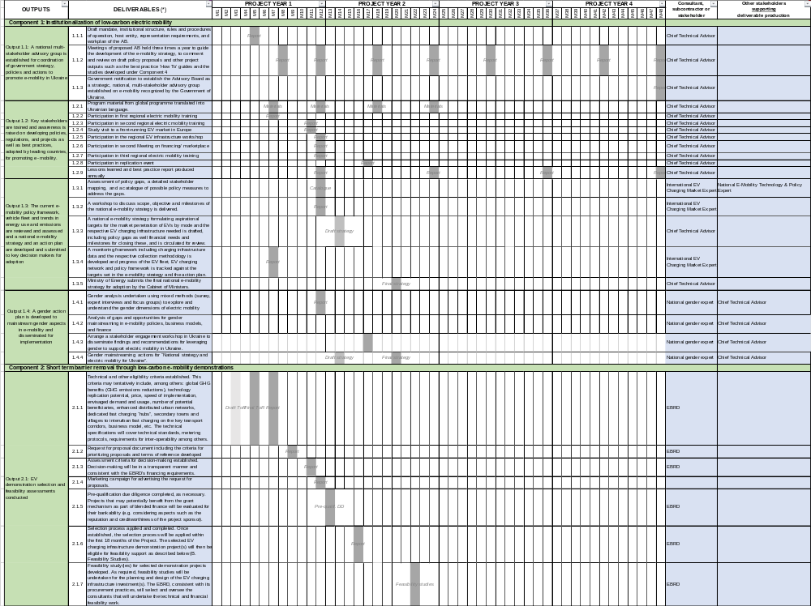
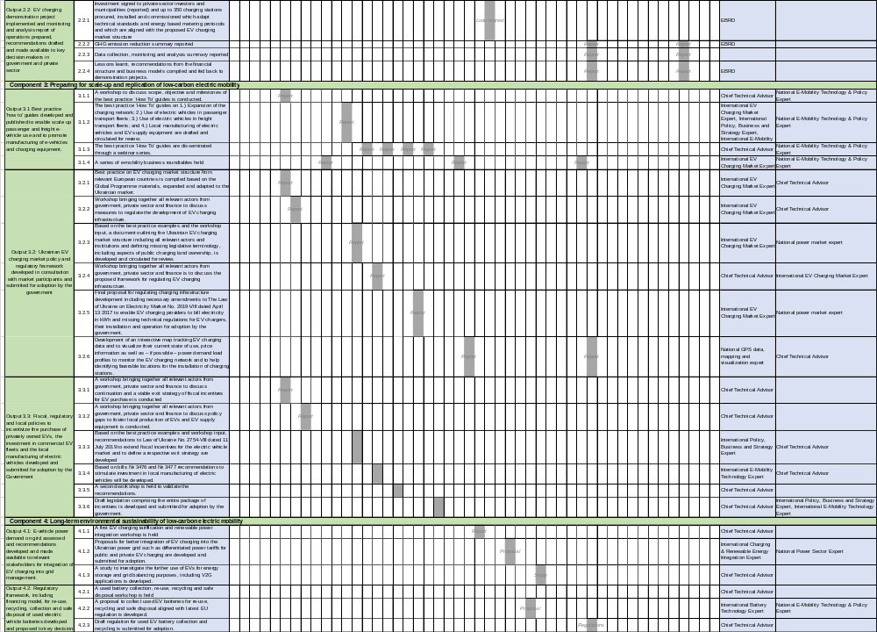

Annex M: Estimates of Direct and Consequential Greenhouse Gas Emission Reductions

Total top-down emission mitigation potential, tCO2 |  | 12,763,327
Thereof attributable to the project:
Total direct emission mitigation from demonstration, tCO2 |  | 47,426
Total secondary direct emission mitigation, tCO2 |  | 278,610
Total indirect emission mitigation, tCO2 |  | 2,226,629
Total project related emissions reductions, tCO2 |  | 2,552,665

Methodology for the estimation of GHG reductions and energy savings benefits

A uniform methodology was applied in all GEF Global E-Mobility Child Projects for assessing the short, medium and long-term benefits in terms of GHG emission reductions and energy savings. The methodology compares two scenarios, the “benchmark scenario” and the “e-mobility scenario”. In the benchmark scenario, the transport sector evolves assuming a “business as usual” behaviour with regards to vehicle fleet growth, vehicle use, technology and fuel use. It is based on the current policy framework with no or limited incentives to buy and use clean and efficient electric vehicles. The e-mobility scenario uses the same projections with regards to vehicle fleet growth but assumes a high penetration of electric vehicles within the new vehicle market, as a consequence of the project interventions including the adoption of EV policies, the use of business models and the existence of financial mechanisms. The scenarios are use a “top-down approach” targeting the national vehicle market. The Child Projects tackle the introduction of electric vehicles for one or multiple modes. In the latter case, calculations are performed for several modes (e.g., passenger cars, buses and 2&3 wheelers).

Projections of fleet growth, energy use and GHG emissions are based on country specific data, and region-specific parameters. Projection of the vehicle fleet growth is based on the elastic relationship between per capita income and vehicle acquisition. Therefore, country specific scenarios for population growth (based on the UNDESA medium scenario) and projections for gross domestic product (GDP PPP) from the World Economic Outlook of the International Monetary Fund (IMF) are used. Vehicle fleet projections are based on vehicle sales and assumptions on technical lifetime of vehicles. A comprehensive set of parameters describing the technologic and economic parameters of various vehicle technologies are used. Country specific grid emission factors for the carbon footprint of electricity are used. For petroleum-based fuels, well-to-wheel emission factors are used. Historic development of the vehicle fleet is based on country specific vehicle stock and sales data. Emission reductions which accrued during and after the project timeframe are taken into account. GHG emission benefits are classified as direct and indirect GHG emission reductions. This categorization follows the methodology suggested by the GEF.

Direct benefits correspond to the GHG emission reductions and energy savings obtained from 1.) The investments that are planned and executed during the project lifetime, i.e., the emission and energy use savings stemming from the demonstration of electric vehicles and EV supply equipment such as chargers purchased as part of the project. In the case of the Ukraine project, direct emission reductions are based on the amounts of electricity sold through the use of the demonstrated chargers and consequently the kilometres driven with EVs substituting and equal amount of kilometres driven using conventional vehicles and therefore reducing CO2 emissions (net CO2 savings based on petroleum fuel emissions saved minus power generation emissions emitted); and 2.) emission reductions and energy savings as a result of investment in replication and upscaling (secondary direct benefits). In the case of the Ukraine, secondary direct emissions are the vehicle life-time emission savings from newly added EVs to the fleet as a result of a denser charging network. To estimate the new EV fleet induced by the expansion of the charging network the ratio of EVs per charger as stated by the IEA in its 2017 Global EV Outlook of 250 vehicles per fast charger and 15 vehicles per slow charger have been applied. With and anticipated installation of 320 slow chargers and 32 fast chargers, the resulting EV fleet induced would account for 4,800 vehicles for the slow chargers and 8,000 vehicles for the fast charger. The higher value of 8,000 vehicles induced by the densified fast charging network has been used to estimate secondary direct emission benefits.

Indirect benefits correspond to the GHG reductions and energy savings obtained during and beyond the project as the result of outputs and outcomes of the project. This includes in particular the adoption of policies, business models and financial mechanisms, which incentivize the uptake of electric mobility. Total emission reductions attributable to the project are based on the cumulative sum of annual emission reductions compared to the baseline scenario over a time frame equivalent to the lifetime of the demonstration assets purchased as part of the project or for a period of ten years after the end of the project.

Quantification of indirect benefits is based on an e-mobility scenario considering the maximum realizable electric mobility market (both in terms of size and pace of technology introduction). Causality factors are used to estimate the contribution of the GEF funded project to the projected large-scale and nation-wide introduction of electric vehicles. Guidelines issued by the GEF for the selection of the causality factor level are as following:

- Level 5 = “The project contribution is critical, and nothing would have happened in the benchmark scenario,” causality factor = 100%
- Level 4 = “The project contribution is dominant, but some of this reduction can be attributed to the benchmark scenario,” causality factor = 80%
- Level 3 = “The project contribution is substantial, but modest indirect emission reductions can be attributed to the benchmark scenario,” causality factor = 60%
- Level 2 = “The project contribution is modest, and substantial indirect emission reductions can be attributed to the benchmark,” causality factor = 40%
- Level 1 = “The project contribution is weak, and most indirect emission reductions can be attributed to the benchmark scenario,” GEF causality = 20%

In the case of the Ukraine, a level 1 causality factor has been applied to estimate the indirect emission reduction attributable to the project and based on the national, top-down light-duty vehicle e-mobility scenario anticipating EV penetration as outlined under section 6.

A selection of the parameters and variables to describe the benchmark and the e-mobility scenario are shown in Table 5, a flow diagram of the e-mob calculator is shown in Figure 7.

Table 5 VAriables and parameters of the benchmark and emobility scenario
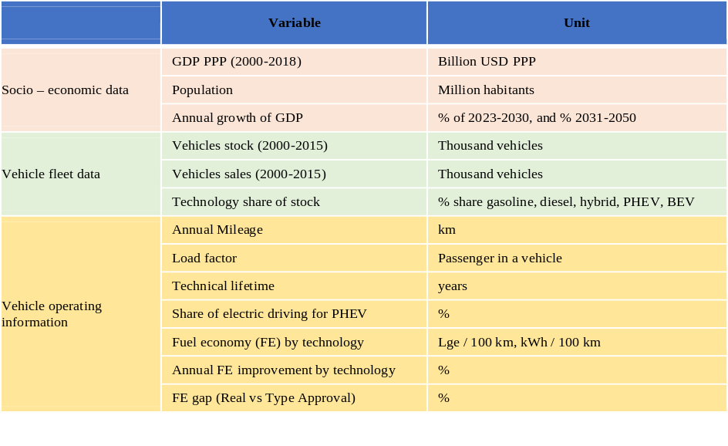

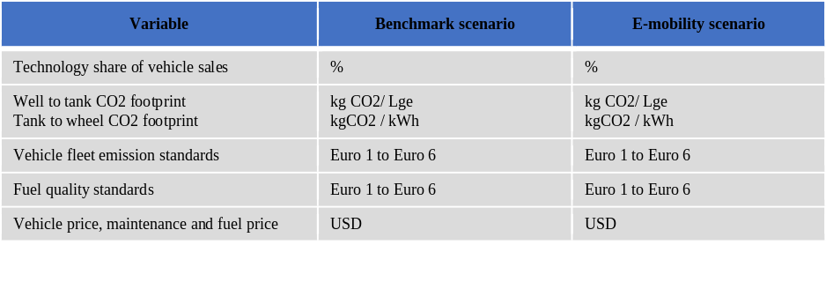
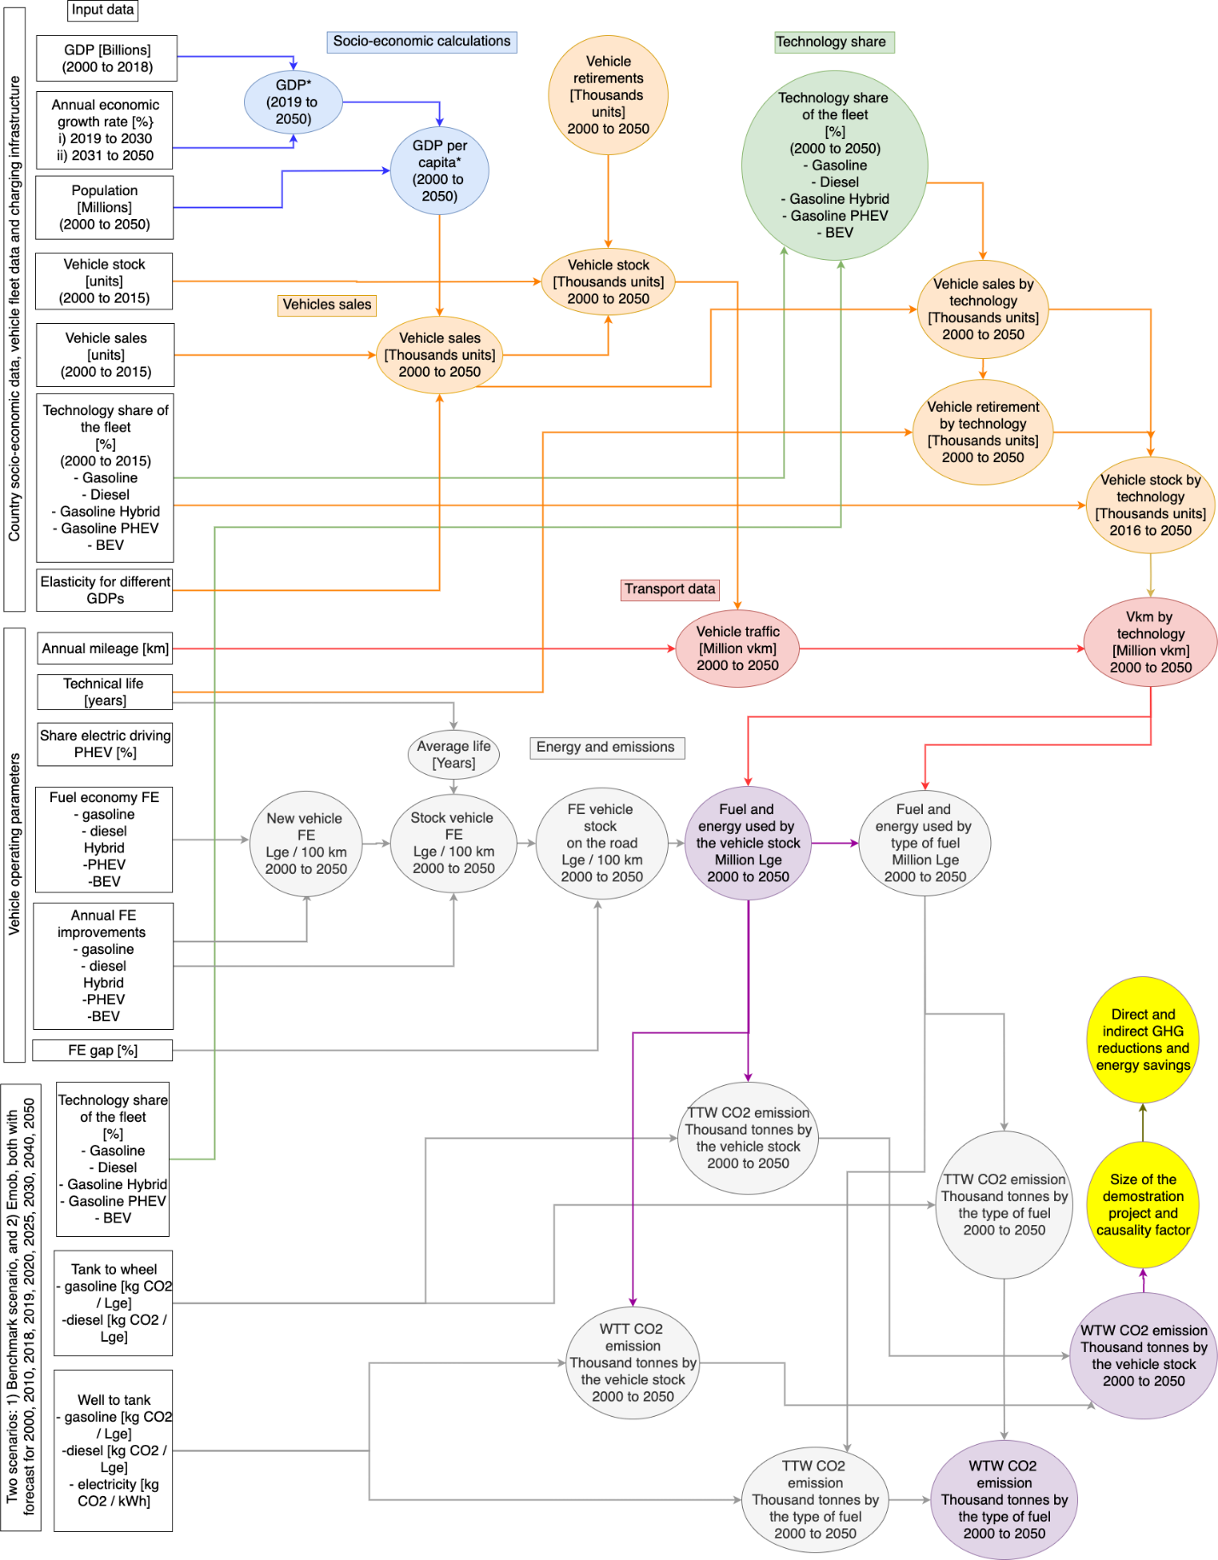
Figure 15 Flow diagramme of the emob calculator

Annex N: OFP Endorsement letter
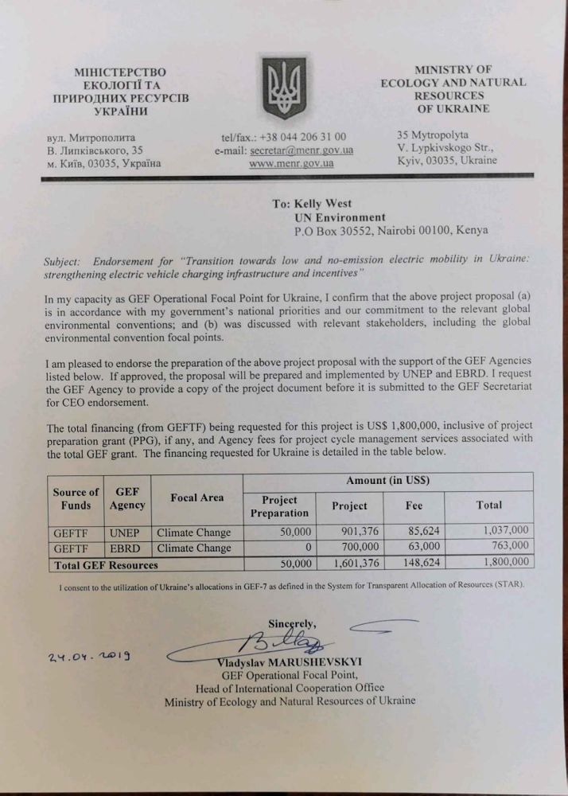

Annex O: Co-financing commitment letters from project partner

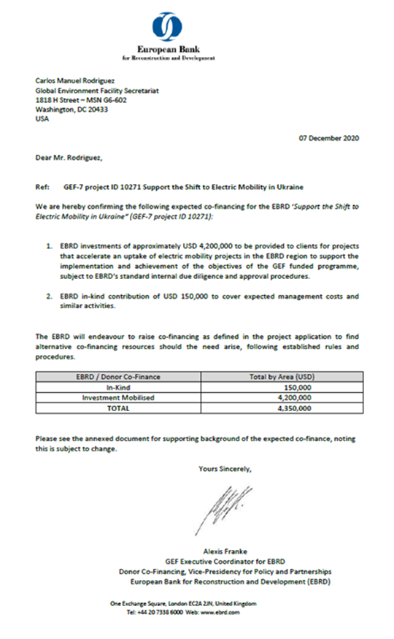
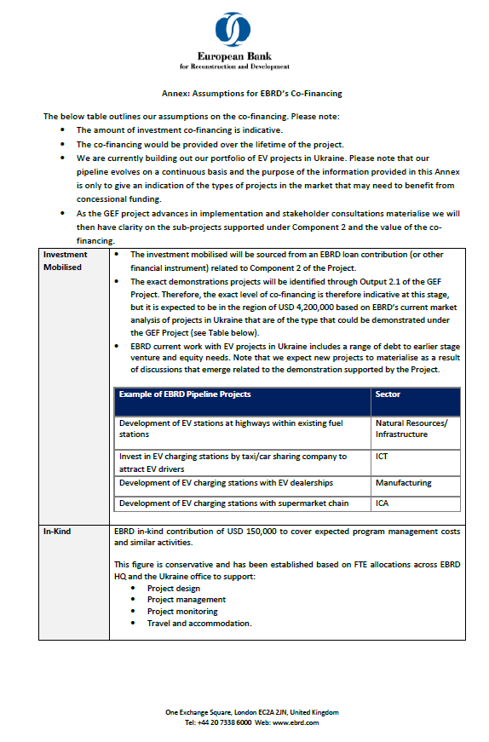
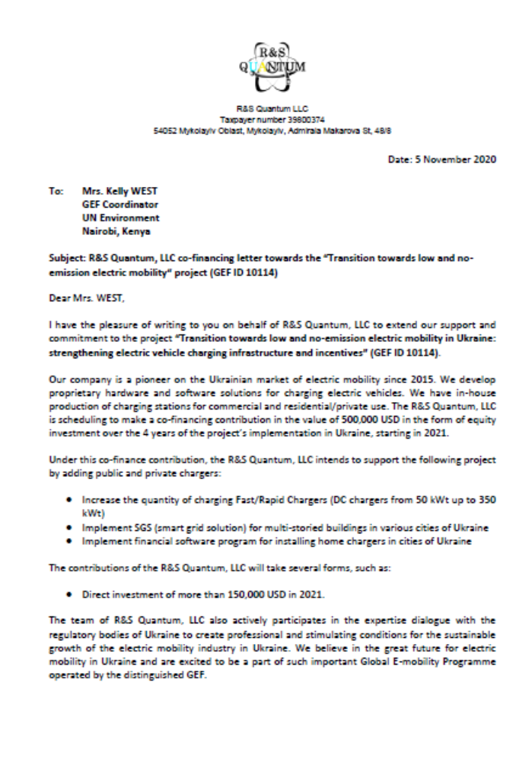


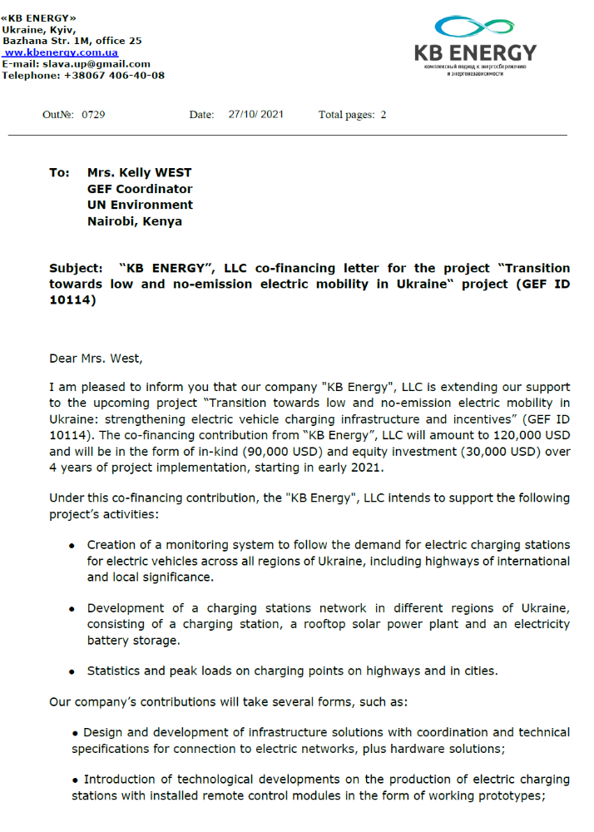
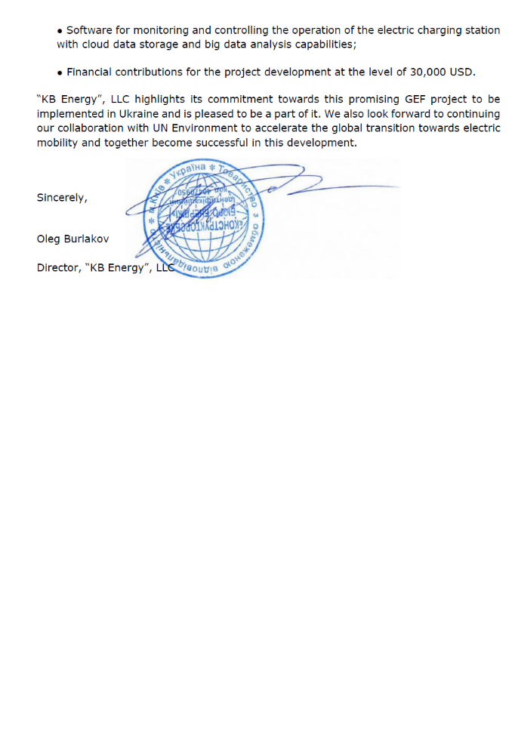
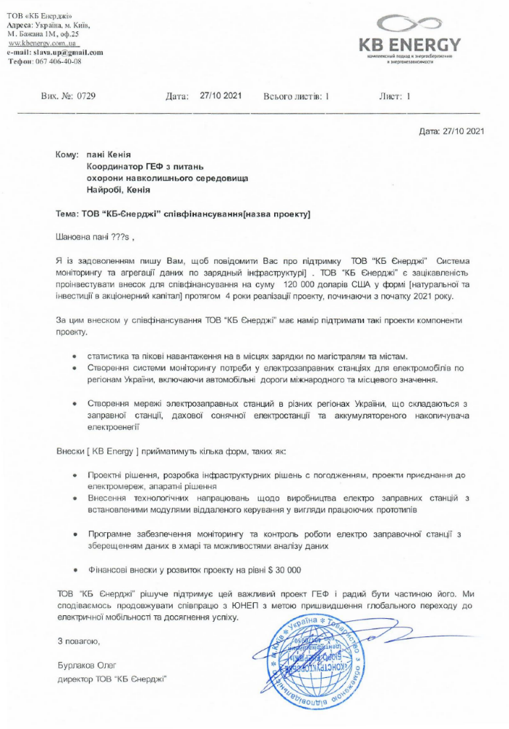
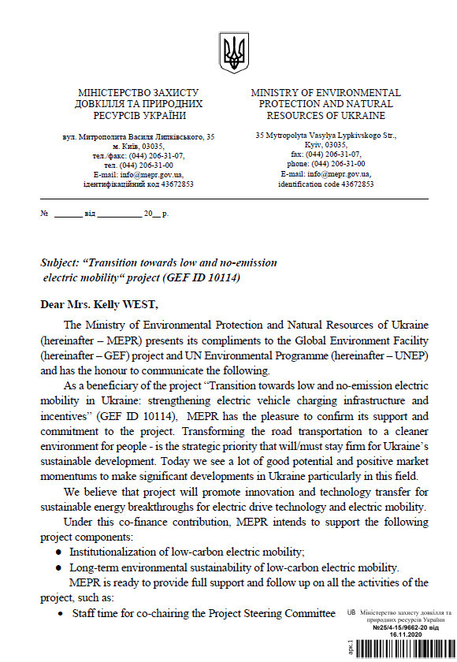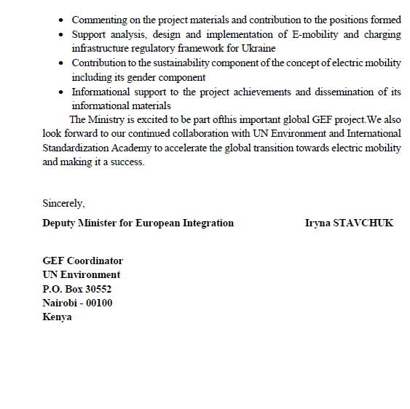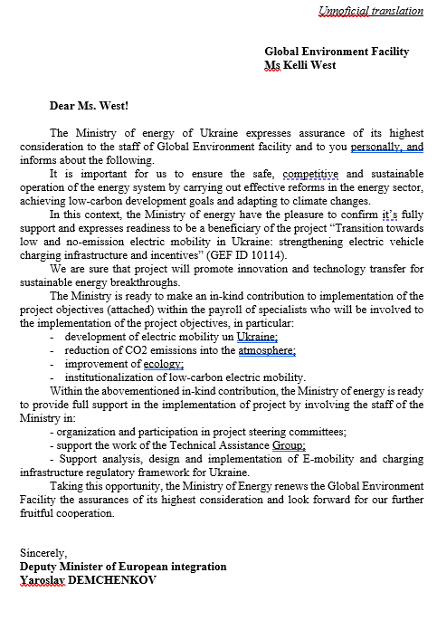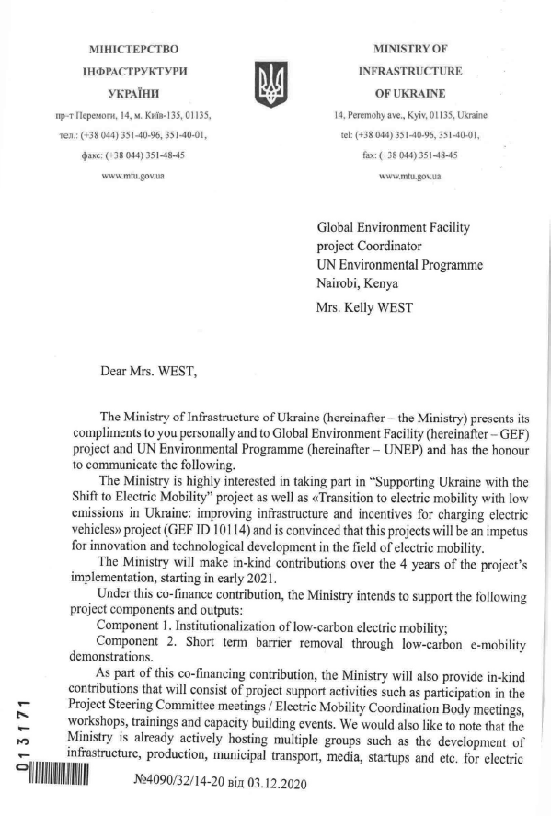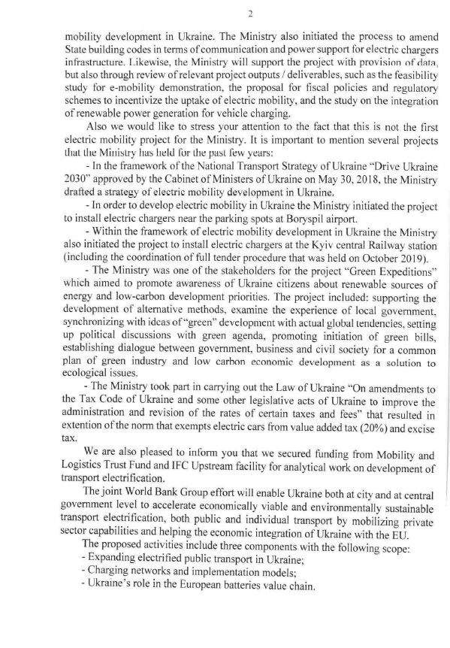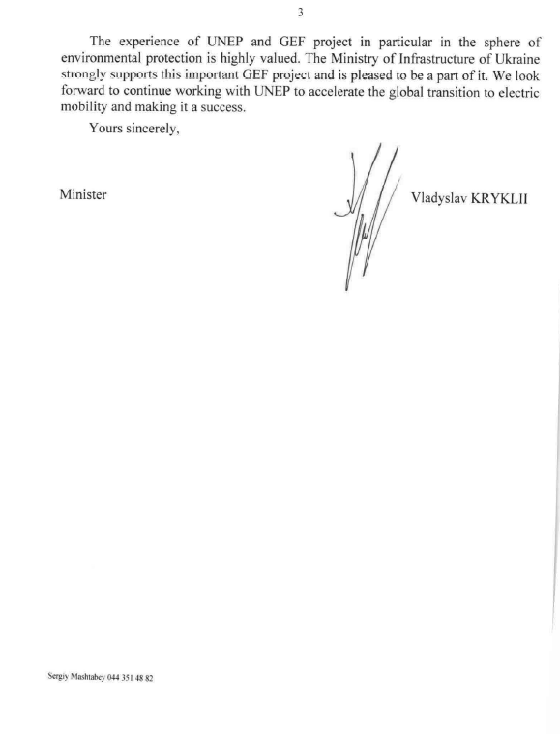
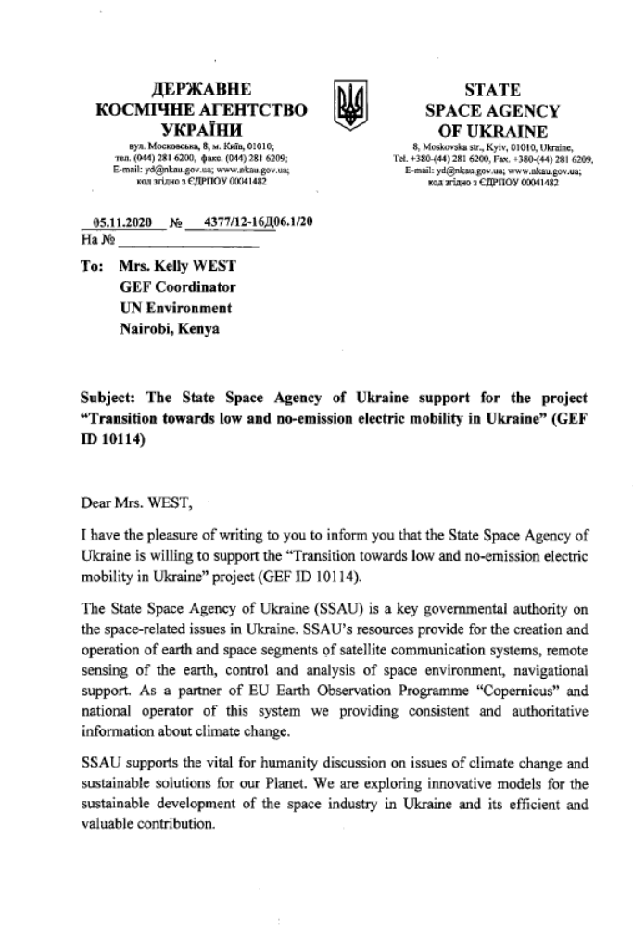
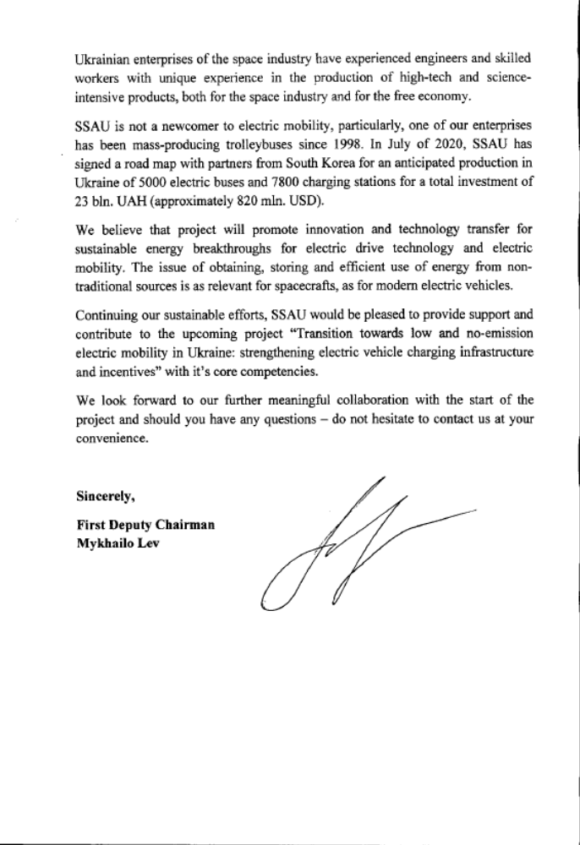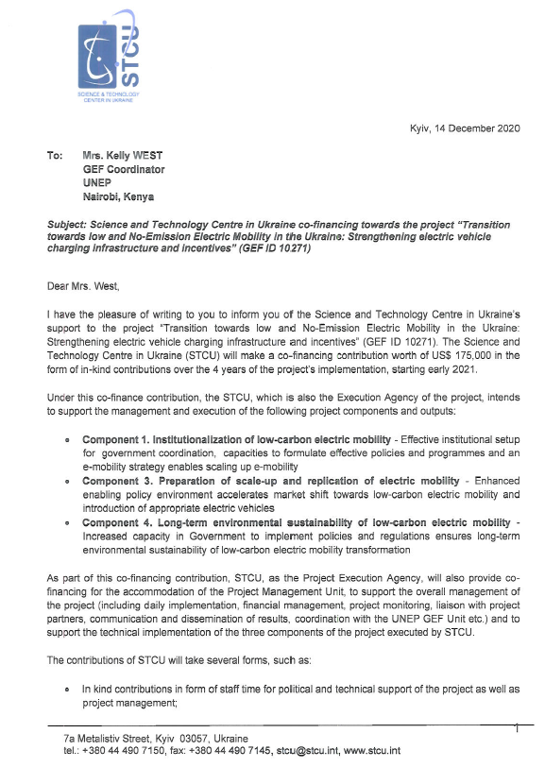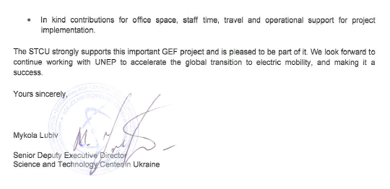

ANNEX P: SAFEGUARD RISK IDENTIFICATION FORM (SRIF)

Section 1: Project Overview
SAFEGUARD RISK IDENTIFICATION FORM (SRIF)

Identification | 10271
Project Title | Project preparation proposal for Transition towards low and No-Emission Electric Mobility in the Ukraine: Strengthening electric vehicle charging infrastructure and incentives
Managing Division | Economy Division. UN Environment Programme
Type/Location | National
Region | Europe
List Countries | Ukraine
Project Description | The project aims to accelerate the shift to electric mobility in the Ukraine. This will be achieved through a combination of Technical Assistance implemented by UNEP and Investment into charging infrastructure implemented by the European Bank for Reconstruction and Development (EBRD).  With the support of the global Programme, the project will develop supportive policies, incentives and strategies to build capacity for change and scale up of the electric mobility market. The project aims to engage with the government, the private sector and financial institutions to demonstrate and scale-up the deployment of electric mobility charging infrastructure in Ukraine. Additionally, the Project targets the integration of renewable energies into the power sector to enable the introduction of accelerated and sustainable energy market transformation in Ukraine supportive of electric mobility scale-up.  The Project includes four components, of which three provide Technical Assistance (component 1, 3 and 4, implemented by UNEP and executed by the Science and Technology Center in Ukraine) and one is dedicated to Investment (component 2, implemented and executed by the EBRD):  - Component 1: Institutionalization of low-carbon electric mobility  - Component 2: Short term barrier removal through low-carbon e-mobility demonstrations  - Component 3: Preparing for scale-up and replication of low-carbon electric mobility  - Component 4: Long-term environmental sustainability of low-carbon electric mobility
Relevant Subprogrammes
Estimated duration of project | 48 months
Estimated cost of the project | USD 1,601,376
Name of the UNEP project manager responsible | Rob Jong
Funding Source(s) | GEF 7
Executing/Implementing partner(s) | Executing Science and Technology Center in Ukraine (STCU), EBRD  Implementing: UNEP, EBRD
SRIF submission version | If it is not the first time, mark the time of your previous submission  Concept Review [ ] During Project development [ ] PRC [ ]  Other ____________________
Safeguard-related reports prepared so far  (Please attach the documents or provide the hyperlinks) | - Feasibility report [ ]  - Gender Action Plan [ ]  - Stakeholder Engagement Plan [X ]  - Safeguard risk assessment or impact assessment [ ]  - ES Management Plan or Framework [ ]  - Indigenous Peoples Plan [ ]  - Cultural Heritage Plan [ ]  - Others __________________________________
Section 2: Safeguards Risk Summary
- Summary of the Safeguards Risk Triggered

Safeguard Standards Triggered by the Project | Impact of Risk (1-5) | Probability of Risk (1-5) | Significance of Risk (L, M, H)  Please refer to the matrix below
SS 1: Biodiversity, Ecosystems and Sustainable Natural Resource Management | 1 | 1 | L
SS 2: Climate Change and Disaster Risks | 2 | 2 | L
SS 3: Pollution Prevention and Resource Efficiency | 1 | 1 | L
SS 4: Community Health, Safety and Security | 1 | 1 | L
SS 5: Cultural Heritage | 1 | 1 | L
SS 6: Displacement and Involuntary Resettlement | 1 | 1 | L
SS 7: Indigenous Peoples | 1 | 1 | L
SS 8: Labor and working conditions | 1 | 1 | L

- ESS Risk Level -
5 | H | H | H | H | H
4 | M | M | H | H | H
3 | L | M | M | M | M
2 | L | L | M | M | M
1 | L | L | L | L | L
# | 1 | 2 | 3 | 4 | 5

Refer to the UNEP ESSF (Chapter IV)
and the UNEP’s ESSF Guidelines.
X
Low risk
Impact

Moderate risk

High risk

Additional information required

Probability
- Development of ESS Review Note and Screening Decision

Prepared by

Name: __Alex Koerner_ Date: 1 November 2020

Screening review by

Name: Yunae Yi Date: _6 November 2020

Cleared
Signature

- Safeguard Review Summary (by the safeguard team)

This is likely a low risk project. However, the components 2 and 3 would require vigilant attention on potential safeguard issues and project’s potential impact to the marginalized and vulnerable people.
UNEP ESSF guiding principles-- resilience and sustainability; human rights, gender equality and women empowerment, accountability and leave no one behind--are still applicable for low risk projects. Project level grievance mechanism (if the government does not have such venue) should be established for any complaints to be handled swiftly at the project level.

- Safeguard Recommendations (by the safeguard team)

yesx
- Take Good Practice approach

Section 3: Safeguard Risk Checklist

Screening checklist | Y/N/  Maybe | Justification for the response (please provide answers to each question)
Guiding Principles (these questions should be considered during the project development phase)
GP1 Has the project analyzed and stated those who are interested and may be affected positively or negatively around the project activities, approaches or results? | Y
GP2 Has the project identified and engaged vulnerable, marginalized people, including disabled people, through the informed, inclusive, transparent and equal manner on potential positive or negative implication of the proposed approach and their roles in the project implementation? | N | Will form part of stakeholder engagement
GP3 Have local communities or individuals raised human rights or gender equality concerns regarding the project (e.g. during the stakeholder engagement process, grievance processes, public statements)? | N
GP4 Does the proposed project consider gender-balanced representation in the design and implementation? | Y
GP5 Did the proposed project analyze relevant gender issues and develop a gender responsive project approach? | Y
GP6 Does the project include a project-specific grievance redress mechanism? If yes, state the specific location of such information. | Y | The advisory board
GP7 Will or did the project disclose project information, including the safeguard documents? If yes, please list all the webpages where the information is (or will be) disclosed. | N
GP8 Were the stakeholders (including affected communities) informed of the projects and grievance redress mechanism? If yes, describe how they were informed. | Y | Stakeholder consultation workshop held.
GP9 Does the project consider potential negative impacts from short-term net gain to the local communities or countries at the risk of generating long-term social or economic burden? | Y
GP10 Does the project consider potential partial economic benefits while excluding marginalized or vulnerable groups, including women in poverty? | Y
Safeguard Standard 1: Biodiversity, Ecosystems and Sustainable Natural Resource Management
Would the project potentially involve or lead to:
1.1 conversion or degradation of habitats (including modified habitat, natural habitat and critical natural habitat), or losses and threats to biodiversity and/or ecosystems and ecosystem services? | N
1.2 adverse impacts specifically to habitats that are legally protected, officially proposed for protection, or recognized as protected by traditional local communities and/or authoritative sources (e.g. National Park, Nature Conservancy, Indigenous Community Conserved Area, (ICCA); etc.)? | N
1.3 conversion or degradation of habitats that are identified by authoritative sources for their high conservation and biodiversity value? | N
1.4 activities that are not legally permitted or are inconsistent with any officially recognized management plans for the area? | N
1.5 risks to endangered species (e.g. reduction, encroachment on habitat)? | N
1.6 activities that may result in soil erosion, deterioration and/or land degradation? | N
1.7 reduced quality or quantity of ground water or water in rivers, ponds, lakes, other wetlands? | N
1.8 reforestation, plantation development and/or forest harvesting? | N
1.9 support for agricultural production, animal/fish production and harvesting | N
1.10 introduction or utilization of any invasive alien species of flora and fauna, whether accidental or intentional? | N
1.11 handling or utilization of genetically modified organisms? | N
1.12 collection and utilization of genetic resources? | N
Safeguard Standard 2: Climate Change and Disaster Risks
Would the project potentially involve or lead to:
2.1 improving resilience against potential climate change impact beyond the project intervention period? | N
2.2 areas that are now or are projected to be subject to natural hazards such as extreme temperatures, earthquakes, extreme precipitation and flooding, landslides, droughts, severe winds, sea level rise, storm surges, tsunami or volcanic eruptions in the next 30 years? | N
2.3 outputs and outcomes sensitive or vulnerable to potential impacts of climate change (e.g. changes in precipitation, temperature, salinity, extreme events)? | N
2.4 local communities vulnerable to the impacts of climate change and disaster risks (e.g. considering level of exposure and adaptive capacity)? | N
2.5 increases of greenhouse gas emissions, black carbon emissions or other drivers of climate change? | N | The purpose of this project is to decrease GHG emissions in the transport sector compared to the baseline situation. Please refer to section “1.b.6) Global environmental benefits” and Annex M of the CEO Endorsement Document for further details.
2.6 Carbon sequestration and reduction of greenhouse emissions, resource-efficient and low carbon development, other measures for mitigating climate change | N
Safeguard Standard 3: Pollution Prevention and Resource Efficiency
Would the project potentially involve or lead to:
3.1 the release of pollutants to the environment due to routine or non-routine circumstances with the potential for adverse local, regional, and/or transboundary impacts? | N | The proposed project seeks to improve air quality through sustainable and low-emissions transport.
3.2 the generation of waste (both hazardous and non-hazardous)? | N | To address this issue, the activities to be undertaken under project Component 4 will include the development of life-cycle management of battery packs that are used to power electric vehicles, as well as plans for battery recycling, reuse and sound disposal.
3.3 the manufacture, trade, release, and/or use of hazardous materials and/or chemicals? | N
3.4 the use of chemicals or materials subject to international bans or phase-outs? (e.g. DDT, PCBs and other chemicals listed in international conventions such as the Montreal Protocol, Minamata Convention, Basel Convention, Rotterdam Convention, Stockholm Convention) | N
3.5 the application of pesticides or fertilizers that may have a negative effect on the environment (including non-target species) or human health? | N
3.6 significant consumption of energy, water, or other material inputs? | N | The project seeks to reduce fossil fuel consumption through the promotion of electric vehicles.
Safeguard Standard 4: Community Health, Safety and Security
Would the project potentially involve or lead to:
4.1 the design, construction, operation and/or decommissioning of structural elements such as new buildings or structures (including those accessed by the public)? | N
4.2 air pollution, noise, vibration, traffic, physical hazards, water runoff? | N
4.3 exposure to water-borne or other vector-borne diseases (e.g. temporary breeding habitats), communicable or noncommunicable diseases? | N
4.4 adverse impacts on natural resources and/or ecosystem services relevant to the communities’ health and safety (e.g. food, surface water purification, natural buffers from flooding)? | N
4.5 transport, storage use and/or disposal of hazardous or dangerous materials (e.g. fuel, explosives, other chemicals that may cause an emergency event)? | N
4.6 engagement of security personnel to support project activities (e.g. protection of property or personnel, patrolling of protected areas)? | N
4.7 an influx of workers to the project area or security personnel (e.g. police, military, other)? | N
Safeguard Standard 5: Cultural Heritage
Would the project potentially involve or lead to:
5.1 activities adjacent to or within a Cultural Heritage site? | N
5.2 adverse impacts to sites, structures or objects with historical, cultural, artistic, traditional or religious values or to intangible forms of cultural heritage (e.g. knowledge, innovations, practices)? | N
5.3 utilization of Cultural Heritage for commercial or other purposes (e.g. use of objects, practices, traditional knowledge, tourism)? | N
5.4 alterations to landscapes and natural features with cultural significance? | N
5.5 significant land clearing, demolitions, excavations, flooding? | N
5.6 identification and protection of cultural heritage sites or intangible forms of cultural heritage
Safeguard Standard 6: Displacement and Involuntary Resettlement
Would the project potentially involve or lead to:
6.1 full or partial physical displacement or relocation of people (whether temporary or permanent)? | N
6.2 economic displacement (e.g. loss of assets or access to assets affecting for example crops, businesses, income generation sources)? | N
6.2 involuntary restrictions on land/water use that deny a community the use of resources to which they have traditional or recognizable use rights? | N
6.3 risk of forced evictions? | N
6.4 changes in land tenure arrangements, including communal and/or customary/traditional land tenure patterns (including temporary/permanent loss of land)? | N
Safeguard Standard 7: Indigenous Peoples
Would the project potentially involve or lead to: | N
7.1 areas where indigenous peoples are present or uncontacted or isolated indigenous peoples inhabit or where it is believed these peoples may inhabit? | N
7.2 activities located on lands and territories claimed by indigenous peoples? | N
7.3 impacts to the human rights of indigenous peoples or to the lands, territories and resources claimed by them? | N
7.4 the utilization and/or commercial development of natural resources on lands and territories claimed by indigenous peoples? | N
7.5 adverse effects on the development priorities, decision making mechanisms, and forms of self-government of indigenous peoples as defined by them? | N
7.6 risks to the traditional livelihoods, physical and cultural survival of indigenous peoples? | N
7.7 impacts on the Cultural Heritage of indigenous peoples, including through the commercialization or use of their traditional knowledge and practices? | N
Safeguard Standard 8: Labor and working conditions
8.1 Will the proposed project involve hiring or contracting project staff ? | Y
If the answer to 8.1 is yes, would the project potentially involve or lead to:
8.2 working conditions that do not meet national labour laws or international commitments (e.g. ILO conventions)? | N
8.3 the use of forced labor and child labor? | N
8.4 occupational health and safety risks (including violence and harassment)? | N
8.5 the increase of local or regional unemployment? | N
8.6 suppliers of goods and services who may have high risk of significant safety issues related to their own workers? | N
8.7 unequal working opportunities and conditions for women and men | N

EBRD Environmental and Social Safeguards Annex: Environmental and Social Safeguards (ESS) Risks

Provide information on the identified environmental and social risks and potential impacts associated with the project/program based on your organization's ESS systems and procedures
Overall Project/Program Risk Classification | Medium/Moderate
Measures to address & Identify risks and Impacts
Elaborate on the types and risk classifications/ratings of any identified environmental and social risks and impacts (considering the GEF ESS Minimum Standards) and any measures undertaken as well as planned management measures to address these risks during implementation.
Introduction: Following initial desktop assessment and review of the Project’s Component 2 – to be executed by the EBRD -- the EBRD has rated the project as “Medium/Moderate” risk. The (sub-)project(s) to be financed under the Project is expected to be Categorised as “B” in accordance with EBRD’s Environmental and Social Policy. The (sub-)project(s) will result in significant environmental benefits, including reduction of GHG emissions reductions and local air pollution. Bespoke due diligence will be conducted at the (sub-)project-level, which will typically involve an environmental audit carried out by an independent expert. Where risks or impacts are identified, the EBRD will agree specific time-bound actions with the companies to address these, and the EBRD will monitor implementation throughout the tenor of the loan.
Assessment of Types of Risks Across the GEF Project
Below are the key potential risks that could arise throughout the lifetime of the Project.
Please note:
- This is an initial desk based assessment based on the types of sub-project that is expected to be financed under the Project. These risks will be reviewed at the time of annual review.
- As the sub-project investment is progressed through internal review, the EBRD will, where applicable, undertake environmental and social assessment in line with its 2019 Environment and Social Policy. The risk rating of the sub-project will depend on the project technology choice, location and environmental characteristics.
- EBRD categorises the (sub-)project to determine the nature and level of environmental and social investigations, information disclosure and stakeholder engagement required. This will be commensurate with the nature, location, sensitivity and scale of the project, and the significance of its potential environmental and social impacts which are new and additional.
- At this stage, we cannot share any additional documentation.

Type of ESS Risk | Risk Classification | Example Measures to Address Impacts
Borrower E&S management capacity | Medium / Moderate | Borrower capacity to manage environmental and social risks is assessed during due diligence. Action will be agreed as necessary.
Occupational health and safety | Medium / Moderate (potentially, depending on the context) | Due diligence will assess risk to employees from, including normal operations and potential accident scenarios. Health and safety management systems and plans will be developed as needed.
Air Emissions, ground or surface water pollution | Medium / Moderate | EBRD’s environmental and social policy requires compliance with applicable EU standards. Technical solutions are typically available.
Community concerns and complaints | Medium / Moderate | Borrowers will be required to develop Stakeholder Engagement Plans and implement grievance mechanisms. Non-technical summaries can be used to provide information to local communities.

ANNEX Q: ACRONYMS AND ABBREVIATIONS

AB Advisory Board
AC Alternate Current
AUC Association of Ukrainian Cities
AVERE European Association for Electromobility, Sustainable Transport and Infrastructure
CASE Climate package for a Stable Economy
CEDAW Convention on the Elimination of All Forms of Discrimination against Women
CO_{2e} CO₂ equivalent
CGTN Transboundary Green Transport Network
CTA Chief Technical Advisor
CPO Charge Point Operator
DSO Distribution System Operator
DC Direct Current
E2C2 Energy Efficiency and Climate Change
EBRD European Bank for Reconstruction and Development
EC European Commission
ELV End-of-Life Vehicle
EOU Environment Programme Evaluation Office
EPG Economic, Policy and Governance
EU European Union
EUEA European-Ukrainian Energy Agency
EUCARIS European Car and Driving License Information System
ENTSO-E European Network of Transmission System Operators for Electricity
ESAP Environmental and Social Action Plan
ESD Environmental and Sustainability Department
ESIA Environmental and Social Impact Assessment
EV Electric Vehicles
GDP Gross Domestic Product
GEF Global Environment Facility
GEFTF GEF Trust Fund
GFEI Global Fuel Economy Initiative
GHG Greenhouse gas
ICE Internal Combustion Engine
IDA International Development Agency
IEA International Energy Agency
IKI Internationale Klimaschutzinitiative (German Government’s International Climate Initiative)
INV Investment
ILO International Labour Organization
ISA International Standardization Academy
kWh Kilo Watt hours
KRAZ Kremenchuk Automobile Plant or AvtoKrAZ
L/100km Liter per 100km
MCTDU Ministry for Communities and Territories Development of Ukraine
MIU Ministry of Infrastructure of Ukraine
MJ Mega Joule
MoSP Ministry of Social Policy
MSP Mobility Service Provider
MW Mega Watt
NDC Nationally Determined Contributions
NPV Net Present Value
NREL National Renewable Energy Laboratory
IRENA International Renewable Energy Funding
LDV Light Duty Vehicle
M&E Monitoring and Evaluation
MEEP Ministry of Energy and Environmental Protection
MRV Monitoring, Reporting and Verification
NEURC National Energy and Utilities Regulatory Commission
NPD National Project Director
NREAP National Renewable Energy Action Plan
OGC Legal Department
OL Operational Leaders
PM Particulate Matter
PMC Project Management Costs
PMU Project Management Unit
PPP Public private partnership
PSC Project Steering Committee
RES Renewable Energy Sources
SMU Sustainable Mobility Unit
STCU Science and Technology Center in Ukraine
SSAU State Space Agency of Ukraine
TA Technical Assistance
TFEC Total Final Energy Consumption
TWG Technical Working Group
UAH Ukrainian Hryvnia
UNCT United Nations Country Team
UNDP United Nations Development Programme
UNEP United Nations Environment Programme
USD USA Dollar
WHO World Health Organization
VAT Value added tax
ZAZ Zaporizhia Automobile Building Plant

ANNEX R: TABLE OF CONTENT

Part i: Project Information 1
A. Focal/Non-Focal Area Elements 1
B. Project description summary 1
C. Confirmed sources of Co-financing for the project by name and by type 4
D. Trust Fund Resources Requested by Agency, Country, Focal Area and the Programming of Funds 5
E. DOES THE PROJECT INCLUDE A “NON-GRANT” INSTRUMENT? ☐ Yes ☒ No 5
F. Project’s Target Contributions to GEF 7 Core Indicators 5
G. Project Taxonomy 6
Part ii: Project Justification 7
1a. Changes in project design 7
1b. Project Description 9
1c. Project Map and Geo-Coordinates 45
1d. Child Project 46
2. Stakeholders 48
3. Gender Equality and Women's Empowerment 54
4. Private Sector Engagement 59
5. Risks 61
6. Institutional Arrangement and Coordination 67
7. Consistency with National Priorities 70
8. Knowledge Management 71
9. Monitoring and Evaluation 73
10. Benefits 74
PART III: CERTIFICATION BY GEF PARTNER AGENCY(IES) 76
PART IV: ANNEXES 77
Annex A: Project Results Framework 78
Annex B: Response to Project Reviews 80
Annex C: Status of Utilization of Project Preparation Grant (PPG) 80
Annex D: Calendar of Expected Reflows (if non-grant instrument is used) 81
Annex E: Project Map(s) and Coordinates 82
Annex F: GEF 7 Core Indicator Worksheet 83
Annex G: GEF Project Taxonomy Worksheet 84
Annex H: INDICATIVE Terms of Reference for Project Personnel, Consultants and Subcontracts 86
Annex I-1 Detailed GEF budget 97
Annex I-2 Detailed Co-finance budget 98
Annex J: M&E Budget and Workplan 99
Annex K: Project Implementation Arrangements 102
Annex L: Project Workplan and Deliverables 108
Annex M: Estimates of Direct and Consequential Greenhouse Gas Emission Reductions 110
Annex N: OFP Endorsement letter 114
Annex O: Co-financing commitment letters from project partner 115
ANNEX P: SAFEGUARD RISK IDENTIFICATION FORM (SRIF) 137
ANNEX Q: ACRONYMS AND ABBREVIATIONS 148
ANNEX R: TABLE OF CONTENT 150

Depending on the final mix of fast and slow chargers
The Ministry of Environmental Protection and Natural Resources provided a co-finance letter clearly stating the commitment to support the project through in-kind contributions but where not able to commit to monetary values due to legal issues.
The Ministry of Energy provided a co-finance letter clearly stating the commitment to support the project through in-kind contributions but where not able to commit to monetary values due to legal issues.
The Ministry of Infrastructure provided a co-finance letter clearly stating the commitment to support the project through in-kind contributions but where not able to commit to monetary values due to legal issues
Based on punctual data on mode choice by gender published in “Gender and Transport in Less Developed Countries: A Background Paper in Preparation for CSD-9”, Paper commissioned by UNED Forum as input for the workshop "Gender Perspectives for Earth Summit 2002: Energy, Transport, Information for Decision-Making" Berlin, Germany, 10 - 12 January 2001
Depending on the mix of slow and fast chargers supported.
CO2 Emissions from Fuel Combustion Highlights 2019, IEA 2019
IEA Mobility Model, 2019
https://mepr.gov.ua/files/docs/Zmina_klimaty/kadastr2017/Ukraine_NIR_2019_draft.pdf
https://www.usnews.com/news/best-countries/articles/2017-11-09/air-pollution-kills-the-most-people-in-these-countries , https://www.boell.de/sites/default/files/2020-01/Ukraine_Energie_2019.pdf
GFEI 2018, Statistics of the Ministry of Infrastructure of Ukraine
Assuming a fuel consumption of 18kWh/100km for the EV, 7.0 L/100km for the conventional car and annual driving distance of 15,000km.
Global Fuel Economy Initiative
https://www.irena.org/-/media/Files/IRENA/Agency/Publication/2015/Apr/IRENA_REmap_Ukraine_paper_2015.pdf
https://www.oecd.org/eurasia/competitiveness-programme/eastern-partners/Snapshot-of-Ukraines-Energy-Sector-EN.pdf, Snapshot of Ukraine’s Energy Sector
Dornier 2016, Updated Transport Strategy for Ukraine
Source: https://cleantechnica.com/2019/03/17/financing-your-ev-charging-network-costs-revenues-business-models/
Estimating electric vehicle charging infrastructure costs across major U.S. metropolitan areas, ICCT, 2019
Estimating electric vehicle charging infrastructure costs across major U.S. metropolitan areas, ICCT, 2019
Estimating electric vehicle charging infrastructure costs across major U.S. metropolitan areas, ICCT, 2019
Also based on additional literature: Average installation costs for level 2 public chargers (up to 19.4 kW) range around USD 3,000 to 6,000 in the U.S. Costs for level 2 charging stations range around USD 2,000 to USD 6,000. Average installation costs for DC fast chargers range around USD 4,000 to 51,000 in the U.S. Costs for DC fast charging stations range around USD 10,000 to USD 40,000. From: Costs Associated With Non-Residential Electric Vehicle Supply Equipment Factors to consider in the implementation of electric vehicle charging stations, NREL 2015
https://www.kmu.gov.ua/en/yevropejska-integraciya/ugoda-pro-asociacyu
National Transport Strategy of Ukraine 2030
Engine displacement or size of an engine refers to the total volume of air and fuel being pushed through the engine per stroke.
Eastern Partnership 14th Panel on Transport: Electric Vehicles in Ukraine
https://www.kievcheckin.com/discover-kiev/are-we-entering-the-era-of-the-electric-car-heres-everything-you-need-to-know
Eastern Partnership 14th Panel on Transport: Electric Vehicles in Ukraine
https://www.ecolex.org/details/legislation/law-no-2019-viii-on-electric-energy-market-lex-faoc179080/
Eastern Partnership 14th Panel on Transport: Electric Vehicles in Ukraine
https://112.international/politics/verhovna-rada-registers-draft-bills-on-production-of-electric-cars-51360.html
https://www.rvo.nl/sites/default/files/2019/02/Waste-management-in-Ukraine.pdf
http://uwea.com.ua/en/news/entry/ukraina-planiruet-osuschestvit-zelenyj-energeticheskij-perehod-k-2050-godu/#:~:text=On%20January%2021%2C%202020%2C%20the,with%20focus%20on%20climate%20change
EU4Energy 2019, Annual Monitoring Report on Ukraine’s Progress on the Implementation of the EU-Ukraine Association Agreement in the Fields of Energy and Environment in 9 months of 2019
State Agency on Energy Efficiency
Depending on the mix of slow and fast chargers supported.
Based on the 2019 sales share of EVs of 7.5 % (7,542 vehicles) but anticipating a growth of overall sales to 200,000 units
Based in IEA EV to charger ratios for public slow and fast charging published in the 2017 edition of the Global EV Outlook.
Depending on the final mix of fast and slow chargers
Depending on the mix of slow and fast chargers supported.
Depending on the mix of slow and fast chargers supported.
INCEPTION IMPACT ASSESSMENT, ENV.B3 – Waste management & Secondary Materials, Ref. Ares(2020)2777034 - 28/05/2020
Data obtained with an in-house built model
GEF (2014). Guidelines for the Implementation of the Public Involvement Policy. Accessed at http://www.thegef.org/sites/default/files/council-meeting-documents/39_EN_GEF.C.47.Inf_.06_Guidelines_for_the_Implementation_of_the_Public_Involvement_Policy_4.pdf in December 2019.
Transportation Research Part D 72 (2019) 187–202- Benjamin K. Sovacoola,, Johannes Kester, Lance Noel and Gerardo Zarazua de Rubens
https://www.thegef.org/sites/default/files/council-meeting-documents/EN_GEF.STAP_.C.56.Inf_.03_STAP%20guidance%20on%20climate%20risk%20screening.pdf
PR1 Assessment and Management of Environmental and Social Risks and Impacts; PR2 Labour and Working conditions; PR3 Resource efficiency and Pollution Prevention and control; PR4 Health, Safety and Security; PR5 Land Acquisition, Restrictions on Land Use and Involuntary Resettlement ; PR6 Biodiversity Conservation and Sustainable Management of Living Natural Resources; PR7 Indigenous Peoples; PR8 Cultural Heritage; PR9 Financial Intermediaries; and, PR10 Information Disclosure and Stakeholder Engagement.
http://www.stcu.int
https://www.google.com/url?sa=t&rct=j&q=&esrc=s&source=web&cd=&ved=2ahUKEwjMipW1h6LsAhXKyIUKHY3gDaQQFjAAegQIBhAC&url=https%3A%2F%2Fwww.undp.org%2Fcontent%2Fdam%2Fundp%2Flibrary%2Fcorporate%2FExecutive%2520Board%2F2017%2FSecond-regular-session%2FDPDCPUKR3_UNDAF%2520Results%2520Matrix%25208%2520May.docx&usg=AOvVaw3lUZ1Q0aWa_8sp7WFtG1rQ
These benefits are calculated over the lifetime of the purchased assets (e.g. 15 years for cars and buses, 5 years for 2&3 wheelers and 20 years for EV supply equipment).
Whichever time frame is longer is applied. E.g. if the project demonstrates e-buses with an assumed lifetime of 15 years (which are introduced in year 2 of the project) then the timeframe for the calculation of indirect emission reductions is the year 2036 (2021 plus 15 years). If electric motorcycles with a lifetime of only 5 years are demonstrated, the timeframe is 2034 (end of project 2024 plus ten years).
Refer to UNEP Environmental and Social Sustainability Framework (ESSF): Implementation Guidance Note to assign values to the Impact of Risk and the Probability of Risk to determine the overall significance of Risk (Low, Moderate or High).
Low risk: Negative impacts minimal or negligible: no further study or impact management required. Moderate risk: Potential negative impacts, but limited in scale, not unprecedented or irreversible and generally limited to programme/project area; impacts amenable to management using standard mitigation measures; limited environmental or social analysis may be required to develop a Environmental and Social Management Plan (ESMP). Straightforward application of good practice may be sufficient without additional study. High risk: Potential for significant negative impacts (e.g. irreversible, unprecedented, cumulative, significant stakeholder concerns); Environmental and Social Impact Assessment (ESIA) (or Strategic Environmental and Social Assessment (SESA)) including a full impact assessment may be required, followed by an effective comprehensive safeguard management plan.
This is signed only for the full projects latest by the PRC time.
Good practice approach: For most low-moderate risk projects, good practice approach may be sufficient. In that case, no separate management plan is necessary. Instead, the project document demonstrates safeguard management approach in the project activities, budget, risks management, stakeholder engagement or/and monitoring segments of the project document to avoid or minimize the identified potential risks without preparing a separate safeguard management plan.

